XYZ is a right-angled triangle.  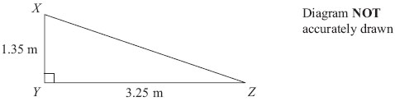  Calculate the length of XZ.  Give your answer correct to 3 significant figures.  ......................................................................................  (Total for Question is 3 marks) | XYZ is a right-angled triangle.  Calculate the length of XZ.  Give your answer correct to 3 significant figures.  ......................................................................................  (Total for Question is 3 marks)
XYZ is a right-angled triangle.  Calculate the length of XZ.  Give your answer correct to 3 significant figures.  ......................................................................................  (Total for Question is 3 marks) | XYZ is a right-angled triangle.  Calculate the length of XZ.  Give your answer correct to 3 significant figures.  ......................................................................................  (Total for Question is 3 marks)
The diagram shows a ladder leaning against a vertical wall.  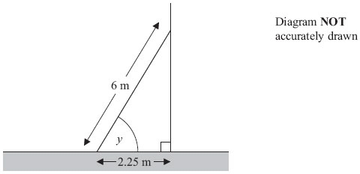  The ladder stands on horizontal ground. The length of the ladder is 6 m. The bottom of the ladder is 2.25 m from the bottom of the wall. A ladder is safe to use when the angle marked y is about 75°.  Is the ladder safe to use?  You must show all your working.  (Total for Question is 3 marks) | The diagram shows a ladder leaning against a vertical wall.  The ladder stands on horizontal ground. The length of the ladder is 6 m. The bottom of the ladder is 2.25 m from the bottom of the wall. A ladder is safe to use when the angle marked y is about 75°.  Is the ladder safe to use?  You must show all your working.  (Total for Question is 3 marks)
The diagram shows a ladder leaning against a vertical wall.  The ladder stands on horizontal ground. The length of the ladder is 6 m. The bottom of the ladder is 2.25 m from the bottom of the wall. A ladder is safe to use when the angle marked y is about 75°.  Is the ladder safe to use?  You must show all your working.  (Total for Question is 3 marks) | The diagram shows a ladder leaning against a vertical wall.  The ladder stands on horizontal ground. The length of the ladder is 6 m. The bottom of the ladder is 2.25 m from the bottom of the wall. A ladder is safe to use when the angle marked y is about 75°.  Is the ladder safe to use?  You must show all your working.  (Total for Question is 3 marks)
The diagram shows a pyramid.  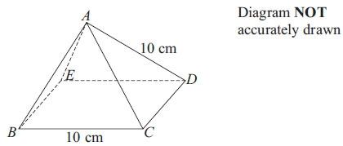  BCDE is a square with sides of length 10 cm. The other faces of the pyramid are equilateral triangles with sides of length 10 cm.  Find the size of angle DAB.  ...............................................................  (Total for Question is 2 marks) | The diagram shows a pyramid.  BCDE is a square with sides of length 10 cm. The other faces of the pyramid are equilateral triangles with sides of length 10 cm.  Find the size of angle DAB.  ...............................................................  (Total for Question is 2 marks)
The diagram shows a pyramid.  BCDE is a square with sides of length 10 cm. The other faces of the pyramid are equilateral triangles with sides of length 10 cm.  Find the size of angle DAB.  ...............................................................  (Total for Question is 2 marks) | The diagram shows a pyramid.  BCDE is a square with sides of length 10 cm. The other faces of the pyramid are equilateral triangles with sides of length 10 cm.  Find the size of angle DAB.  ...............................................................  (Total for Question is 2 marks)
ABC is a triangle.  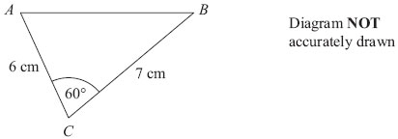  Work out the length of the side AB.  Give your answer correct to 3 significant figures.  ..........................................................................  (Total for Question is 3 marks) | ABC is a triangle.  Work out the length of the side AB.  Give your answer correct to 3 significant figures.  ..........................................................................  (Total for Question is 3 marks)
ABC is a triangle.  Work out the length of the side AB.  Give your answer correct to 3 significant figures.  ..........................................................................  (Total for Question is 3 marks) | ABC is a triangle.  Work out the length of the side AB.  Give your answer correct to 3 significant figures.  ..........................................................................  (Total for Question is 3 marks)
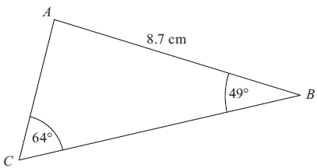  Diagram NOT accurately drawn  ABC is a triangle. AB = 8.7 cm. Angle ABC = 49°.  Angle ACB = 64°.  Calculate the area of triangle ABC.  Give your answer correct to 3 significant figures.  . . . . . . . . . . . . . . . . . . . . . cm²  (Total for Question is 5 marks) | Diagram NOT accurately drawn  ABC is a triangle. AB = 8.7 cm. Angle ABC = 49°.  Angle ACB = 64°.  Calculate the area of triangle ABC.  Give your answer correct to 3 significant figures.  . . . . . . . . . . . . . . . . . . . . . cm²  (Total for Question is 5 marks)
Diagram NOT accurately drawn  ABC is a triangle. AB = 8.7 cm. Angle ABC = 49°.  Angle ACB = 64°.  Calculate the area of triangle ABC.  Give your answer correct to 3 significant figures.  . . . . . . . . . . . . . . . . . . . . . cm²  (Total for Question is 5 marks) | Diagram NOT accurately drawn  ABC is a triangle. AB = 8.7 cm. Angle ABC = 49°.  Angle ACB = 64°.  Calculate the area of triangle ABC.  Give your answer correct to 3 significant figures.  . . . . . . . . . . . . . . . . . . . . . cm²  (Total for Question is 5 marks)

