Pythagoras’ Theorem

Start where you feel is appropriate for you and continue to work through the questions.

PLEASE DO NOT WRITE ON THIS SHEET.

1. Calculate the length of the longest side in these questions. Some of the working out has been started for you. Give your answers correct to 1 decimal place.
a) b) c) d)
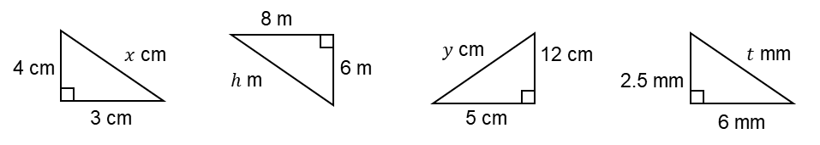
$3^{2}+4^{2}=25$ $8^{2}+6^{2}=$ ${_____}^{2}+{_____}^{2}=$
$\sqrt{25}=$ $\sqrt{ }=$

2. Calculate the length of the hypotenuse in these questions. Give your answers correct to 1 decimal place.
a) b) c) d)
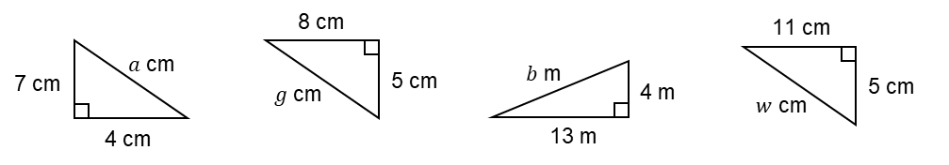

3. Look carefully at whether you need to calculate the hypotenuse or one of the other sides. Give your answers correct to 1 decimal place.
a) b) c) d)
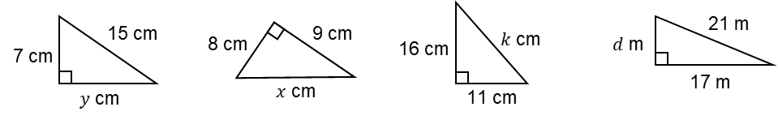

e) f) g) h)
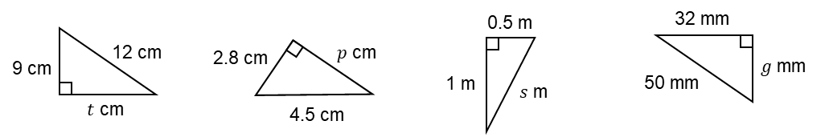

4. A man walks 10km north then 24km east. How far is he from his starting position? (Draw a diagram to help you).

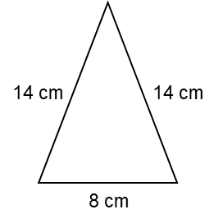
5. A rectangular door measures 2.5m by 1m. How long is the diagonal of the door? Give your answer to 1 decimal place.

6. To the right is an isosceles triangle. Use Pythagoras’ Theorem to calculate the height of the triangle. Give your answer to 1 decimal place. (Hint: you will need to cut the triangle in half to get a right-angled triangle first).

7. A cylindrical container has diameter 8cm and height 15cm. My pencil measures 18cm. Can the pencil fit completely inside the container?

8. An equilateral triangle has sides of length 5cm. Calculate the height of the triangle, then calculate its area. Give your answers to 1 decimal place.

