Mathematics Assessment

Bands 3-5 Problem Solving – Test 2
Calculators allowed on questions with this symbol:

Name: ______________________________

Class: ______________________________

Teacher: ______________________________

Remember:
- The test is 1 hour long.
- You will need: pen, pencil, rubber and a ruler.
- Try to answer all questions.
- Write all your answers and working in the spaces provided in this test paper – do not use any rough paper. Marks may be awarded for working.
- Check your work carefully.
- Don’t spend too long on one question. Leave it and try the next one.

1. | 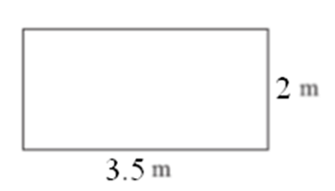  The diagram shows a patio in the shape of a rectangle. The patio is 3.5 m long and 2m wide. Matt is going to cover the patio with paving slabs. Each paving slab is a square of side 50 cm. Matt buys 30 of the paving slabs. Does Matt buy enough paving slabs to cover the patio? You must show all your working. | / 4
2. | Arnie saw a camera priced at £250 in London. He saw the same camera priced at $297.50 in New York. This is a 30% saving on the London price. How many dollars are there to the pound?  $ ____________ | / 3
3. | The circumference of circle A touches the edge of circle B and passes through its centre. The area of circle A is 100cm². What is the area of circle B?  ______________ cm² | / 3
4. | Five times a number gives the same answer as adding 24 to the number. What is the number?  __________ | / 3
5. | Peter goes for a walk. He walks 17 ½ miles in 5 hours.  (a) Work out Peter’s average speed. Give your answer in miles per hour.  _____________ mph  (b) Given 5 miles = 8 km, Sunita says that Peter walked more than 25 km. Is Sunita right? | / 4
6. | 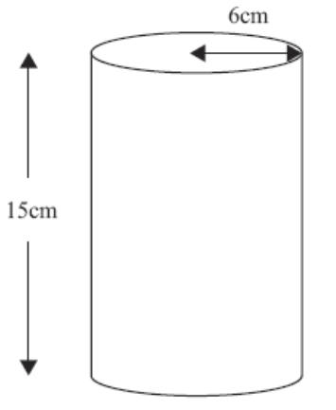  Jenny fills some empty flowerpots completely with compost. Each flowerpot is in the shape of a cylinder of height 15 cm and radius 6 cm. She has a 15 litre bag of compost. She fills up each flowerpot completely. How many flowerpots can she fill? You must show your working.  _____________ | / 4
7. | A and B are two weights. A is five times as heavy as B. The difference between the weights is 6kg. Find the weight of A.  ___________ kg | / 4
8. | These towers are made of identical hexagons and identical rectangles.  Calculate the height of the smallest tower.  _______________ cm | / 5
9. | Henry wants to invest £4000 for 2 years. He can choose between two different banks.  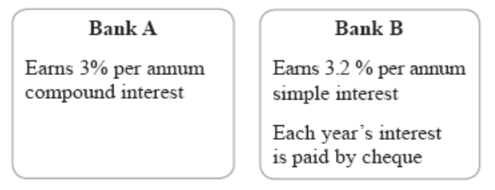  Henry wants to earn as much interest on his investment as possible. Which bank should Henry choose? You must show your working. | / 5
10. | Each shape contained within the largest square is also a  square. The number in each square gives the length of its sides. What are the values of A, B, C and D?  A = _____ B = _____ C = _____ D = _____ | / 5
11. | Mrs Binder owns a second hand book shop. She buys in 30 ‘good as new books’ for £3 each. She chooses a selling price that will give her a 40% profit. She sells $\frac{3}{5}$ of the books at this price. She then reduced the selling price by 20% and sold the remaining books at this price. Calculate Mrs Binder’s overall percentage profit on this transaction.  ______________ % | / 8

