**Pythagoras’ Theorem and Trigonometry**

**(F)**

Post-Intervention Assessment

Name: _______________________________

Class: _______________________________

Date: _______________________________

|  |  |  |
| --- | --- | --- |
| **Question** | **Objective** | **RAG** |
| 1 | Use SOH CAH TOA |  |
| 2 | Use the sine and cosine rules |  |
| 3 | Calculate the area of a non-right-angled triangle |  |

**1.** ****Calculate the length of the side *x* in this right-

angled triangle.  
Give your answer correct to 3 significant figures.

Diagram **NOT** accurately drawn

........................................................... cm

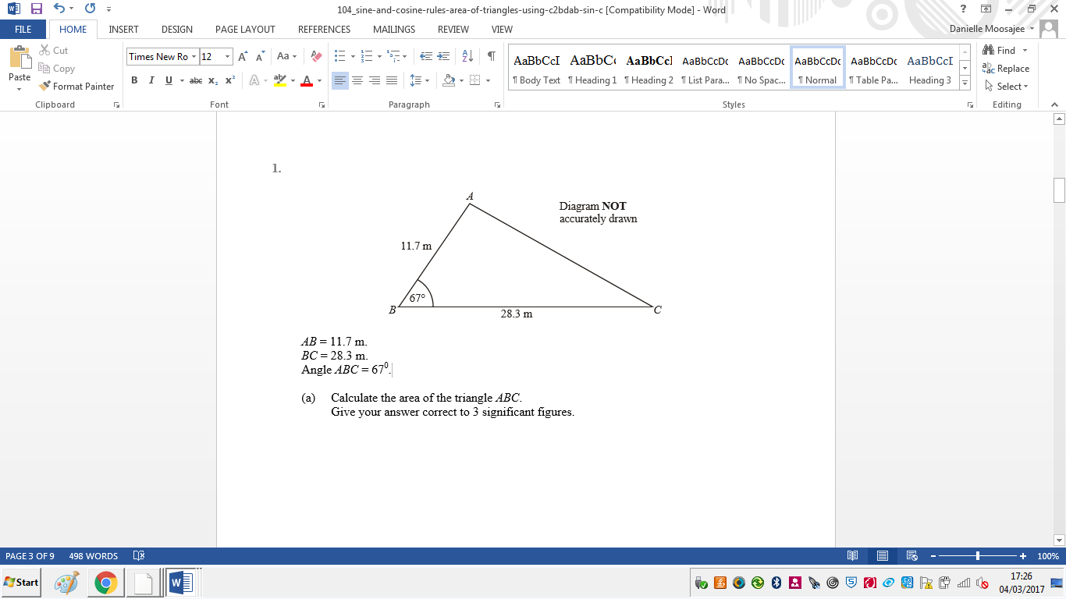**2**. AB = 11.7 m.

BC = 28.3 m.

Angle ABC = 670.

Calculate the length of AC.

Give your answer correct to 3 significant figures

........................................................... m

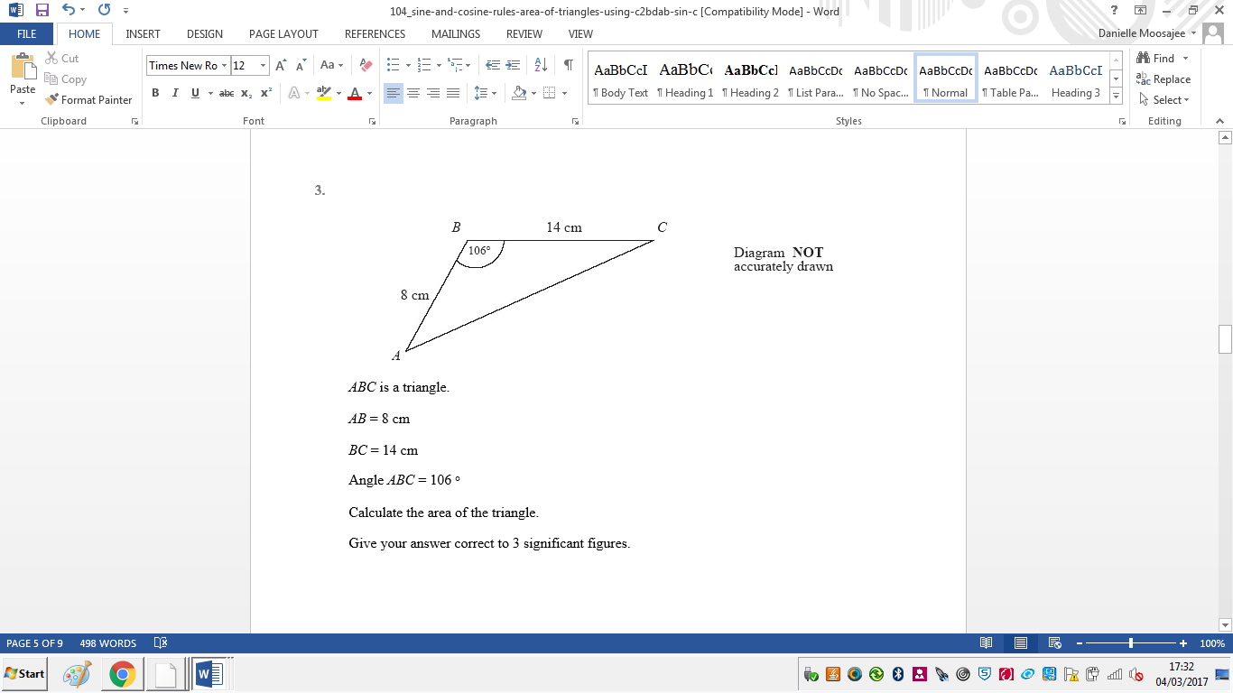**3**. ABC is a triangle.

AB = 8 cm

BC = 14 cm

Angle ABC = 106

Calculate the area of the triangle.

Give your answer correct to 3 significant figures.

........................................................... cm²

[Glue here]