End of Unit Test Name: ____________________________
Area and Perimeter - HIGHER

1. Not drawn accurately

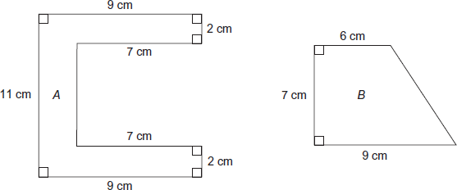

Which shape has the greater area and by how much? You must show your working.

…………………………………………………………………………………………………………

…………………………………………………………………………………………………………

…………………………………………………………………………………………………………

…………………………………………………………………………………………………………

…………………………………………………………………………………………………………

…………………………………………………………………………………………………………

…………………………………………………………………………………………………………

…………………………………………………………………………………………………………

…………………………………………………………………………………………………………

…………………………………………………………………………………………………………

…………………………………………………………………………………………………………

…………………………………………………………………………………………………………

Shape ........... is greater by ............................ cm²
(Total 6 marks)

2) The diagram shows a lawn with a fence along one edge.

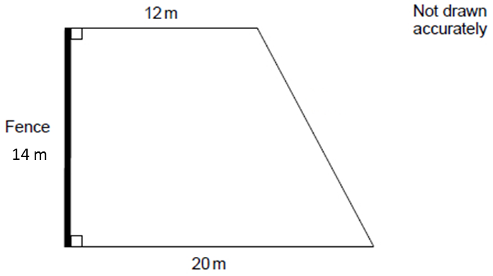

One can of weed killer covers 90 square metres. Each can costs £19.25. Work out the total cost of the cans of weed killer needed to cover the lawn.

…………………………………………………………………………………………………………

…………………………………………………………………………………………………………

…………………………………………………………………………………………………………

…………………………………………………………………………………………………………

…………………………………………………………………………………………………………

…………………………………………………………………………………………………………

…………………………………………………………………………………………………………

…………………………………………………………………………………………………………

…………………………………………………………………………………………………………

…………………………………………………………………………………………………………

…………………………………………………………………………………………………………

Answer £ .................................................................................
(Total 5 marks)

3) This semi-circle has a radius of 5 cm. Not drawn accurately.

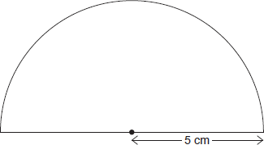

Work out the perimeter of the semi-circle. Remember to include the base. Use the approximation π = 3.1

…………………………………………………………………………………………………………

…………………………………………………………………………………………………………

…………………………………………………………………………………………………………

…………………………………………………………………………………………………………

Answer .................................................................. cm
(Total 3 marks)
4) The diagram shows a semicircle of radius 8 cm.Not drawn accurately

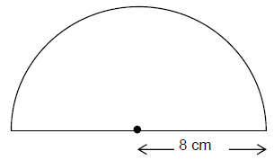

Work out the area of the semicircle. Give your answer in terms of π.

…………………………………………………………………………………………………………

…………………………………………………………………………………………………………

…………………………………………………………………………………………………………

…………………………………………………………………………………………………………

Answer ............................................ cm²
(Total 2 marks)

5) This shape is made from two sectors and two squares of side 8 cm. The radius of each sector is also 8 cm. Not drawn accurately

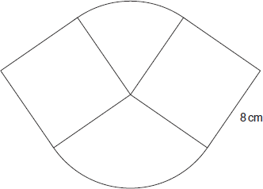
Work out the total area of the shape. Give your answer in terms of π.

…………………………………………………………………………………………………………

…………………………………………………………………………………………………………

…………………………………………………………………………………………………………

…………………………………………………………………………………………………………

…………………………………………………………………………………………………………

…………………………………………………………………………………………………………

…………………………………………………………………………………………………………

…………………………………………………………………………………………………………

…………………………………………………………………………………………………………

…………………………………………………………………………………………………………

…………………………………………………………………………………………………………

…………………………………………………………………………………………………………

Answer ............................................................... cm²
(Total 4 marks)

(Total for test = 20 marks)

