Inequalities (H)

Intervention Booklet

Name: _______________________________

Class: _______________________________

Useful websites:

www.mathswatchvle.com
(Video explanations and questions)
Username: STH…@twgash
Password: stmaths

www.methodmaths.com
(Past papers online that get instantly marked)
Centre ID: wga
Username: firstname
Password: lastname

www.hegartymaths.com
(Online tutorials and quizzes)
Login: first name and last name are case sensitive

www.bbc.co.uk/schools/gcsebitesize/maths

Graphical Inequalities

Things to remember:
- Use a table of values if you need to help you draw the linear graphs.
- Use a solid line for ≥ or ≤, and a dotted line for > or <.
- Test a coordinate ((0, 0) is easiest) to work out which side of the line to shade.

Questions:
1. (a) Solve the inequality 5e + 3 > e + 12

...........................................................
(2)
(b) On the grid, shade the region defined by the inequality x + y > 1
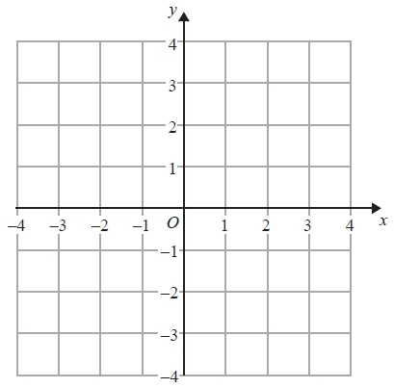
(2)
(Total for Question is 4 marks)

2. The lines y = x – 2 and x + y = 10 are drawn on the grid.

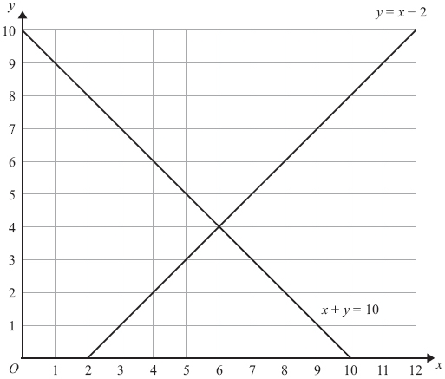

On the grid, mark with a cross (×) each of the points with integer coordinates that are in the region defined by

y > x – 2
x + y < 10
x > 3
(Total for Question is 3 marks)

3. (a) Given that x and y are integers such that

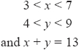

find all the possible values of x.
...........................................................
(2)
(b) On the grid below show, by shading, the region defined by the inequalities

Mark this region with the letter R.
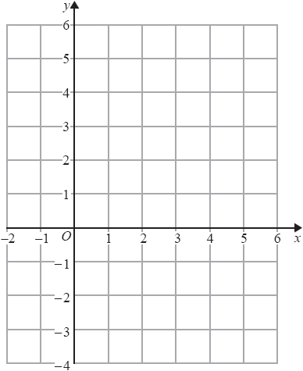
(4)
(Total for question = 6 marks)

Solving Quadratic Inequalities

Things to remember:
- Start by solving the quadratic to find the values of x, then sketch the graph to determine the inequality.

Questions:
1. Solve x² > 3x + 4

...........................................................
(Total for question = 3 marks)

2. Solve the inequality x² > 3(x + 6)

...........................................................
(Total for question = 4 marks)
3. Solve the inequality x² + 5x > 6

...........................................................
(Total for question = 3 marks)

4. Solve the inequality x² - 2x + 8 < 0

...........................................................
(Total for question = 3 marks)

