End of Unit Test Name: ____________________________
Measures - HIGHER

1. Which of these is used to work out density? Tick a box.

mass × volume
mass² × volume
mass ÷ volume
volume ÷ mass
(Total 1 mark)
2. The table shows information about journeys A and B. Complete the table.

 |  | Distance travelled | Time taken | Average speed
 | A | 32 miles |  | 64 mph
 | B |  | 1 hour 20 minutes | 42 mph

…………………………………………………………………………………………………………

…………………………………………………………………………………………………………

…………………………………………………………………………………………………………

…………………………………………………………………………………………………………

…………………………………………………………………………………………………………

…………………………………………………………………………………………………………

…………………………………………………………………………………………………………
(Total 2 marks)

3. PQR is an enlargement of ABC. Not drawn accurately.

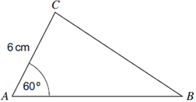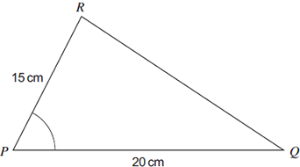

(a) Work out the scale factor of the enlargement.

…………………………………………………………………………………………………

Answer ......................................................................
(1)
(b) Write down the size of angle P.
Answer ........................................................ degrees
(1)
(c) Work out the length AB.

…………………………………………………………………………………………………

Answer ................................................................ cm
(2)
(Total 4 marks)
4. These two solid shapes are similar. Not drawn accurately.
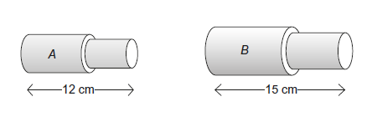
The volume of A is 1400 cm³. Work out the volume of B.

…………………………………………………………………………………………………………

…………………………………………………………………………………………………………

…………………………………………………………………………………………………………

…………………………………………………………………………………………………………

…………………………………………………………………………………………………………

Answer ........................................................................ cm³
(Total 3 marks)

5. Three items were bought at a car boot sale.

 | Item A | Item B | Item C
 | Mass = 9.5 grams  Volume = 2 cm³ | Mass = 57 grams  Volume = 3 cm³ | Mass = 76 grams  Volume = 4 cm³
The density of gold is approximately 19 grams per cm³. Which item or items cannot be gold? You must show your working.

…………………………………………………………………………………………………………

…………………………………………………………………………………………………………

…………………………………………………………………………………………………………

…………………………………………………………………………………………………………

…………………………………………………………………………………………………………

…………………………………………………………………………………………………………

…………………………………………………………………………………………………………

…………………………………………………………………………………………………………

Answer ......................................................................
(Total 4 marks)

6. The distance around a cycle track is 400 metres. Robin cycles on the track. Here is his speed-time graph.

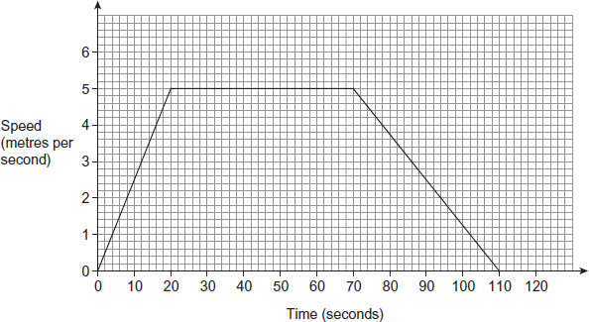

(a) Show that Robin cycles exactly once around the track in 110 seconds.

…………………………………………………………………………………………………

…………………………………………………………………………………………………

…………………………………………………………………………………………………

…………………………………………………………………………………………………

…………………………………………………………………………………………………

…………………………………………………………………………………………………
(3)

(b) Sanjay cycles on the same track. Here is his speed-time graph.

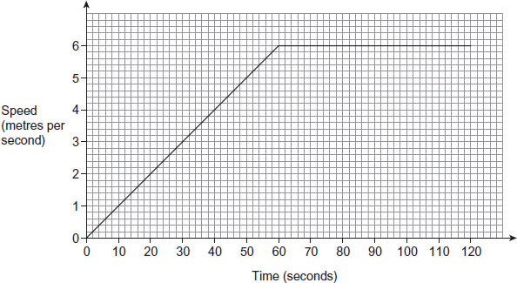

Does Sanjay cycle the first 400 metres in a quicker time than Robin? You must show your working.

…………………………………………………………………………………………………

…………………………………………………………………………………………………

…………………………………………………………………………………………………

…………………………………………………………………………………………………

…………………………………………………………………………………………………

…………………………………………………………………………………………………

…………………………………………………………………………………………………

…………………………………………………………………………………………………

…………………………………………………………………………………………………

…………………………………………………………………………………………………
(3)
(Total 6 marks)
(Total for test = 20 marks)

