Start | Find A  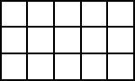 | Perimeter  = 16 cm | Finish
Area  = 6 cm² | Find P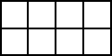 | Area  = 15 cm² | Find P  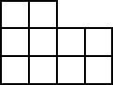
Area  = 9 cm² | Find A  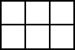 | Area  = 12 cm² | Find A  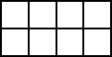
Area  = 8 cm² | Find P  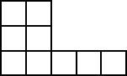 | Perimeter  = 14 cm | Find A  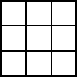
Perimeter  = 16 cm | Find A  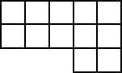 | Perimeter  = 12 cm | Find P  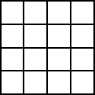

Start | Find A | Perimeter  = 16 cm | Finish
Area  = 6 cm² | Find P | Area  = 15 cm² | Find P
Area  = 9 cm² | Find A | Area  = 12 cm² | Find A
Area  = 8 cm² | Find P | Perimeter  = 14 cm | Find A
Perimeter  = 16 cm | Find A | Perimeter  = 12 cm | Find P

