Bands 5 – 7 Problem Solving – Test 2 Answers

1. | a) 4 4 4  b) Any combination where indices sum to 12 | 1 mark for each correct set of indices | 2
2. | 350 x 1000 ÷ 3600 = 97.2 m/s  or  108 x 3600 ÷ 1000 = 388.8 km/h  The peregrine falcon is the fastest when you convert km/h to m/s or m/s to km/h | 1 mark for x 1000  1 mark for ÷ 3600  1 mark for 97.2 seen  or  1 mark for x 3600  1 mark for ÷ 1000  1 mark for 388.8 seen  1 mark for correct conclusion | 4
3. | ½ x 4.6 x 10.2 x sin B = 21  sin B = 0.8951…  B = 63.52650… | 1 mark for equation set up  1 mark for sin B calculated  1 mark for correct answer given to suitable degree of accuracy | 3
4. | $\sqrt{2500 ÷625}$ = √4 = 2  21 x 2 = 42 cm | 1 mark for 2500 ÷ 625  1 mark for √4 or 2 seen  1 mark for 21 x 2  1 mark for correct answer | 4
5. | (x + 5)(x + 2) - x² = 31  x² + 2x + 5x + 10 - x² = 31  7x + 10 = 31  7x = 21  x = 3 cm | 1 mark for equation set up for area  1 mark for brackets expanded  1 mark for 7x seen  1 mark for correct answer | 3
6. | 2a(a + 1) = 12  2a² + 2a – 12 = 0  a² + a – 6 = 0  (a + 3)(a – 2) = 0  a = -3 or 2 (-3 not possible)  Dimensions 2 x 2 | 1 mark for equation set up for large rug area  1 mark for brackets expanded  1 mark for simplified  1 mark for factorised  1 mark for solved  1 mark for 2 chosen  1 mark for correct answer | 7
7. | 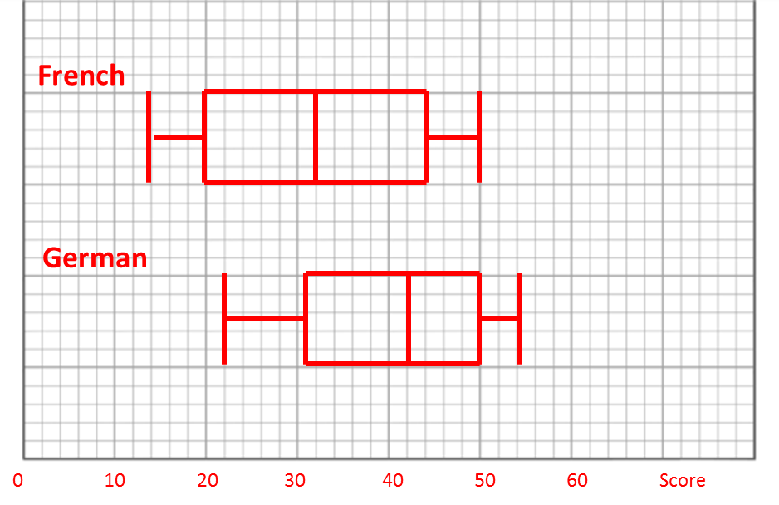  German marks were better because:  - Higher minimum and maximum  - Smaller interquartile range so more consistent  - Higher average than French | 1 mark for medians plotted correctly  1 mark for lower quartiles and upper quartiles plotted correctly  1 mark for minimum and maximum plotted correctly  1 mark for a correct comparison (only accept if in context of question) | 4

8. | C α s³  50 = k x 10³  k = 0.05  C = 0.05s³  C = 0.05 x 5³ = £6.25 | 1 mark for proportion sentence written  1 mark for C and s substituted  1 mark for k calculated  1 mark for s substituted  1 mark for correct answer | 5
9. | cos A = $\frac{7^{2} + 7^{2} -{ 12}^{2}}{2 x 7 x 7}$  A = 117.9945… = 118°  $\left(\frac{118}{360} x π x 7^{2}\right)-\left(\frac{1}{2} x 7 x 7 sin118\right)$  = 50.45746… - 21.63221…  = 28.82524…  = 28.825 cm² | 1 mark for cos A substitution  1 mark for A calculated  1 mark for area of sector calculations  1 mark for area of triangle calculations  1 mark for 28 seen  1 mark for correct answer | 6
10. | 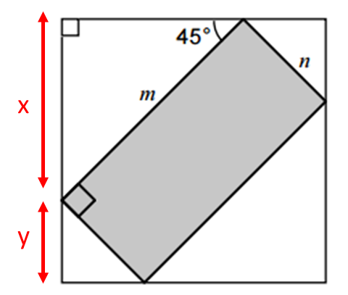  x = m sin 45 = $\frac{\sqrt{2}}{2}$ m  y = n sin 45 = $\frac{\sqrt{2}}{2}$ n  Area of square  = $\left(\frac{\sqrt{2}}{2} m+ \frac{\sqrt{2}}{2} n\right)\left(\frac{\sqrt{2}}{2} m+ \frac{\sqrt{2}}{2} n\right)$  = ½ m² + ½ mn + ½ mn + ½ n²  = ½ (m² + n²) + mn | 1 mark for x in terms of m  1 mark for y in terms of n  1 mark for multiplying sides of square  1 mark for correct answer oe (does not have to be in simplest form) | 4
11. | f(x) = x(x + 3)  f(4) = 4 8 on graph  f(2x) = 2x(x + 3) = 2x² + 6x | 1 mark for x(x + 3) seen  1 mark for 4 substituted  1 mark for x2 or f(2x) seen  1 mark for correct answer oe | 4

