Band 7 – Test 2 Answers

1. | F: 2 x 1 = 2  O: 2 x √3 = 2√3  I: √3 x 1 = √3  L: √3 x √3 = 3  2 + 2√3 + √3 + 3 = 5 + 3√3 | 1 mark for at least 3 correct terms from expansion  1 mark for attempt to simplify  1 mark for correct answer | 3
2. | $\frac{2}{\sqrt{8}} x \frac{\sqrt{8}}{\sqrt{8}}= \frac{2\sqrt{8}}{8}= \frac{\sqrt{8}}{4}= \frac{2\sqrt{2}}{4}= \frac{\sqrt{2}}{2}$ | 1 mark for multiplying numerator and denominator by √8  1 mark for $\frac{\sqrt{8}}{4}$ oe | 2
3. | $\frac{3}{x+3}$ - $\frac{4}{x-3}$ = $\frac{5x}{x^{2}-9}$  $\frac{3\left(x-3\right)-4(x+3)}{(x+3)(x-3)}$ = $\frac{5x}{(x+3)(x-3)}$  3x – 9 – 4x – 12 = 5x  -6x = 21  x = -3.5 | 1 mark for calculating a common denominator  1 mark for 6x or -6x seen  1 mark for correct answer oe | 3
4. | $\frac{3}{x+2}$ + $\frac{5}{2x-1}$ = 2  $\frac{3\left(2x-1\right)+5(x+2)}{(x+2)(2x-1)}$ = 2  6x – 3 + 5x + 10 = 2(2x² + 3x – 2)  0 = 4x² - 5x – 11  $x=\frac{--5±\sqrt{{(-5)}^{2}-4(4)(-11)}}{2(4)}$ = 2.40 or -1.15 | 1 mark for calculating a common denominator  1 mark for = 0 seen  1 mark for substitution into quadratic formula  1 mark for correct answer oe | 4

5. | y = f(x – 4)  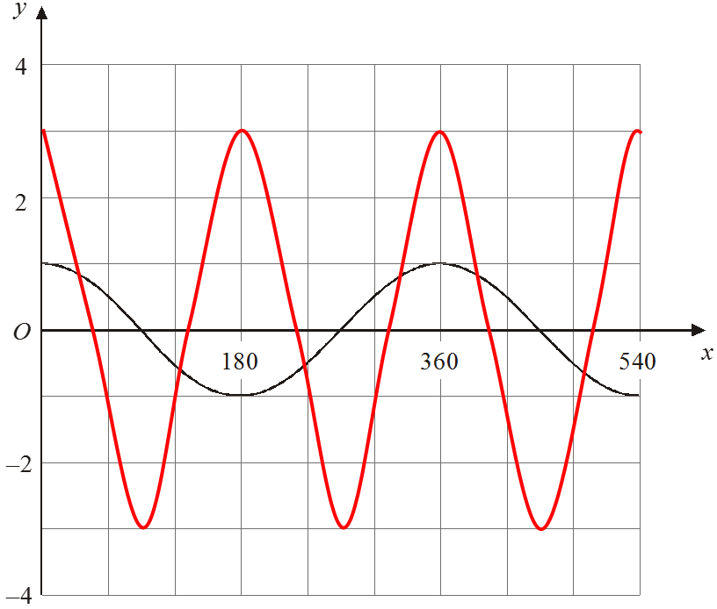 | 2 marks for y = f(x – 4)  (1 mark for 4 seen)  2 marks for correct graph drawn | 4

6. | x 0 1 2 3 4 5 6  y 0 36 56 60 48 20 -24  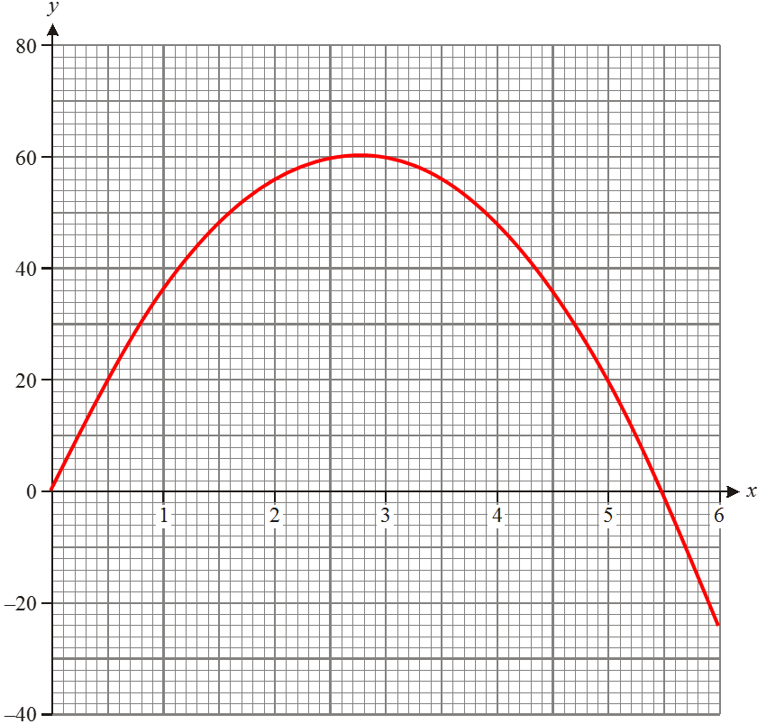  (2.75, 60.5) | 2 marks for all y values correct  (1 mark for at least 2 y values correct)  1 mark for all coordinates plotted correctly  1 mark for smooth graph  1 mark for correct turning point  (2.5 ≤ x ≤ 3, 60 ≤ y ≤ 62) | 5

7. | (x - 7)² + 49  a = 49  b = -7 | 1 mark for (x - 7)² seen  1 mark for a = 49  1 mark for b = -7 | 3
8. | 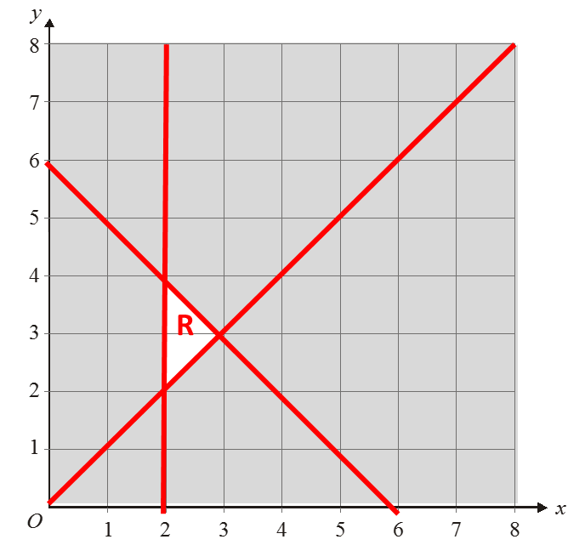 | 1 mark for each inequality plotted correctly (including solid or dotted line and shading)  1 mark for correct region identified | 4
9. | ADC = 60°  ADB = 35°  Angles in a semi-circle are 90°. 90 – 25 = 65° so Ben is correct | 1 mark for each correct answer  1 mark for correct reason  1 mark for correct conclusion | 4
10. | cosQ = 3.5² + 5² - 6.5²  2 x 3.5 x 5  Q = cos⁻¹ (-5 ÷ 35) = 109.125789… = 109° | 1 mark for correct substitution into cosine rule  1 mark for cos⁻¹ seen  1 mark for correct answer | 3

11. | _XY_ = __9__  sin62 sin76  XY = 9 x sin62 = 8.189800… = 8.19 cm  sin76 | 1 mark for correct substitution into sine rule  1 mark for multiplying by sin62  1 mark for correct answer | 3
12. | $\overset{→}{AC}$ = $2\left(\overset{→}{AB}\right)$ = 2(b – a) = 2b – 2a  $\overset{→}{OD}$ = $\overset{→}{OA}$ + $2\left(\overset{→}{OC}\right)$ = a + $2$(2b – 2a) = $4$b – 3a | 1 mark for correct answer  1 mark for any section of $\overset{→}{OD}$ correctly calculated  1 mark for correct answer | 3
13. | 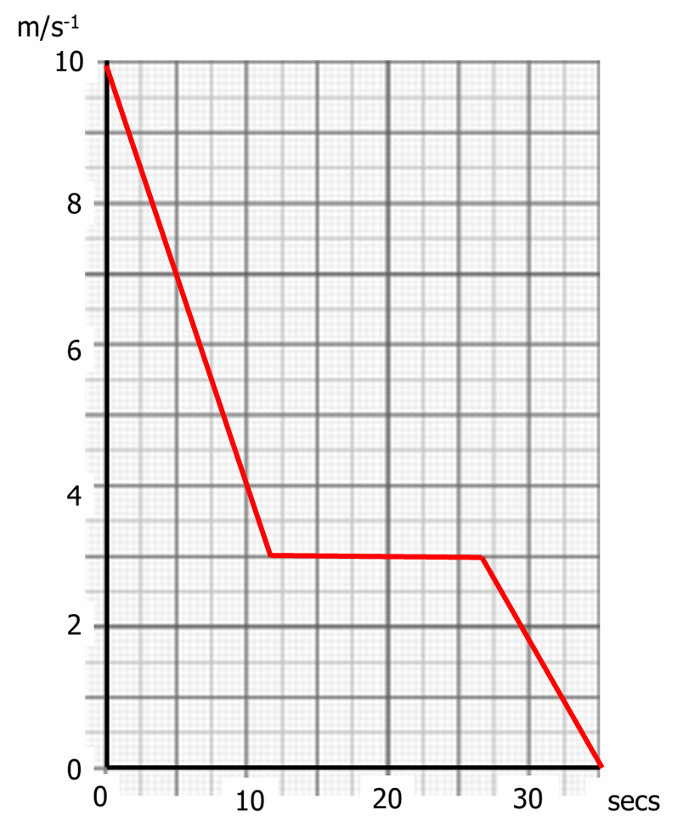 | 1 mark for a line segment from (0, 10) to (12, 3)  1 mark for a line segment from (12, 3) to (27, 3)  1 mark for a line segment from (27, 3) to (35, 0) | 3

14. | Time (t hours) Frequency Cumulative frequency  50 ≤ t < 55 12 12  55 ≤ t < 60 21 33  60 ≤ t < 65 36 69  65 ≤ t < 70 23 92  70 ≤ t < 75 8 100  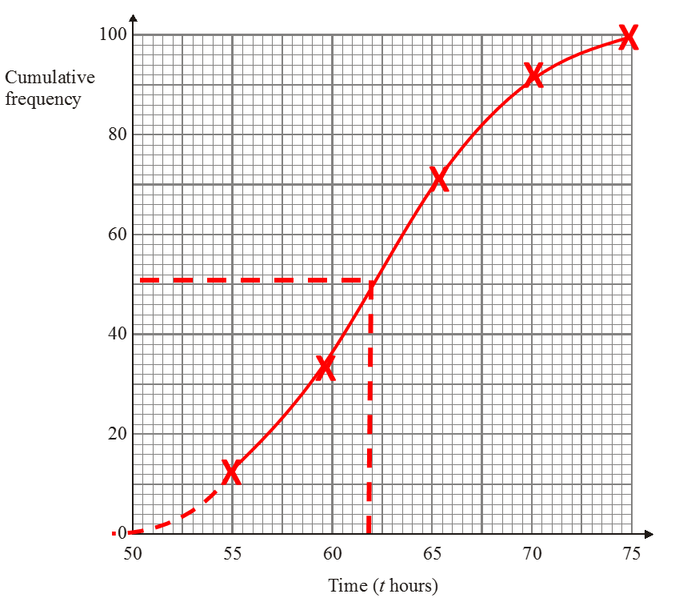 | 1 mark for cumulative frequency column filled in correctly  1 mark for coordinates plotted at endpoint of each category  1 mark for coordinates joined with smooth curve  1 mark for median between 61 and 63 hours | 4

15. | 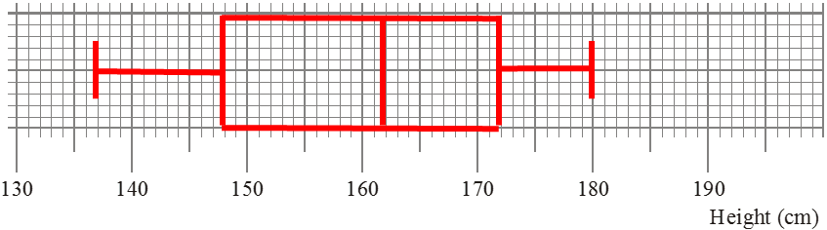 | 1 mark correct median  1 mark for correct upper quartile and lower quartile  1 mark for correct minimum and maximum | 3

