End of Unit Test Name: ____________________________
Data – Interpreting Results - FOUNDATION

1. The table shows the sales of food and drink for three days at a market stall.

 | Day | Sales of food (£) | Sales of drink (£)
 | Thursday | 34 | 16
 | Friday | 22 | 48
 | Saturday | 46 | 28

Hannah uses this information to draw a composite bar chart.
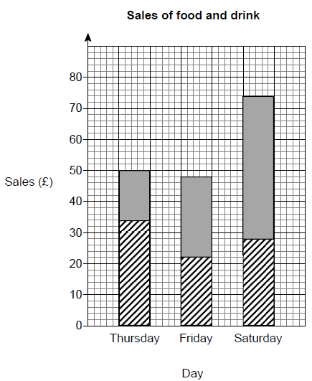
Write down three different mistakes that she has made.

Mistake 1 ……………………………………

………………………………………………...

Mistake 2 ……………………………………

………………………………………………...

Mistake 3 ……………………………………

………………………………………………...
(Total 3 marks)

2. Here are seven numbers.
13 6 12 7 6 4 8

(a) Work out the range of the seven numbers. Circle your answer.

5 6 7 8 9
(1)
(b) What is the mode of the seven numbers? Circle your answer.

5 6 7 8 9
(1)
(Total 2 marks)

3. I am thinking of three positive numbers. The mode is 5. The median is 5. The range is 9. Work out the three numbers.

Answer ....................... , ....................... , .......................
(Total 2 marks)

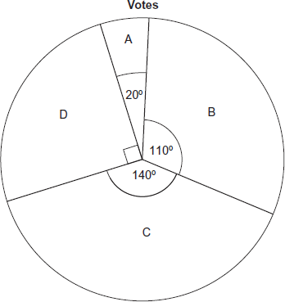
4. The pie chart shows information about how people voted in an election. 1800 people voted for D. How many more people voted for C than B?

…………………………………………………………

…………………………………………………………

…………………………………………………………

…………………………………………………………

…………………………………………………………

Answer .......................................................................
(Total 3 marks)

5. Seven students have to learn some French words. The table shows the time they spent learning the words and the number of words they got wrong in a test.

 | Time (hours) | 1 | 3 | 3 | 4 | 6 | 7 | 8
 | Number of wrong words | 8 | 6 | 5 | 4 | 3 | 2 | 2

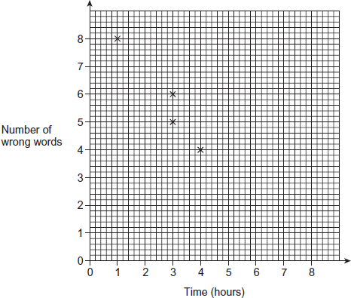
(a) The first four points have been plotted. Complete the scatter diagram.
(1)
(b) Describe the relationship shown by the scatter diagram.

………………………

………………………

………………………

………………………
(1)

(c) Another student spent 5 hours learning the words. Use a line of best fit to estimate the number of words he got wrong.

Answer ......................................................................
(2)
(d) Ellie has to take the test. She says, “If I learn the words for 12 hours, I will definitely not get any wrong.” Is she correct? Give a reason for your answer.

…………………………………………………………………………………………………

…………………………………………………………………………………………………
(1)
(Total 5 marks)
6. The table shows information about the pay per hour of 40 people.

 | Pay per hour, x (£) | Frequency
 | 5 < x ≤ 15 | 14
 | 15 < x ≤ 25 | 12
 | 25 < x ≤ 35 | 11
 | 35 < x ≤ 45 | 2
 | 45 < x ≤ 55 | 1
 |  | Total = 40
(a) Which group contains the median pay per hour? Circle your answer.

5 < x ≤ 15 15 < x ≤ 25 25 < x ≤ 35 35 < x ≤ 45 45 < x ≤ 55
(1)
(b) Work out an estimate of the mean pay per hour.

…………………………………………………………………………………………………

…………………………………………………………………………………………………

…………………………………………………………………………………………………

Answer £ .................................................................................
(4)
(Total 5 marks)
(Total for test = 20 marks)

