Band 7 – Test 1 Answers

1. | F: √3 x √3 = 3  O: √3 x √2 = √6  I: -√2 x √3 = -√6  L: -√2 x √2 = 2  3 + √6 - √6 – 2 = 3 – 2 = 1 | 1 mark for at least 3 correct terms from expansion  1 mark for attempt to simplify  1 mark for correct answer | 3
2. | $\frac{2}{\sqrt{6}} x \frac{\sqrt{6}}{\sqrt{6}}= \frac{2\sqrt{6}}{6}= \frac{\sqrt{6}}{3}$ | 1 mark for multiplying numerator and denominator by √6  1 mark for correct answer | 2
3. | $\frac{3}{x}$ + $\frac{3}{2x}$ = 2  $\frac{6}{2x}$ + $\frac{3}{2x}$ = 2  6 + 3 = 4x  $\frac{9}{4}$ = x | 1 mark for calculating a common denominator  1 mark for 4x seen  1 mark for correct answer oe | 3
4. | $\frac{x}{2x-3}$ + $\frac{4}{x+1}$ = 1  $\frac{x\left(x+1\right)+4(2x-3)}{(2x-3)(x+1)}$ = 1  x² + x + 8x – 12 = 2x² + 2x – 3x – 3  0 = x² - 10x + 9  0 = (x – 9)(x – 1)  x = 9 or 1 | 1 mark for calculating a common denominator  1 mark for = 0 seen  1 mark for correct factorisation  1 mark for correct answer oe | 4
5. | 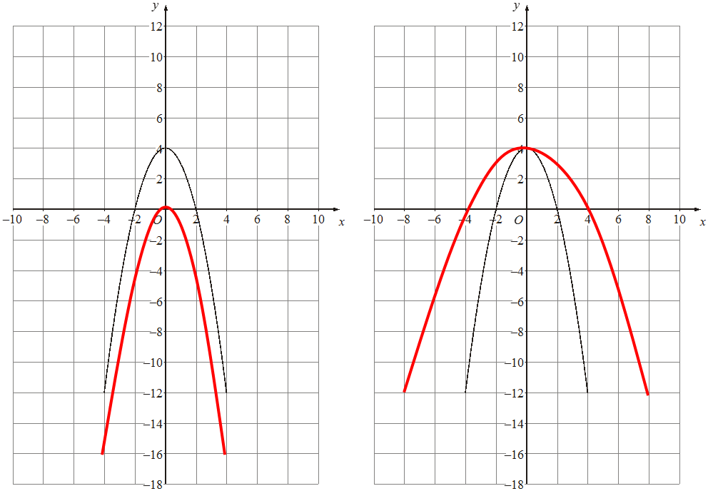 | 2 marks for each correct graph drawn | 4

6. | x -2 -1 0 1 2 3 4  y 11 5 1 -1 -1 1 5  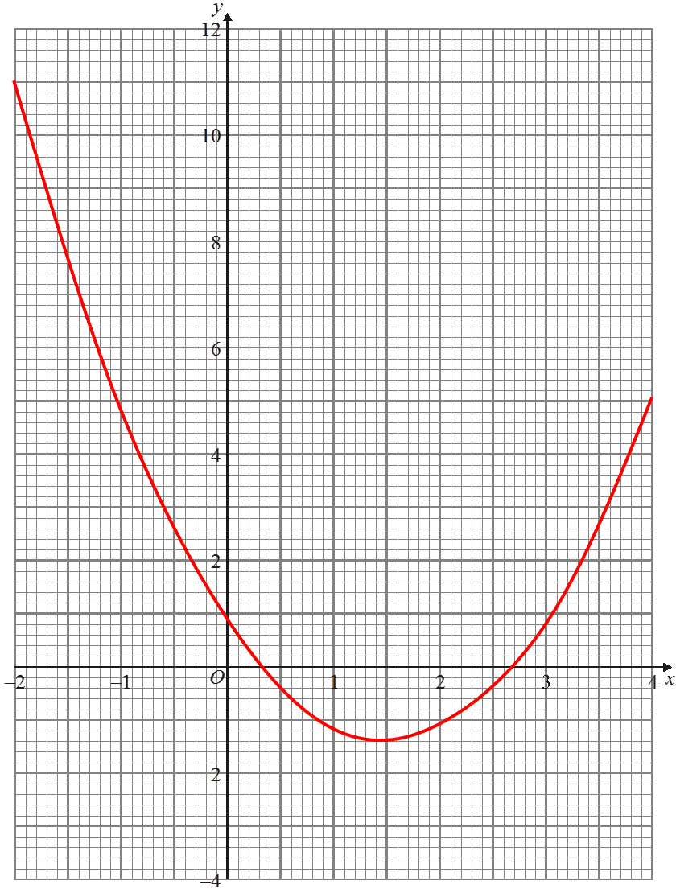  (1.5, -1.2 ≤ y ≤ -1.6) | 2 marks for all y values correct  (1 mark for at least 2 y values correct)  1 mark for all coordinates plotted correctly  1 mark for smooth graph  1 mark for correct turning point | 5
7. | (x + 3)² - 9 = 4  (x + 3)² = 13  x = -3 ± √13 | 1 mark for (x + 3)² seen  1 mark for -9 seen  1 mark for correct answer | 3
8. | 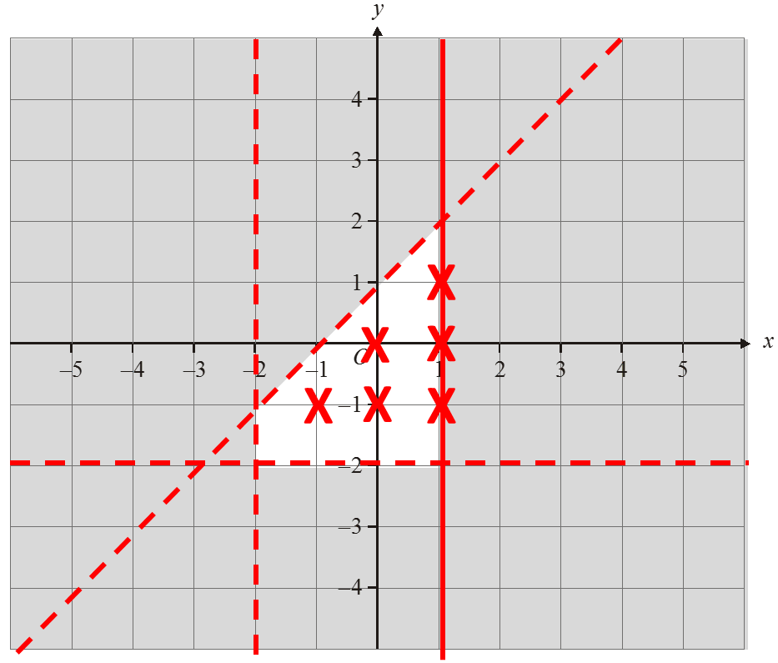  Coordinates identified:  (-1, -1), (0, -1), (0, 0), (1, -1), (1, 0), (1, 1) | 1 mark for each inequality plotted correctly (including solid or dotted line and shading)  1 mark for correct coordinates identified | 4
9. | ACB = 27°  Tangent and radius are perpendicular  BAC = 63°  Angles in alternate segments are equal | 1 mark for each correct answer  1 mark for each correct reason | 4
10. | PR² = 7² + 10² - 2 x 7 x 10 x cos64  = 87.628039…  PR = 9.3609849… = 9.36 cm | 1 mark for correct substitution into cosine rule  1 mark for √ seen  1 mark for correct answer | 3

11. | sin(X) = sin83  4 6.5  sin(X) = 4 x sin83 = 0.6107976…  6.5  X = sin⁻¹(0.610…) = 37.647199… = 37.6° | 1 mark for correct substitution into sine rule  1 mark for sin⁻¹ seen  1 mark for correct answer | 3
12. | $\overset{→}{PQ}$ = $\overset{→}{PO}$ + $\overset{→}{OQ}$ = -a + b  $\overset{→}{OT}$ = $\overset{→}{OP}$ + $\frac{2}{3}\overset{→}{PQ}$ = a + $\frac{2}{3}$ (b – a) = $\frac{1}{3}$ a + $\frac{2}{3}$ b | 1 mark for correct answer  1 mark for $\overset{→}{OP}$ and $\overset{→}{PQ}$ oe seen  1 mark for correct answer | 3
13. | 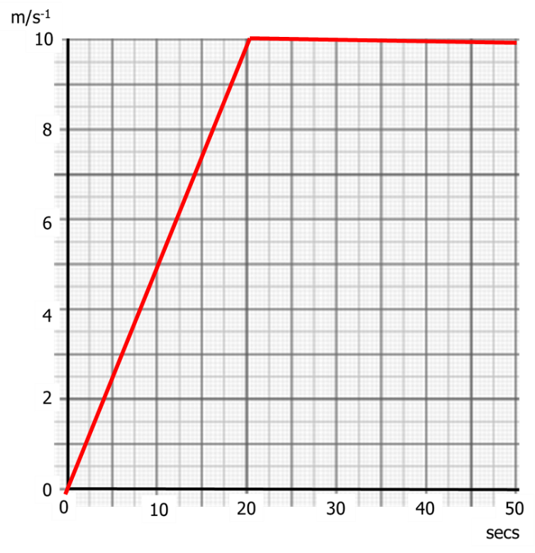 | 1 mark for a line starting from (0, 0)  1 mark for a line with gradient ½ or intersecting (20, 10)  1 mark for a horizontal line from (20, 10) to (50, 10) | 3

14. | Height (h cm) Frequency Cumulative frequency  170 ≤ h < 175 5 5  175 ≤ h < 180 18 23  180 ≤ h < 185 12 35  185 ≤ h < 190 4 39  190 ≤ h < 195 1 40  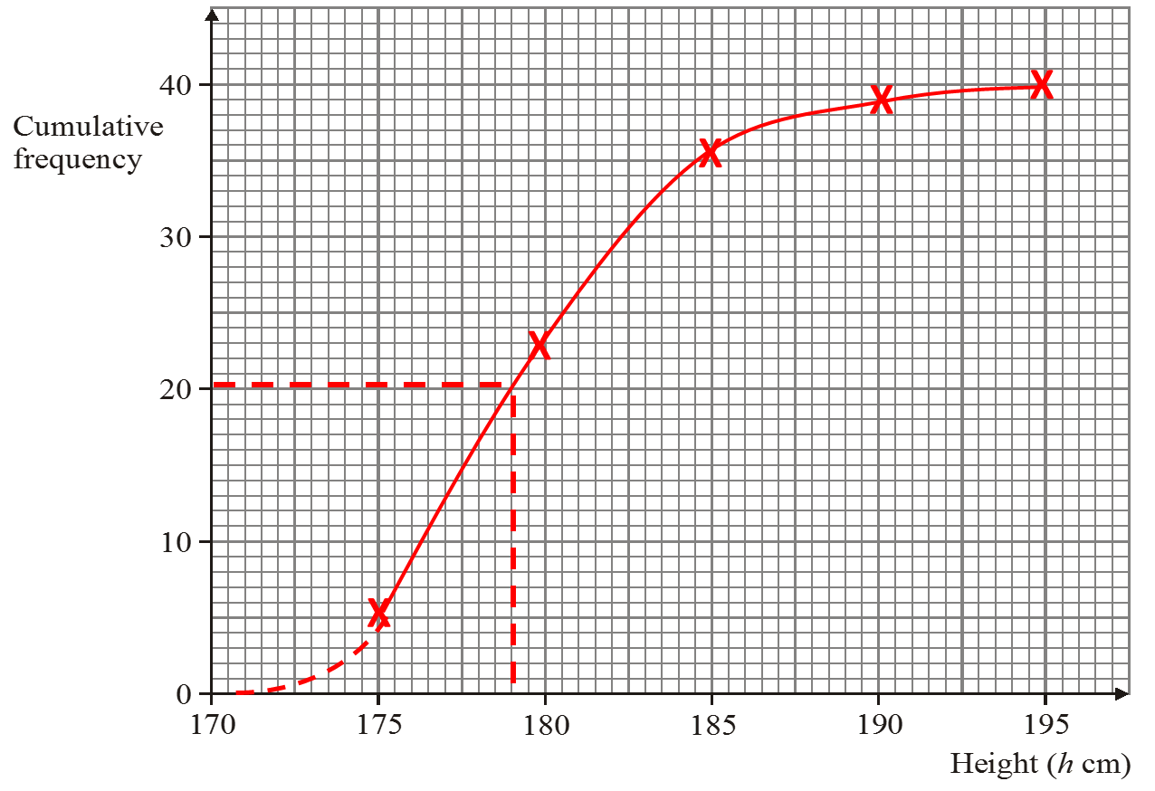 | 1 mark for cumulative frequency column filled in correctly  1 mark for coordinates plotted at endpoint of each category  1 mark for coordinates joined with smooth curve  1 mark for median between 177 and 179 cm | 4

15. | 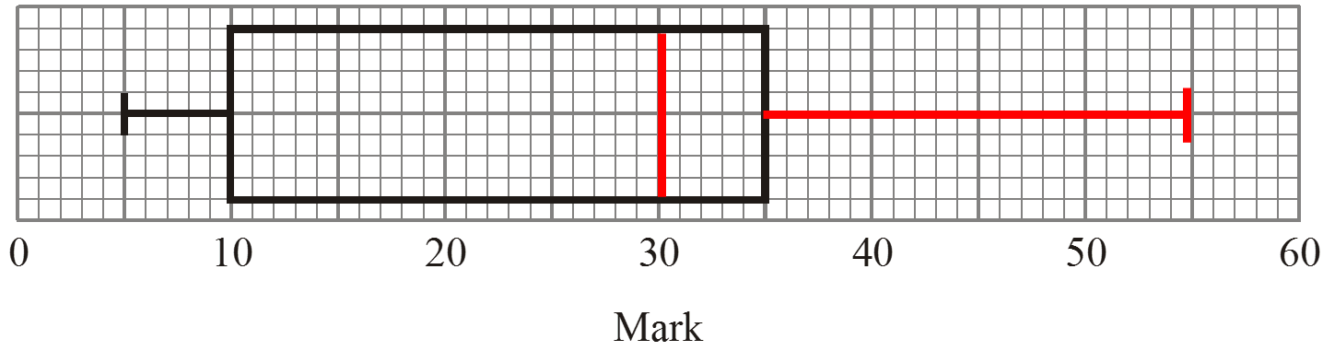  Mark  Lowest mark 5  Lower quartile 10  Median 30  Upper quartile 35  Highest mark 55 | 1 mark for median at 30 on diagram  1 mark for upper quartile at 55 on diagram  1 mark for lower quartile at 10 in table | 3

