Statistical Inquiry (H)

Pre-Intervention Assessment

Name: _______________________________

Class: _______________________________

Date: _______________________________

Question | Objective | RAG
1 | Understand and apply types of sampling
2 | Calculate averages from a table
3 | Use the Petersen capture-recapture method to estimate population sizes

1. The table shows information about 1065 students.
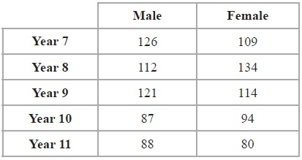
Elena takes a stratified sample of 120 students by year group and by gender.
Work out the number of Year 8 female students in her sample.

...........................................................

2. Fred did a survey on the areas of pictures in a newspaper.
The table gives information about the areas.

Area (A cm²) | Frequency
0 < A ≤ 10 | 38
10 < A ≤ 25 | 36
25 < A ≤ 40 | 30
40 < A ≤ 60 | 46

Work out an estimate for the mean area of a picture.

........................................................... cm²
3. A fisherman wants to estimate the number of fish in his pond.
One day he catches 128 fish. He puts a tag on each fish then releases them.
Then next day the fisherman catches 143 fish.
33 of these fish have a tag on them.
Work out an estimate for the total number of fish in his pond.
Write down any assumptions you have made.

[Glue here]

