Patterns and Sequences

Pattern 1
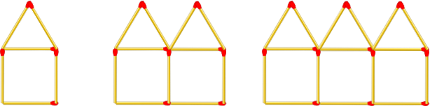

Pattern 2
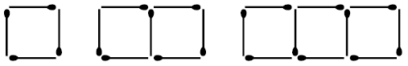

Pattern 3
