Construction and Loci

Post-Intervention Assessment

Name: _______________________________

Class: _______________________________

Date: _______________________________

Question | Objective | RAG
1 | Draw and measure bearings
2 | Draw to scale
3 | Construct triangles accurately
4 | Solve loci problems

1. The diagram shows the
positions of a lighthouse and a harbour on a map.
A boat is on a bearing of
300° from the lighthouse
040° from the harbour.
On the diagram, mark with a cross (×) the position of the boat.
Label the boat B.

2. A model plane has a length of 17cm.
The scale of the model is 1:200
Work out the length of the real plane.
Give your answer in metres.

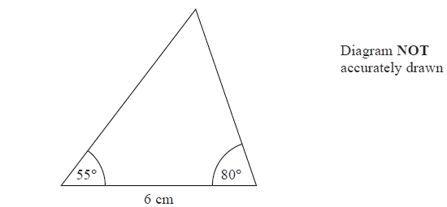
3. Here is a sketch of a triangle.
In the space below, make an accurate drawing of the triangle.

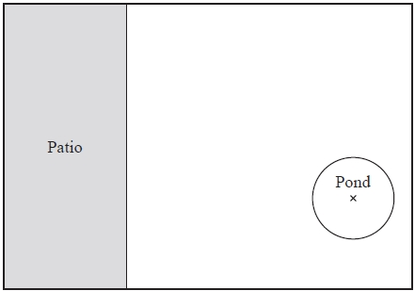
4. The diagram shows a garden in the shape of a rectangle.
The scale of the diagram is 1 cm represents 2 m.

Scale: 1 cm represents 2 m

Irfan is going to plant a tree in the garden.
The tree must be

more than 3 metres from the patio
and more than 6 metres from the centre of the pond.
On the diagram, shade the region where Irfan can plant the tree.

[Glue here]

