End of Unit Test Name: ____________________________
Probability - FOUNDATION

1. Here are three events for an ordinary fair dice.
A Roll an odd number
B Roll a number greater than 6
C Roll an even number less than 3
Draw and label arrows to show the probabilities of events B and C on the probability scale.

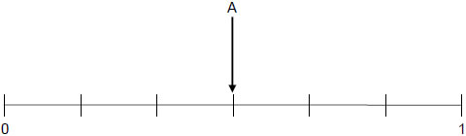
(Total 2 marks)

2. Four teams A, B, C and D play matches against each other. The teams play each other once. Complete the list of matches. One match has been done for you.

A plays B……………………………………………………………………………………………

…………………………………………………………………………………………………………

…………………………………………………………………………………………………………
(Total 2 marks)

3. There are 25 counters in a bag. 12 are red, 5 are green and the rest are white. A counter is chosen at random. Work out the probability that it is white.

…………………………………………………………………………………………………………

…………………………………………………………………………………………………………

Answer ...................................................................................
(Total 2 marks)
4. A spinner has four sections A, B, C and D. The table shows the probabilities of the spinner
landing on A, B or C.

 | Outcome | A | B | C | D
 | Probability | 0.2 | 0.3 | 0.15

Work out the probability of landing on D.

…………………………………………………………………………………………………………

…………………………………………………………………………………………………………

Answer ...................................................................................
(Total 2 marks)
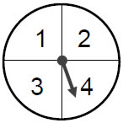
5. A game is played with a fair spinner. The player spins the spinner twice. The score is the difference between the two numbers.
(a) Complete the table to show the scores.
 |  |  | First spin
 |  |  | 1 | 2 | 3 | 4
 | Second  spin | 1 |  |  | 2
 |  | 2
 |  | 3 | 2
 |  | 4

(2)
(b) The player loses if the score is 0 or 1. The player wins if the score is 2 or 3.
Amy says,
“Two scores win and two scores lose, so the chance of winning is evens.”
Is Amy correct? Tick a box.

Yes No

Give a reason for your answer.

…………………………………………………………………………………………………

…………………………………………………………………………………………………

…………………………………………………………………………………………………

…………………………………………………………………………………………………
(2)
(Total 4 marks)

6. Fay is testing an ordinary six-sided dice to see if it is biased. She throws the dice 120 times.
(a) Work out the number of times the dice is expected to land on 1

…………………………………………………………………………………………………

…………………………………………………………………………………………………

Answer ...................................................................................
(1)
(b) Here are the actual results.

 | Number on dice | 1 | 2 | 3 | 4 | 5 | 6 | Total
 | Frequency | 5 | 19 | 17 | 20 | 21 | 38 | 120

Is the dice biased? Tick a box.

Yes No Could not tell

…………………………………………………………………………………………………

…………………………………………………………………………………………………

…………………………………………………………………………………………………

…………………………………………………………………………………………………
(2)
(Total 3 marks)
7. (a) In a statistical experiment a fair, an ordinary die is rolled. Tick a box to show the
correct ending to the sentence below.

When this statistical experiment is repeated you will:

always get the same outcome

usually get the same outcome

usually get a different outcome

always get a different outcome

(1)

(b) Tick a box to show the correct ending to the sentence below. An estimate of probability based on a statistical experiment is more reliable with

more trials

fewer trials

more time between trials

less time between trials
(1)
(Total 2 marks)
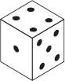
8. An ordinary fair dice is rolled.
(a) Complete the tree diagram for the dice landing on 4

First spin Second spin
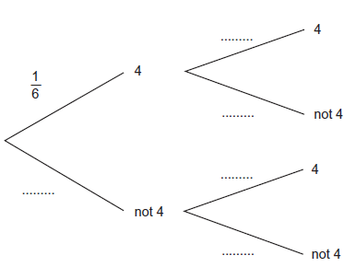
(1)
(b) Work out the probability of the dice landing on 4 both times.

…………………………………………………………………………………………………

…………………………………………………………………………………………………

…………………………………………………………………………………………………

Answer ......................................................................
(2)
(Total 3 marks)
(Total for test = 20 marks)

