Volume of Cylinders GREEN

Question 1
Calculate the volumes of the cylinders below. Give your answers correct to 1 decimal place.
a) b) c)
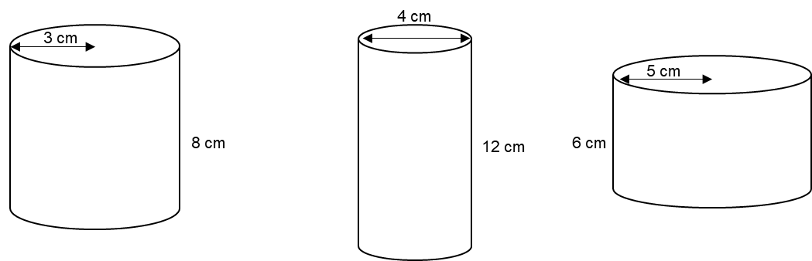

Question 2
Calculate the missing lengths in the cylinders below, using their given volumes. Give your answers correct to 1 decimal place.
a) b) c)
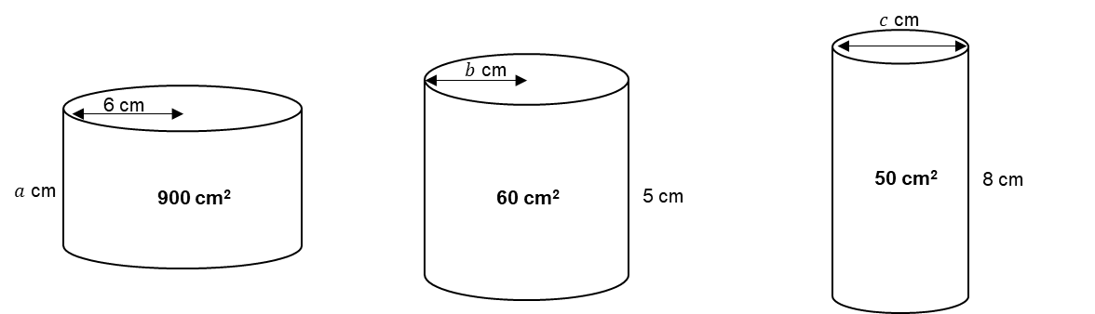

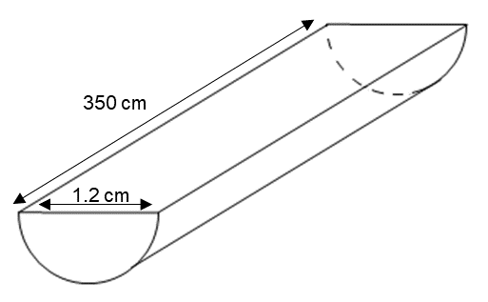
Question 3
The diagram shows a piece of wood.
The piece of wood is a prism of length 350 cm.
The cross-section of the prism is a semi-circle with diameter 1.2 cm.
Calculate the volume of the piece of wood.
Give your answer correct to 3 significant figures.

Volume of Cylinders AMBER

Question 1
Calculate the volumes of the cylinders below. Give your answers correct to 1 decimal place.
a) b) c)
Volume $=π×{_____}^{2}×_____$

Question 2
Calculate the missing lengths in the cylinders below, using their given volumes. Give your answers correct to 1 decimal place.
a) b) c)
$900=π×{_____}^{2}×_____$

This is half a cylinder!
Question 3
The diagram shows a piece of wood.
The piece of wood is a prism of length 350 cm.
The cross-section of the prism is a semi-circle with diameter 1.2 cm.
Calculate the volume of the piece of wood.
Give your answer correct to 3 significant figures.

Volume of Cylinders RED

Question 1
Calculate the volumes of the cylinders below. Give your answers correct to 1 decimal place.
a) b) c)
Volume $=π×3^{2}×8$ Volume $=π×{_____}^{2}×_____$ Volume $=π×{_____}^{2}×_____$
$=$

Question 2
Calculate the missing lengths in the cylinders below, using their given volumes. Give your answers correct to 1 decimal place.
a) b) c)
$900=π×6^{2}×a$ $60=π×{_____}^{2}×_____$ $50=π×{_____}^{2}×_____$

This is half a cylinder!
Question 3
The diagram shows a piece of wood.
The piece of wood is a prism of length 350 cm.
The cross-section of the prism is a semi-circle with diameter 1.2 cm.
Calculate the volume of the piece of wood.
Give your answer correct to 3 significant figures.

Volume $=π×{_____}^{2}×_____÷2$

