**Pythagoras’ Theorem and Trigonometry**

**(F)**

Pre-Intervention Assessment

Name: _______________________________

Class: _______________________________

Date: _______________________________

|  |  |  |
| --- | --- | --- |
| **Question** | **Objective** | **RAG** |
| 1 | Use SOH CAH TOA |  |
| 2 | Use the sine and cosine rules |  |
| 3 | Calculate the area of a non-right-angled triangle |  |

**1.** Diagram **NOT** accurately drawn

Work out the value of *x*.  
Give your answer correct to 1 decimal place.

........................................................... °

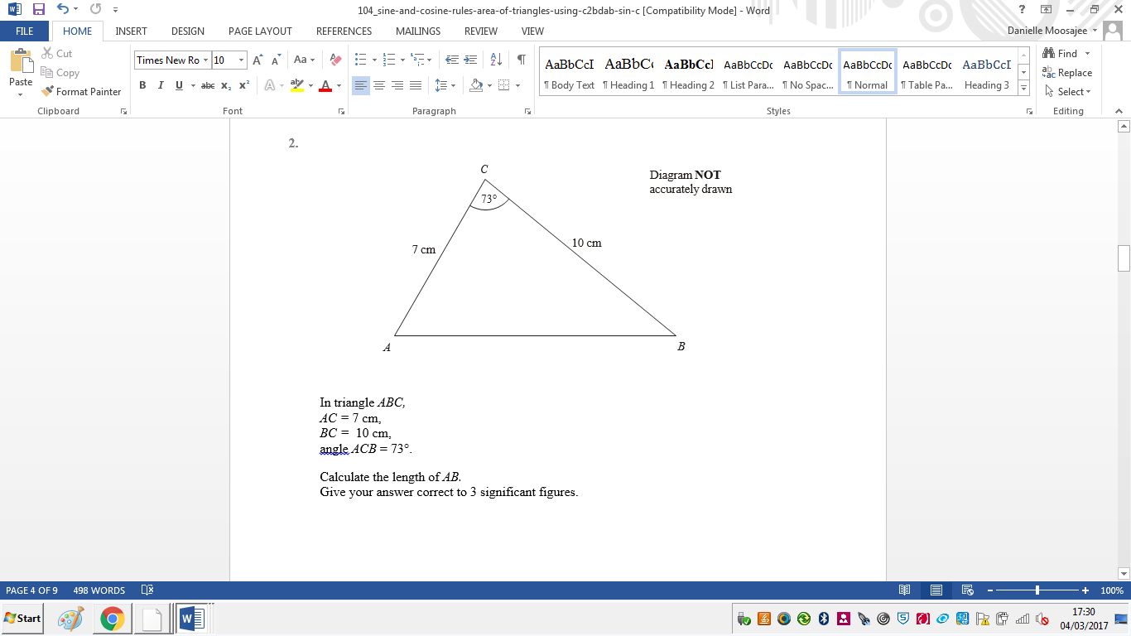**2**. In triangle ABC, AC = 7 cm,

BC = 10 cm,

Angle ACB = 73°.

Calculate the length of AB.

Give your answer correct to 3 significant figures.

........................................................... cm

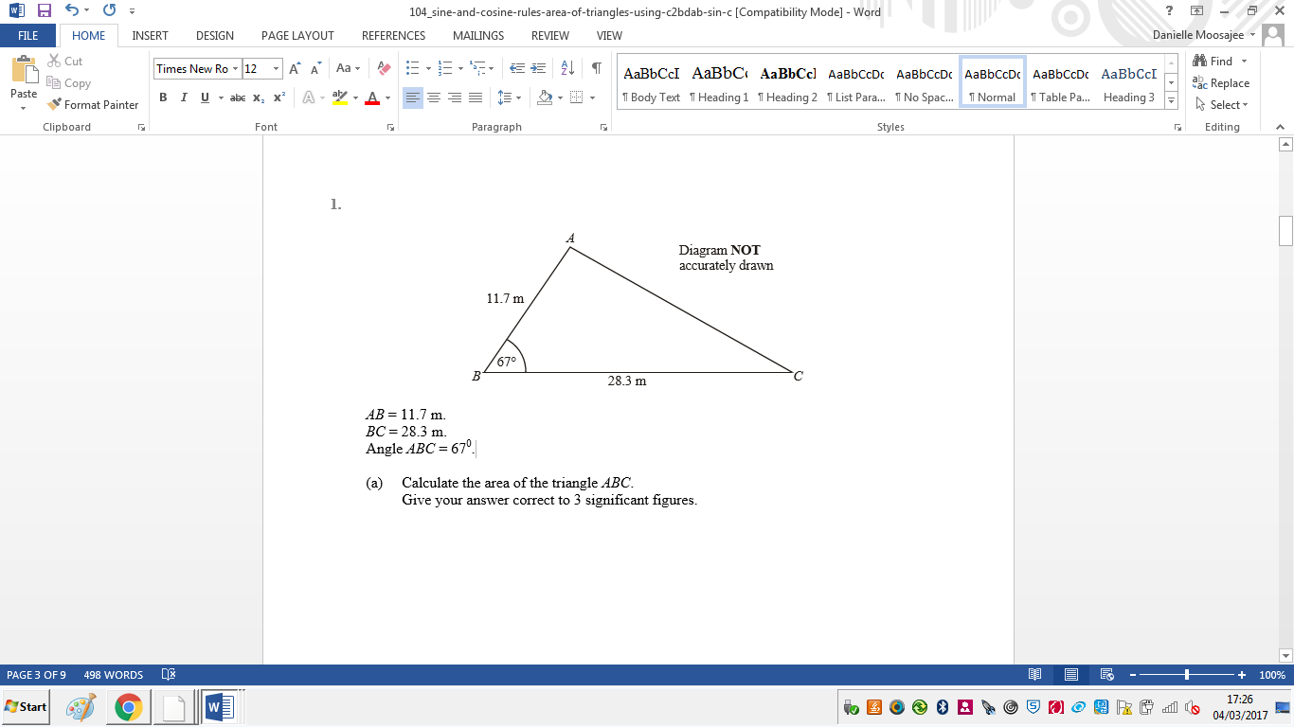**3**. AB = 11.7 m.

BC = 28.3 m.

Angle ABC = 670.

Calculate the area of the triangle ABC.

Give your answer correct to 3 significant figures.

………………………… m²

[Glue here]