End of Unit Test Name: ____________________________
Volume and Surface Area - HIGHER

Calculator allowed

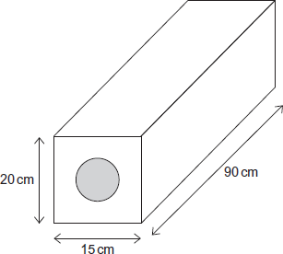
1. This building block is in the shape of a cuboid. The block contains one steel cylindrical rod of length 90 cm. The radius of the rod is 4 cm. The rest of the block is concrete. Work out the volume of concrete in the block.

…………………………………………………………

…………………………………………………………

…………………………………………………………

…………………………………………………………

…………………………………………………………………………………………………………

Answer ......................................................................cm³
(Total 5 marks)
2. A pyramid has a square base of side 10 cm a height of 30 cm

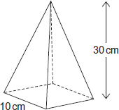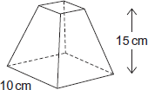

It is cut horizontally at a height of 15 cm. The top pyramid is removed to leave this frustum.
You are given the formula:

Volume of pyramid = $\frac{1}{3}$ × area of base × vertical height

Calculate the volume of the frustum.

…………………………………………………………………………………………………………

…………………………………………………………………………………………………………

…………………………………………………………………………………………………………

…………………………………………………………………………………………………………

Answer ................................................................. cm³
(Total 3 marks)
3. A hemisphere and a cone each have radius 9 cm. They are joined together to make a toy.

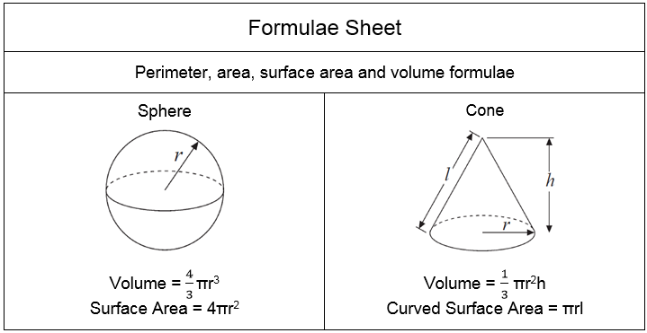
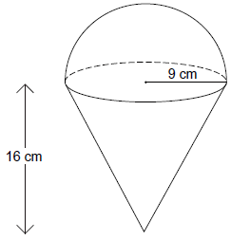

Work out the total volume of the toy.

…………………………………………………………………………………………………………

…………………………………………………………………………………………………………

…………………………………………………………………………………………………………

…………………………………………………………………………………………………………

Answer ............................................................................ cm³
(Total 4 marks)

4. A sphere has a radius of x cm. A cuboid has edges of length x cm, width 2x cm and height 2x cm. Show clearly that the sphere has the larger volume.
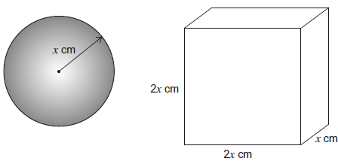
…………………………………………………………………………………………………………

…………………………………………………………………………………………………………

…………………………………………………………………………………………………………

…………………………………………………………………………………………………………

…………………………………………………………………………………………………………

…………………………………………………………………………………………………………

…………………………………………………………………………………………………………
(Total 3 marks)
5. The volume of the sphere is equal to the volume of the cone.
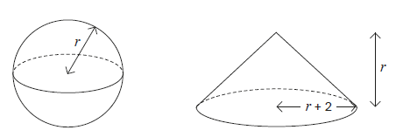
Work out the value of r. Do not use trial and improvement. You must show your working.

…………………………………………………………………………………………………………

…………………………………………………………………………………………………………

…………………………………………………………………………………………………………

…………………………………………………………………………………………………………

…………………………………………………………………………………………………………

…………………………………………………………………………………………………………

…………………………………………………………………………………………………………

…………………………………………………………………………………………………………

…………………………………………………………………………………………………………

…………………………………………………………………………………………………………

…………………………………………………………………………………………………………

Answer ........................................................................... units
(Total 5 marks)
(Total for test = 20 marks)

