**Inequalities (F)**

Intervention Booklet

Name: _______________________________

Class: _______________________________

**Useful websites:**

**www.mathswatchvle.com**

*(Video explanations and questions)*

Username: STH…@twgash

Password: stmaths

**www.methodmaths.com**

*(Past papers online that get instantly marked)*

Centre ID: wga

Username: firstname

Password: lastname

**www.hegartymaths.com**

*(Online tutorials and quizzes)*

Login: first name and last name are case sensitive

**www.bbc.co.uk/schools/gcsebitesize/maths**

**Inequalities**

**Things to remember:**

* < means less than
* > means greater than
* ≤ means less than or equal to
* ≥ means greater than or equal to
* An integer is a whole number
* On a number line, use a full circle to show a value can be equal, and an empty circle to show it cannot.

**Questions:**  
**1.** –2 < *n*  ≤ 3

*n* is an integer.

Write down all the possible values of *n*.

…........................................................

**(Total for Question is 2 marks)**

**2.** (a)   *n* is an integer.

–1 ≤ *n* < 4

List the possible values of *n*.

…........................................................

**(2)**

(b)



Write down the inequality shown in the diagram.

…........................................................

**(2)**

**(Total for Question is 4 marks)**

**3.** Here is an inequality, in *x*, shown on a number line.



Write down the inequality.

…........................................................

**(Total for Question is 2 marks)**

**4.**



(a)   Write down the inequality represented on the number line.

…........................................................

**(1)**

(b) −3 ≤ *n* < 2

−2 < *m* < 4   
*n* and *m* are integers.

Given that *n* = *m*, write down all the possible values of *n*.

…........................................................

**(2)**  
 **(Total for question = 5 marks)**

**5.** −5 < *y* ≤ 0

*y* is an integer.

Write down all the possible values of *y*.

…........................................................

**(Total for Question is 2 marks)**

**6.** –2 < n ≤ 3

Represent this inequality on the number line.



**(Total for Question is 2 marks)**

**Inequalities**

**Things to remember:**

* < means less than
* > means greater than
* ≤ means less than or equal to
* ≥ means greater than or equal to
* An integer is a whole number
* On a number line, use a full circle to show a value can be equal, and an empty circle to show it cannot.

**Questions:**  
**1.** (i) Solve the inequality

5*x* – 7 < 2*x* – 1

 ...........................................................

(ii) On the number line, represent the solution set to part (i).



**(Total 3 marks)**

**2.** (a) List all the possible integer values of *n* such that

–2 ≤ *n <* 3

 ...........................................................

**(2)**

(b) Solve the inequality

4*p –* 8 < 7 – *p*

**(2)**

**(Total 4 marks)**

**3.** (a) –3 ≤ *n* < 2

*n* is an integer.  
Write down all the possible values of *n*.

 ...........................................................

**(2)**

(b) Solve the inequality

5*x* < 2*x* – 6

 ...........................................................

**(2)**

**(Total 4 marks)**

**4.** (a) Solve the inequality

3*t* + 1 < *t* + 12

 ...........................................................

**(2)**

(b) *t* is a whole number.  
Write down the largest value of *t* that satisfies

3*t* + 1 < *t* + 12

 ...........................................................

**(1)**

**(Total 3 marks)**

**Graphical Inequalities**

**Things to remember:**

* Use a table of values if you need to help you draw the linear graphs.
* Use a solid line for ≥ or ≤, and a dotted line for > or <.
* Test a coordinate ((0, 0) is easiest) to work out which side of the line to shade.

**Questions:**

**1.** (a) Solve the inequality 5*e* + 3 > *e* + 12

...........................................................

**(2)**

(b) On the grid, shade the region defined by the inequality *x* + *y* > 1

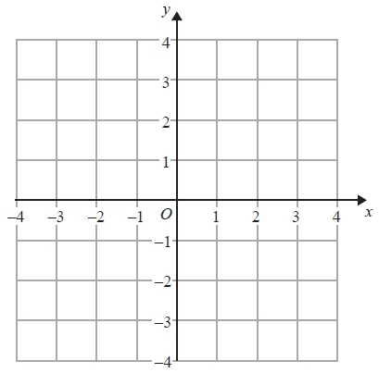

**(2)**

**(Total for Question is 4 marks)**

**2.** The lines *y* = *x* – 2 and *x* + *y* = 10 are drawn on the grid.

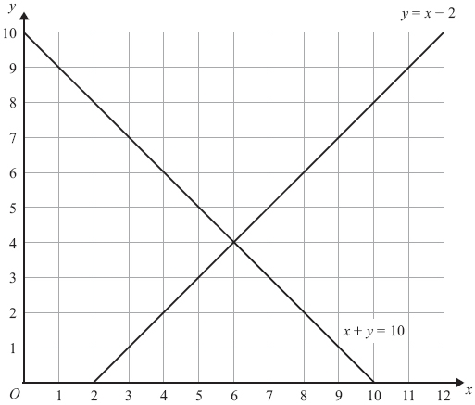

On the grid, mark with a cross (**×**) each of the points with integer coordinates that are in the region defined by

*y* > *x* – 2   
*x* + *y* < 10  
*x* > 3

**(Total for Question is 3 marks)**

**3.** (a)   Given that *x* and *y* are integers such that

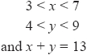

find all the possible values of *x*.

...........................................................

**(2)**

(b)   On the grid below show, by shading, the region defined by the inequalities



Mark this region with the letter R.

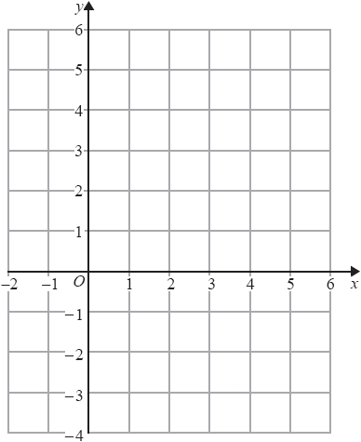

**(4)**

**(Total for question = 6 marks)**