Creative Teaching with Exam Questions

Piece by Piece

Stick an exam question onto a large sheet of paper and draw 3 rectangles around it (see diagram below).

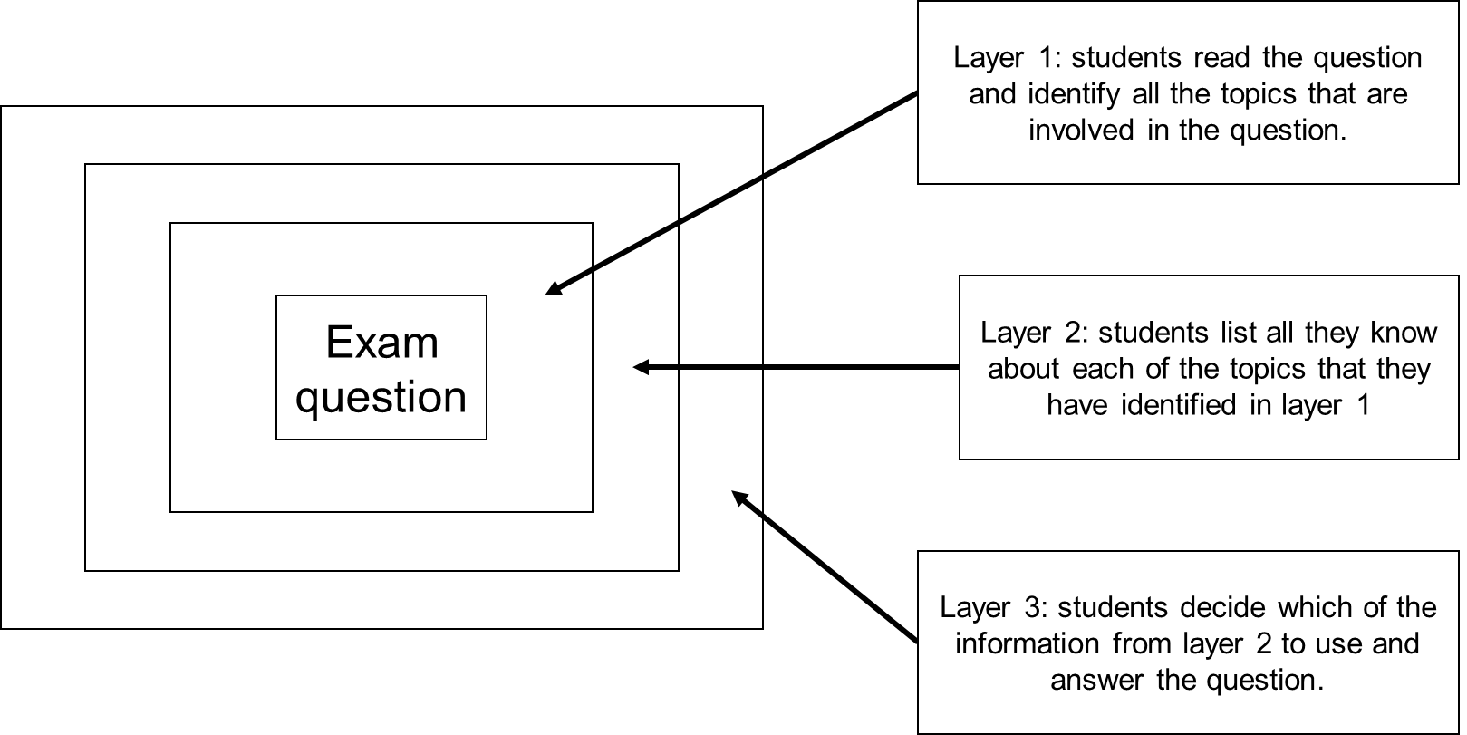

Give students 5 minutes to work on each layer.

This activity works well for questions which need to be broken down and/or use a variety of topics within a question.

By work in groups, students can share their ideas about how to tackle the question and work together on a solution rather than having lots of “stuck” individuals.

Stretch and Challenge
- Students can compare their solutions to other groups – which solution is the best/neatest/shortest?
- Groups can swap their solutions and mark each other’s to engage with the mark scheme.

Sort it out!

Pick a set of questions which involve a variety of areas from a single topic, for example triangles (Pythagoras’ Theorem, trigonometry, area – see below).

Put each question on a separate card.

Give each group of students a set of cards to sort into groups.

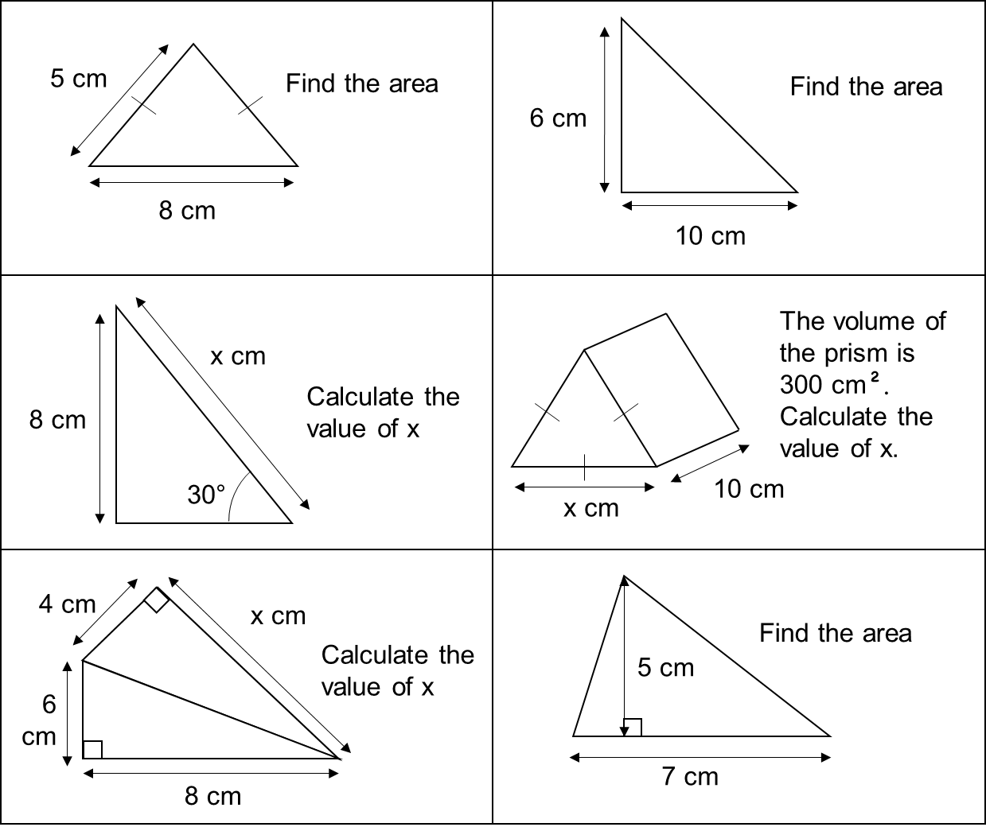

Stretch and Challenge
- Ask the following questions:
  - What groupings do you have? How do the cards fit?
  - Do all the cards fit neatly into a group?
  - Are there any cards that you do know where to put?
  - Which card was the hardest/easiest to place?
  - Are there any other possible groupings?

Find the Mistake

Give students a question with some solutions which are incorrect. Consider common misconceptions when writing these solutions for maximum benefit.

The students (either individually or as a group) go through the solutions and find the mistake/s.

Having found the mistakes, the students write out a correct solution.

Stretch and Challenge
- Looking at the original answers, can you explain what mistakes they made? Why do you think they made that mistake? What were their misconceptions?
- What would you do/say to show those people why they were wrong? What would be the most important thing for them to remember to avoid making that mistake again?
- Once students have been brought together to show their solutions, ask, “which of these answers are best?”

Step Up!

Write the solution to a question, but with each step of working out on a different card. Display the question and ask students to organise the solution steps into the correct order.

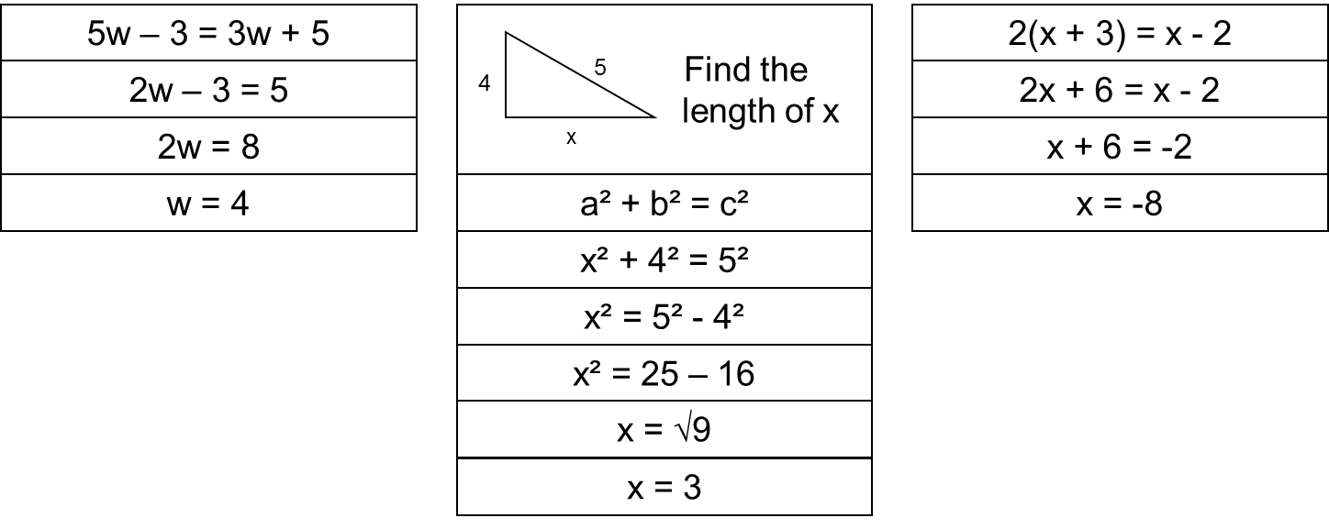

Stretch and Challenge
- Mix up several solutions to several questions. Students then have to decide which cards belong to which questions and sort them into the different answers.

Carousel

Organise your room into groups of tables.

Give each group a different exam question, ensuring that the questions are of similar length/value of marks.

Students have a time limit at each table to answer what they can. Aim for roughly 1 mark per minute.

This works best with questions where quality of written communication is assessed.

Stretch and Challenge
- Let the students compare their solutions and work out any mistakes/ misconceptions.
- Let the students mark their own solutions given the mark scheme.
- Ask students to present their solutions to the group/class, explaining their thinking and working for particular questions.

Playing Detective

Students are given a solution to a question. By looking at the solution, can the students find out what the original question was?

Example 1
Answer: 180 – (23 + 45) = 112
Question could be: If two angles in a triangle are 23° and 45°, what could the third be?
Or
Angles on a straight line… etc.

Example 2
Answer: 8 x 12 = 96 cm²
Question could be: Area of a rectangle
Or
Area of a parallelogram
Or
Volume of a prism (given area of cross-section)

Stretch and Challenge
- Using the question that you have found, is there a neater/better/shorter solution?
- What else could the question have been?

Finish it off

Organise your room into groups of tables.

Each group has a different question stuck to a large sheet of paper. If you have whiteboard tables, the sheet of paper is not necessary.

In groups, the students spend 2 minutes at each table and work around the room clockwise. The first group at a question underlines key words/figures, the second group starts to solve it, the next group continues it, and so on.

Stretch and Challenge
- Ask the last group of students to present the solution to the class.
- Alternatively, ask the last group of students to mark the solution based on the mark scheme.

Build them up…

Have a series of questions on the same topic, each on a different card. Ask students to sort them into order of difficulty.

Working through the answers, identify the extra steps/skills required that make that difference in difficulty.

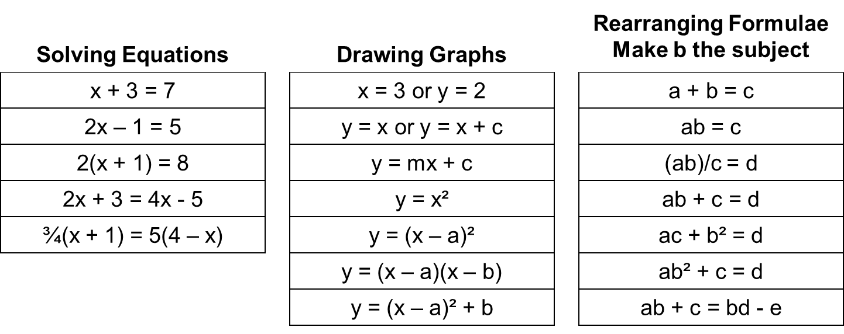

Stretch and Challenge
- Students design a poster or presentation of progression, including the additional skills required for each level.

Odd One Out

Students are shown three questions that have a link and one that does not share that link. Can the students identify the odd one out and explain the link?

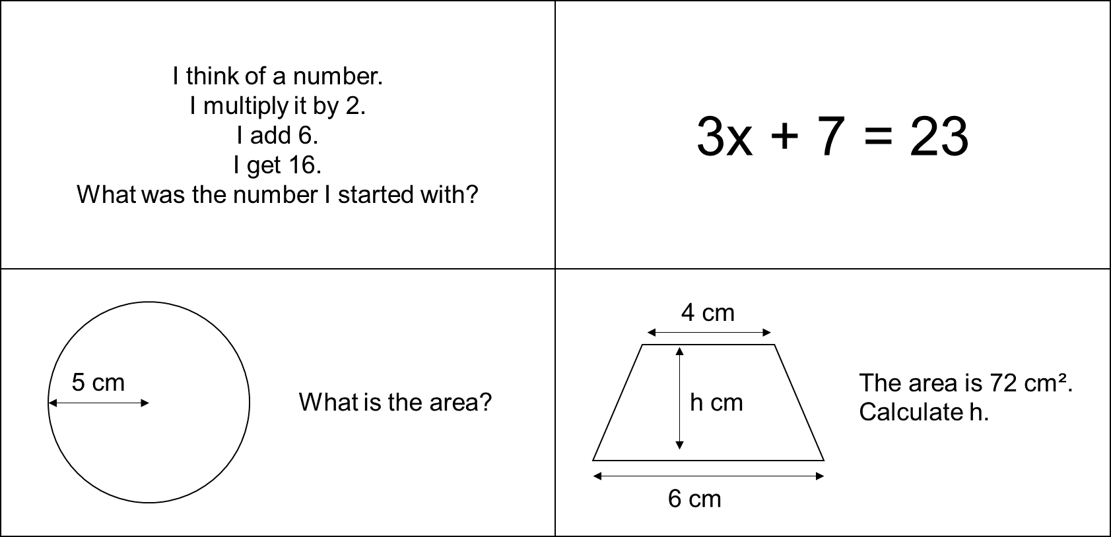

In the example above, the question about the area of the circle requires substitution, whereas the other 3 require setting up an equation and solving it.

Stretch and Challenge
- Ask students to design their own Odd One Out questions.

