Draw the nets of the following shapes. Remember to use a ruler.  a) Cube  b) Triangular prism  c) Square-based pyramid | Draw the nets of the following shapes. Remember to use a ruler.  a) Cube  b) Triangular prism  c) Square-based pyramid
Draw the nets of the following shapes. Remember to use a ruler.  a) Cube  b) Triangular prism  c) Square-based pyramid | Draw the nets of the following shapes. Remember to use a ruler.  a) Cube  b) Triangular prism  c) Square-based pyramid
Draw the nets of the following shapes. Remember to use a ruler.  a) Cube  b) Triangular prism  c) Square-based pyramid | Draw the nets of the following shapes. Remember to use a ruler.  a) Cube  b) Triangular prism  c) Square-based pyramid
Draw the nets of the following shapes. Remember to use a ruler.  a) Cube  b) Triangular prism  c) Square-based pyramid | Draw the nets of the following shapes. Remember to use a ruler.  a) Cube  b) Triangular prism  c) Square-based pyramid
Draw the nets of the following shapes. Remember to use a ruler.  a) Cube  b) Triangular prism  c) Square-based pyramid | Draw the nets of the following shapes. Remember to use a ruler.  a) Cube  b) Triangular prism  c) Square-based pyramid
Draw the nets of the following shapes. Remember to use a ruler.  a) Cube  b) Triangular prism  c) Square-based pyramid | Draw the nets of the following shapes. Remember to use a ruler.  a) Cube  b) Triangular prism  c) Square-based pyramid
Draw the nets of the following shapes. Remember to use a ruler.  a) Cube  b) Triangular prism  c) Square-based pyramid | Draw the nets of the following shapes. Remember to use a ruler.  a) Cube  b) Triangular prism  c) Square-based pyramid
Use the isometric paper below to draw a cube made of 8 cubes. Use multilink cubes to help if you need to. | Use the isometric paper below to draw a cube made of 8 cubes. Use multilink cubes to help if you need to.
Use the isometric paper below to draw a cube made of 8 cubes. Use multilink cubes to help if you need to. | Use the isometric paper below to draw a cube made of 8 cubes. Use multilink cubes to help if you need to.
Use the isometric paper below to draw a cube made of 8 cubes. Use multilink cubes to help if you need to. | Use the isometric paper below to draw a cube made of 8 cubes. Use multilink cubes to help if you need to.
Use the isometric paper below to draw a cube made of 8 cubes. Use multilink cubes to help if you need to. | Use the isometric paper below to draw a cube made of 8 cubes. Use multilink cubes to help if you need to.
Use the isometric paper below to draw a cube made of 8 cubes. Use multilink cubes to help if you need to. | Use the isometric paper below to draw a cube made of 8 cubes. Use multilink cubes to help if you need to.
Use the isometric paper below to draw a cube made of 8 cubes. Use multilink cubes to help if you need to. | Use the isometric paper below to draw a cube made of 8 cubes. Use multilink cubes to help if you need to.
Use the isometric paper below to draw a cube made of 8 cubes. Use multilink cubes to help if you need to. | Use the isometric paper below to draw a cube made of 8 cubes. Use multilink cubes to help if you need to.
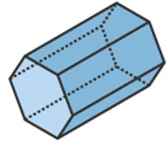  Draw the plan, side elevation and from elevation of this 3D shape. Remember to use a ruler. | Draw the plan, side elevation and from elevation of this 3D shape. Remember to use a ruler.
Draw the plan, side elevation and from elevation of this 3D shape. Remember to use a ruler. | Draw the plan, side elevation and from elevation of this 3D shape. Remember to use a ruler.
Draw the plan, side elevation and from elevation of this 3D shape. Remember to use a ruler. | Draw the plan, side elevation and from elevation of this 3D shape. Remember to use a ruler.
Draw the plan, side elevation and from elevation of this 3D shape. Remember to use a ruler. | Draw the plan, side elevation and from elevation of this 3D shape. Remember to use a ruler.
Draw the plan, side elevation and from elevation of this 3D shape. Remember to use a ruler. | Draw the plan, side elevation and from elevation of this 3D shape. Remember to use a ruler.
Draw the plan, side elevation and from elevation of this 3D shape. Remember to use a ruler. | Draw the plan, side elevation and from elevation of this 3D shape. Remember to use a ruler.
Draw the plan, side elevation and from elevation of this 3D shape. Remember to use a ruler. | Draw the plan, side elevation and from elevation of this 3D shape. Remember to use a ruler.
Jeremy is looking at a scaled plan of his new house. The scale is 1 : 80. The dimensions of the living room on the scaled plan are 4 cm by 5 cm. What is the area of the living room in the real world? | Jeremy is looking at a scaled plan of his new house. The scale is 1 : 80. The dimensions of the living room on the scaled plan are 4 cm by 5 cm. What is the area of the living room in the real world?
Jeremy is looking at a scaled plan of his new house. The scale is 1 : 80. The dimensions of the living room on the scaled plan are 4 cm by 5 cm. What is the area of the living room in the real world? | Jeremy is looking at a scaled plan of his new house. The scale is 1 : 80. The dimensions of the living room on the scaled plan are 4 cm by 5 cm. What is the area of the living room in the real world?
Jeremy is looking at a scaled plan of his new house. The scale is 1 : 80. The dimensions of the living room on the scaled plan are 4 cm by 5 cm. What is the area of the living room in the real world? | Jeremy is looking at a scaled plan of his new house. The scale is 1 : 80. The dimensions of the living room on the scaled plan are 4 cm by 5 cm. What is the area of the living room in the real world?
Jeremy is looking at a scaled plan of his new house. The scale is 1 : 80. The dimensions of the living room on the scaled plan are 4 cm by 5 cm. What is the area of the living room in the real world? | Jeremy is looking at a scaled plan of his new house. The scale is 1 : 80. The dimensions of the living room on the scaled plan are 4 cm by 5 cm. What is the area of the living room in the real world?
Jeremy is looking at a scaled plan of his new house. The scale is 1 : 80. The dimensions of the living room on the scaled plan are 4 cm by 5 cm. What is the area of the living room in the real world? | Jeremy is looking at a scaled plan of his new house. The scale is 1 : 80. The dimensions of the living room on the scaled plan are 4 cm by 5 cm. What is the area of the living room in the real world?
Jeremy is looking at a scaled plan of his new house. The scale is 1 : 80. The dimensions of the living room on the scaled plan are 4 cm by 5 cm. What is the area of the living room in the real world? | Jeremy is looking at a scaled plan of his new house. The scale is 1 : 80. The dimensions of the living room on the scaled plan are 4 cm by 5 cm. What is the area of the living room in the real world?
Jeremy is looking at a scaled plan of his new house. The scale is 1 : 80. The dimensions of the living room on the scaled plan are 4 cm by 5 cm. What is the area of the living room in the real world? | Jeremy is looking at a scaled plan of his new house. The scale is 1 : 80. The dimensions of the living room on the scaled plan are 4 cm by 5 cm. What is the area of the living room in the real world?
Construct accurately the triangle:  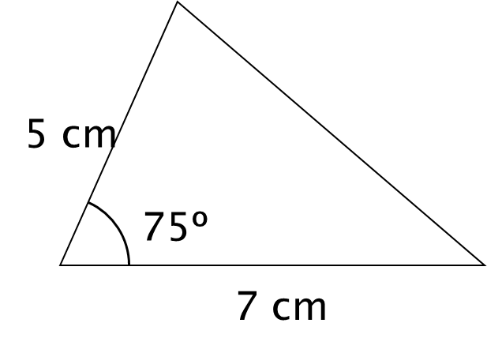 | Construct accurately the triangle:
Construct accurately the triangle: | Construct accurately the triangle:
Construct accurately the triangle: | Construct accurately the triangle:
Construct accurately the triangle: | Construct accurately the triangle:
Construct accurately the triangle: | Construct accurately the triangle:
Construct accurately the triangle: | Construct accurately the triangle:
Construct accurately the triangle: | Construct accurately the triangle:
Construct accurately the triangle:  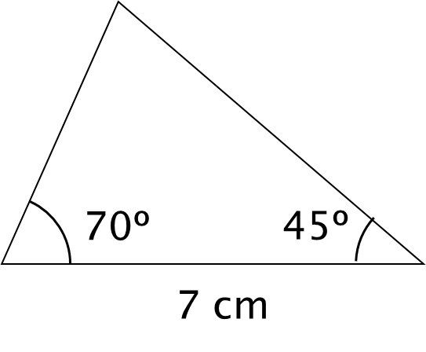 | Construct accurately the triangle:
Construct accurately the triangle: | Construct accurately the triangle:
Construct accurately the triangle: | Construct accurately the triangle:
Construct accurately the triangle: | Construct accurately the triangle:
Construct accurately the triangle: | Construct accurately the triangle:
Construct accurately the triangle: | Construct accurately the triangle:
Construct accurately the triangle: | Construct accurately the triangle:
Construct an accurate drawing of an equilateral triangle with sides 6 cm | Construct an accurate drawing of an equilateral triangle with sides 6 cm
Construct an accurate drawing of an equilateral triangle with sides 6 cm | Construct an accurate drawing of an equilateral triangle with sides 6 cm
Construct an accurate drawing of an equilateral triangle with sides 6 cm | Construct an accurate drawing of an equilateral triangle with sides 6 cm
Construct an accurate drawing of an equilateral triangle with sides 6 cm | Construct an accurate drawing of an equilateral triangle with sides 6 cm
Construct an accurate drawing of an equilateral triangle with sides 6 cm | Construct an accurate drawing of an equilateral triangle with sides 6 cm
Construct an accurate drawing of an equilateral triangle with sides 6 cm | Construct an accurate drawing of an equilateral triangle with sides 6 cm
Construct an accurate drawing of an equilateral triangle with sides 6 cm | Construct an accurate drawing of an equilateral triangle with sides 6 cm
Measure the bearing of the harbour from the lighthouse | Measure the bearing of the harbour from the lighthouse
Measure the bearing of the harbour from the lighthouse | Measure the bearing of the harbour from the lighthouse
Measure the bearing of the harbour from the lighthouse | Measure the bearing of the harbour from the lighthouse
Measure the bearing of the harbour from the lighthouse | Measure the bearing of the harbour from the lighthouse
Measure the bearing of the harbour from the lighthouse | Measure the bearing of the harbour from the lighthouse
Measure the bearing of the harbour from the lighthouse | Measure the bearing of the harbour from the lighthouse
Measure the bearing of the harbour from the lighthouse | Measure the bearing of the harbour from the lighthouse
A boat is on a bearing of 300° from the lighthouse and 040° from the harbour.  On the diagram, mark with a cross (×) the position of the boat. | A boat is on a bearing of 300° from the lighthouse and 040° from the harbour.  On the diagram, mark with a cross (×) the position of the boat.
A boat is on a bearing of 300° from the lighthouse and 040° from the harbour.  On the diagram, mark with a cross (×) the position of the boat. | A boat is on a bearing of 300° from the lighthouse and 040° from the harbour.  On the diagram, mark with a cross (×) the position of the boat.
A boat is on a bearing of 300° from the lighthouse and 040° from the harbour.  On the diagram, mark with a cross (×) the position of the boat. | A boat is on a bearing of 300° from the lighthouse and 040° from the harbour.  On the diagram, mark with a cross (×) the position of the boat.
A boat is on a bearing of 300° from the lighthouse and 040° from the harbour.  On the diagram, mark with a cross (×) the position of the boat. | A boat is on a bearing of 300° from the lighthouse and 040° from the harbour.  On the diagram, mark with a cross (×) the position of the boat.
A boat is on a bearing of 300° from the lighthouse and 040° from the harbour.  On the diagram, mark with a cross (×) the position of the boat. | A boat is on a bearing of 300° from the lighthouse and 040° from the harbour.  On the diagram, mark with a cross (×) the position of the boat.
A boat is on a bearing of 300° from the lighthouse and 040° from the harbour.  On the diagram, mark with a cross (×) the position of the boat. | A boat is on a bearing of 300° from the lighthouse and 040° from the harbour.  On the diagram, mark with a cross (×) the position of the boat.
A boat is on a bearing of 300° from the lighthouse and 040° from the harbour.  On the diagram, mark with a cross (×) the position of the boat. | A boat is on a bearing of 300° from the lighthouse and 040° from the harbour.  On the diagram, mark with a cross (×) the position of the boat.
Bisect the angle. | Bisect the angle.
Bisect the angle. | Bisect the angle.
Bisect the angle. | Bisect the angle.
Bisect the angle. | Bisect the angle.
Bisect the angle. | Bisect the angle.
Bisect the angle. | Bisect the angle.
Bisect the angle. | Bisect the angle.
Construct a perpendicular bisector of the line below. | Construct a perpendicular bisector of the line below.
Construct a perpendicular bisector of the line below. | Construct a perpendicular bisector of the line below.
Construct a perpendicular bisector of the line below. | Construct a perpendicular bisector of the line below.
Construct a perpendicular bisector of the line below. | Construct a perpendicular bisector of the line below.
Construct a perpendicular bisector of the line below. | Construct a perpendicular bisector of the line below.
Construct a perpendicular bisector of the line below. | Construct a perpendicular bisector of the line below.
Construct a perpendicular bisector of the line below. | Construct a perpendicular bisector of the line below.

