End of Unit Test Name: ____________________________
Construction and Loci - HIGHER

Q1. You will need a ruler and a pair of compasses to answer this question.
Construct the perpendicular from point P to the line L.
You must show your construction arcs.

(Total 3 marks)

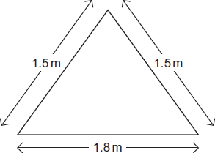
Q2. Jack is 1.28 metres tall. He has a tent in the shape of a triangular prism. The diagram shows the front view of the tent. Not drawn accurately.
Draw a scale drawing to work out if Jack can stand up in the middle of the tent. Show how you decide.

Scale: 1 cm represents 20 cm

(Total 3 marks)
Q3. The diagram shows the positions of towns A and B. Not drawn accurately.

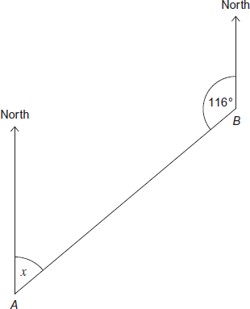

(a) Circle the value, in degrees, of angle x.

44 46 54 56 64 66
(1)
(b) Write down the 3-figure bearing of B from A.
Answer ........................................................ degrees
(1)
(c) Town C is due North of A. Angle ACB = x. Not drawn accurately

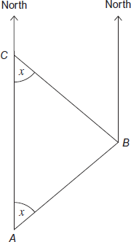

Work out the 3-figure bearing of C from B.

........................................................................................................................

........................................................................................................................

Answer .................................................................... °
(3)
(Total 5 marks)
Q4. Use ruler and compasses to answer this question. Point P is
- the same distance from AB and AD
- 4 cm from C.
Show the position of P on the diagram.

(Total 3 marks)

Q5. The scale drawing shows a post which is 1.5 metres from the fence.

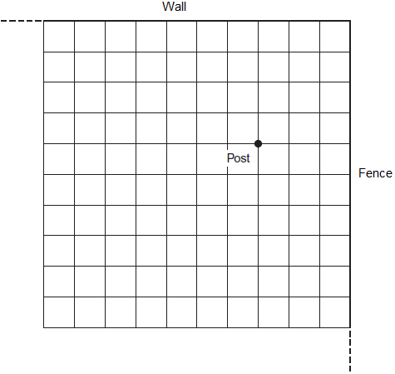
(a) How far is the post from the wall?

.........................................................................................................................

.........................................................................................................................

Answer .......................................................... metres
(1)
(b) A pony is tied to the post by a rope. The pony can reach 2.5 metres from the post. On the scale drawing, show accurately the area that the pony can reach.
(2)
(c) Work out the scale of the drawing as a ratio. Give your answer in its simplest form.

.........................................................................................................................

.........................................................................................................................

Scale ................... : ...................
(3)
(Total 6 marks)

(Total for test = 20 marks)

