End of Unit Test Name: ____________________________
Forming and Solving Equations - FOUNDATION

1) (a) Here is a number machine.

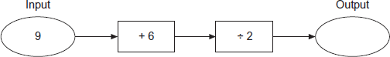

Work out the output when the input is 9.
Answer ......................................................................
(1)
(b) Here is the same number machine.

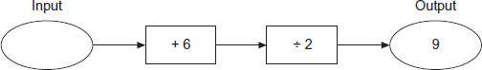

Work out the input when the output is 9.
Answer ......................................................................
(1)
(Total 2 marks)
2) (a) Solve 6x = 54

…………………………………………………………………………………………………

x = .............................................................................
(1)
(b) Solve 3y + 15 = 9

…………………………………………………………………………………………………

…………………………………………………………………………………………………

…………………………………………………………………………………………………

y = .............................................................................
(2)
(c) Solve 4w + 2 = 2w + 7

…………………………………………………………………………………………………

…………………………………………………………………………………………………

…………………………………………………………………………………………………

…………………………………………………………………………………………………

…………………………………………………………………………………………………

w = ............................................................................
(3)
(Total 6 marks)
3) (a) Rearrange the formula to make w the subject of y = 3w + 8

…………………………………………………………………………………………………

…………………………………………………………………………………………………

…………………………………………………………………………………………………

…………………………………………………………………………………………………

Answer ......................................................................
(2)
(b) Solve 5(x + 4) = 3x + 23

…………………………………………………………………………………………………

…………………………………………………………………………………………………

…………………………………………………………………………………………………

…………………………………………………………………………………………………

…………………………………………………………………………………………………

…………………………………………………………………………………………………

…………………………………………………………………………………………………

x = .............................................................................
(3)
(Total 5 marks)
4) Solve the simultaneous equations
5x + 6y = 3
2x – 3y = 12
Do not use trial and improvement. You must show your working.

…………………………………………………………………………………………………………

…………………………………………………………………………………………………………

…………………………………………………………………………………………………………

…………………………………………………………………………………………………………

…………………………………………………………………………………………………………

…………………………………………………………………………………………………………

…………………………………………………………………………………………………………

…………………………………………………………………………………………………………

Answer .................................................................................
(Total 3 marks)
5) The area of the rectangle and the area of the triangle are equal. Not drawn accurately.

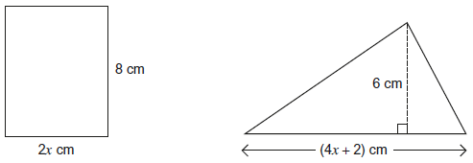

Work out the value of x.

…………………………………………………………………………………………………………

…………………………………………………………………………………………………………

…………………………………………………………………………………………………………

…………………………………………………………………………………………………………

…………………………………………………………………………………………………………

…………………………………………………………………………………………………………

…………………………………………………………………………………………………………

…………………………………………………………………………………………………………

…………………………………………………………………………………………………………

…………………………………………………………………………………………………………

x = ..........................................................................................
(Total 4 marks)

(Total for test = 20 marks)

