**Drawing Pie Charts GREEN**

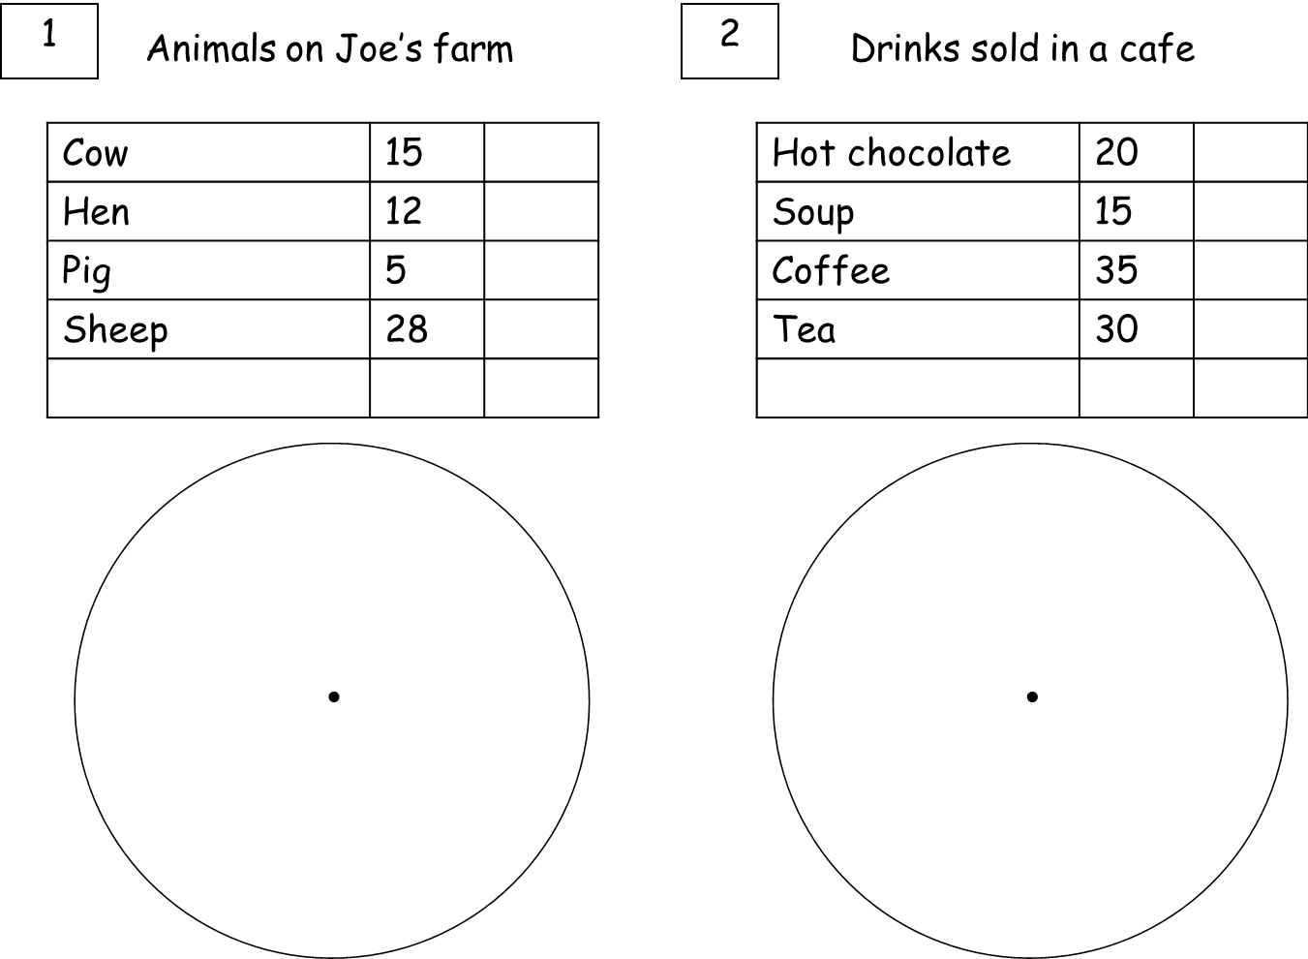

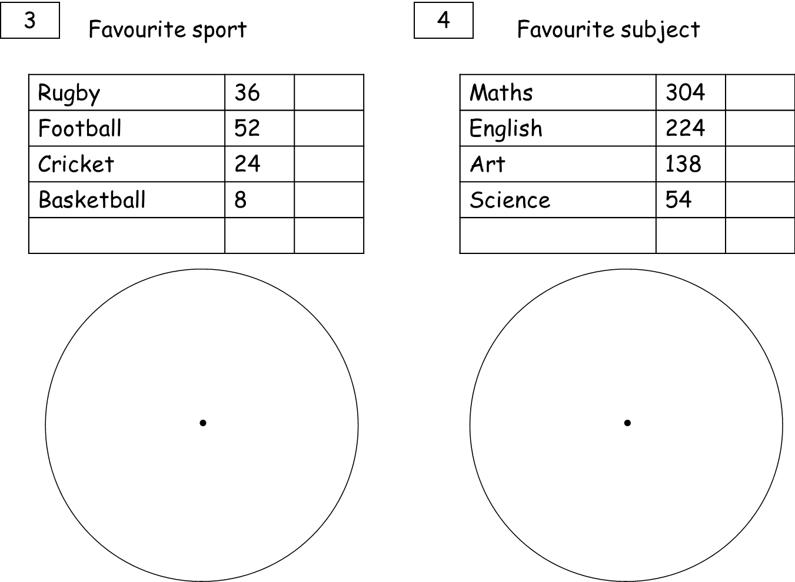

**Drawing Pie Charts AMBER**

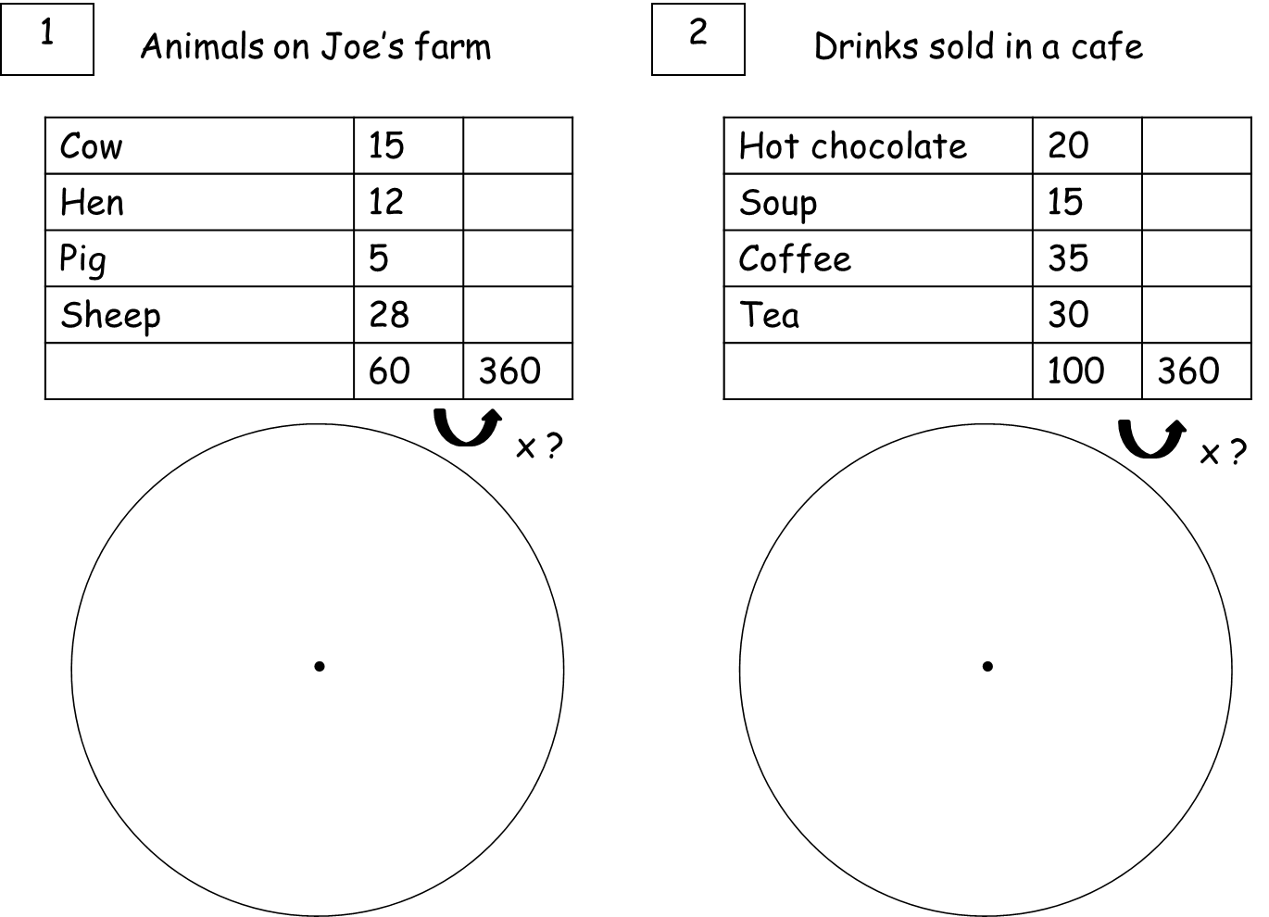

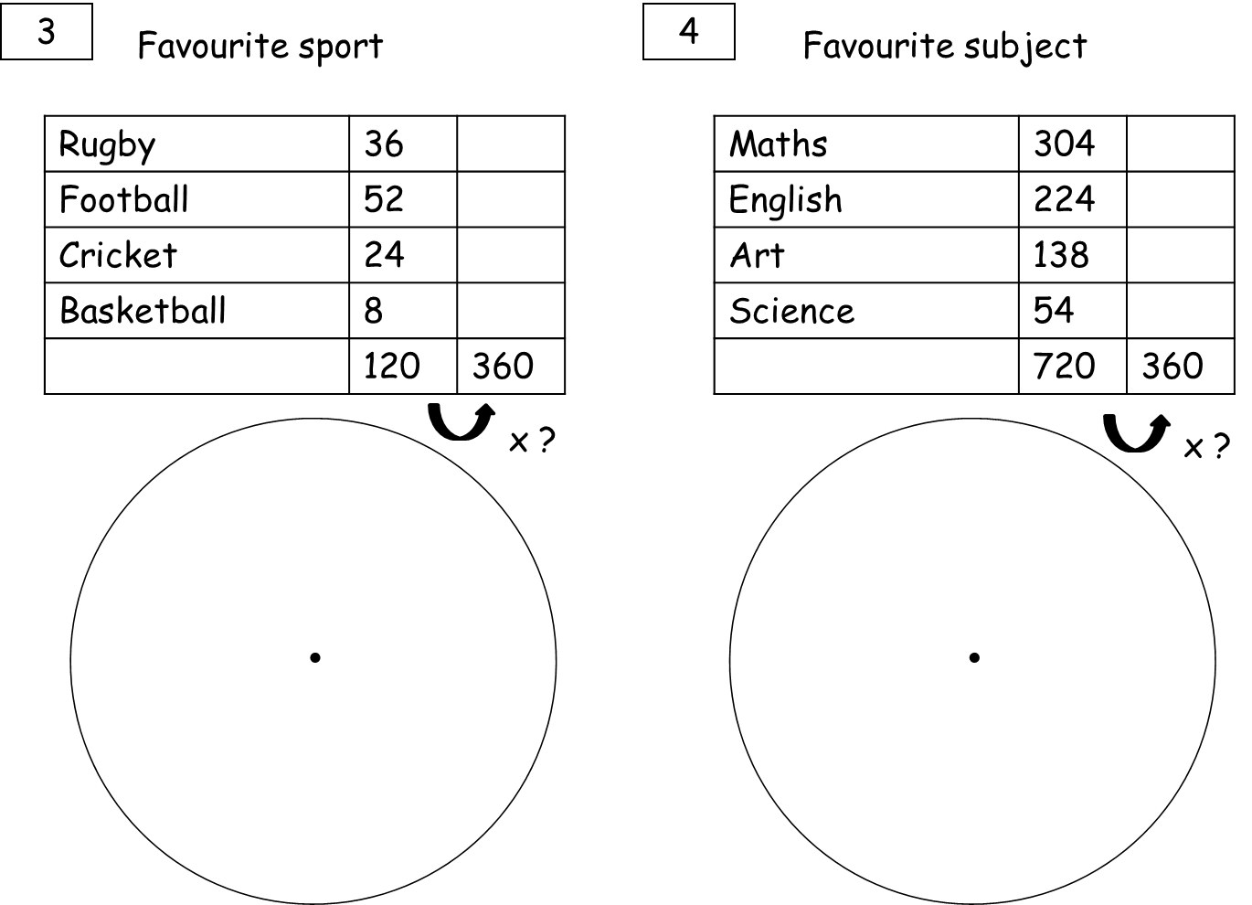

**Drawing Pie Charts RED**

