Maths Problem Solving Starters

Levels 5 – 7

Name: ______________________________

Class: ______________________________

Teacher: ______________________________

Remember:
- You will need: pen, pencil, rubber and a ruler.
- Check your work carefully.
- Show all of your working out, with clear steps.

Formulae Sheet
Perimeter, area, surface area and volume formulae
Sphere | Cone
Volume = $\frac{4}{3}$ πr³  Surface Area = 4πr² | Volume = $\frac{1}{3}$ πr²h  Curved Surface Area = πrl

1. | A 20 Euro note is a rectangle 133 mm long and 72 mm wide. A 500 Euro Note is a rectangle 165 mm long and 82 mm wide. Show that the two rectangles are not mathematically similar.  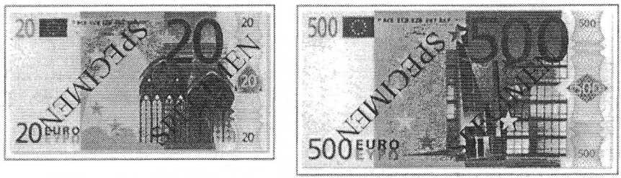  Not drawn accurately. | / 3
2. | A water molecule has a mass of 3 x 10⁻²⁹ kg. A bottle contains 1.7 x 10²⁸ molecules of water. Calculate the mass of the water in the bottle.  _____________ kg | / 3
3. | A scientist wishes to find out how many fish are in a lake. He catches 40 fish and marks them with a small tag. Two weeks later he returns to the lake and catches another 40 fish. Five of the fish he catches are tagged. Estimate how many fish are in the lake.  _____________ | / 3

4. | Two rectangles have the same area. Calculate the value of x.  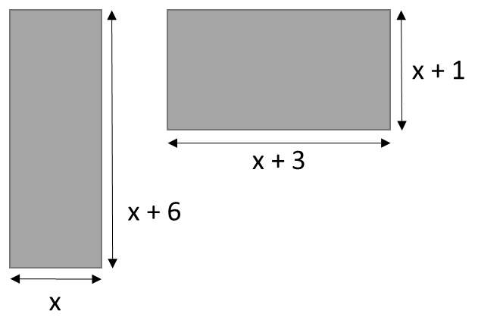  x = _____________ | / 4
5. | A tree can be planted between 10 m and 4 m from corner C. It must be planted at least 14 m from the house. Accurately shade the region where the tree could be planted.  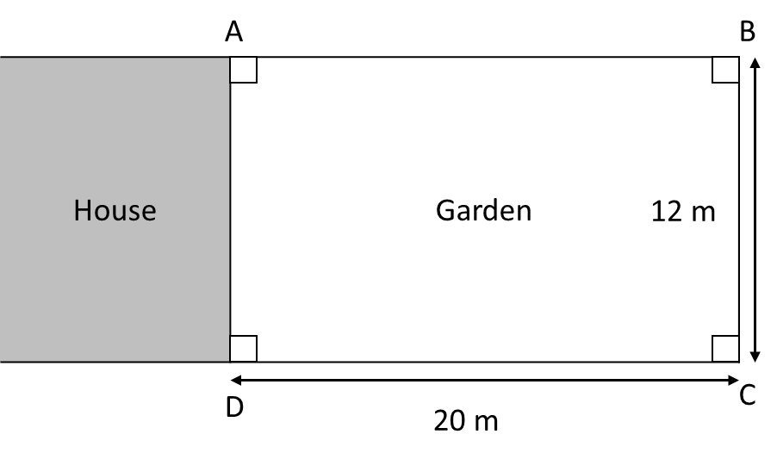  Scale: 1 cm to 2 m | / 4
6. | An internet auction has two identical cars for sale. Both cars are priced at £10 000. The price of each car is to be reduced each week until they are sold. The first car is reduced by 10% each week. The second car is reduced by £800 each week. Assuming that no one buys the cars, after how many weeks will the second car be cheaper than the first? You must show your working. | / 4

7. | The table shows the distances jumped by two athletes training for a long jump event. At the long jump event, both athletes must compete against the current champion who jumped 8.31 m. By considering averages, explain who has the better chance of beating him. You must explain your answer.  Distance (d m) Ben’s frequency Jamie’s frequency  6.5 ≤ d < 7.0 3 8  7.0 ≤ d < 7.5 7 18  7.5 ≤ d < 8.0 25 21  8.0 ≤ d < 8.5 1 3  8.5 ≤ d < 9.0 0 1 | / 7

8. | A rectangle is made using four straight lines on centimetre square paper. Three of these lines are shown on the grid. The point (-4, 0) lies on the missing side. Work out the equation of the missing side.  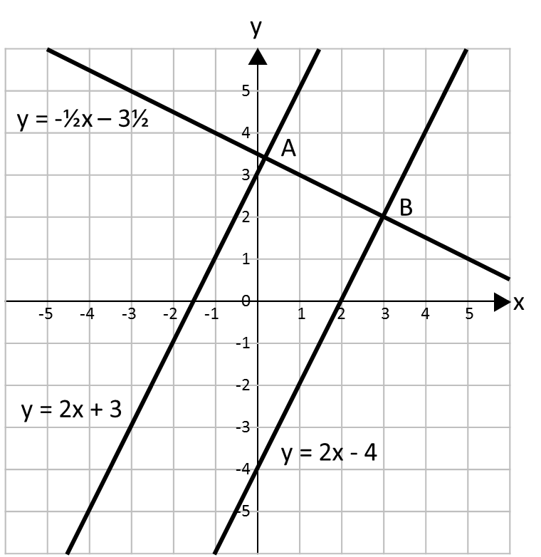  ___________________________ | / 4

9. | The diagram below shows a hexagon. All the measurements are in centimetres. The area of this shape is 102 cm². Work out the length of the longest side of the shape.  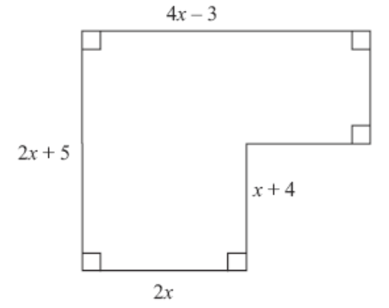  ________________ cm | / 6

 | 10 |  | Calculate the length of the side of the largest square that fits inside a 12 cm diameter circle. Give your answer correct to 2 decimal places.  ___________________ cm |  | / 5
 | 11. |  | Use vectors to show that P(1, 3), Q(4, 6) and R(10, 12) are collinear. |  | / 6
12. |  | You multiply three powers of 9 together.  What could the indices be when:  - All the indices are the same?  _________ _________ _________  - All the indices are different?  _________ _________ _________ |  | / 2
13. |  | A Formula 1 racing car has a top speed of 350 km/h. A peregrine falcon is the fastest bird with a speed of 108 m/s. Which is fastest? Explain your answer. |  | / 4

14. | The area of triangle ABC is 21 cm². Calculate the size of the obtuse angle ABC. Give your answer to a suitable degree of accuracy.  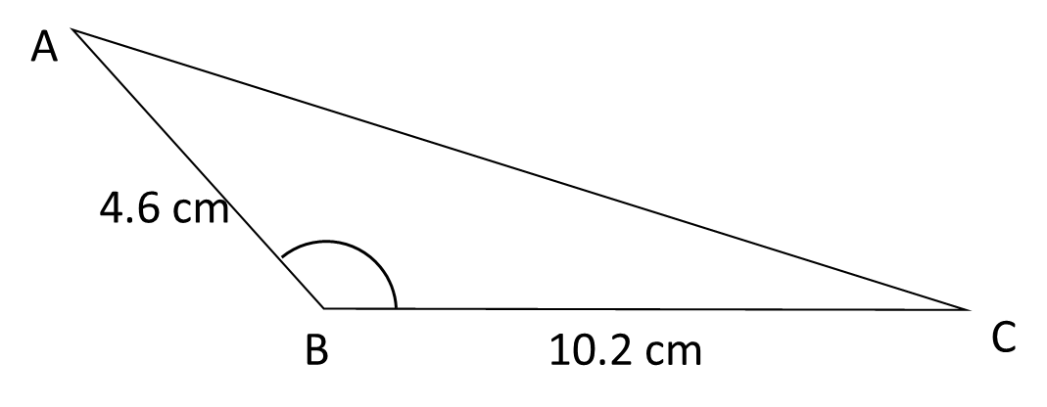  ___________________ ° | / 3
15. | A sheet of A2 paper and a sheet of A4 paper are similar. The area ofa sheet pf A2 paper is 2500 cm² and the area of a sheet of A4 paper is 625 cm². The width of a sheet of A4 paper is 21 cm. What is the width of a sheet of A4 paper?  _________________ cm | / 4
16. | 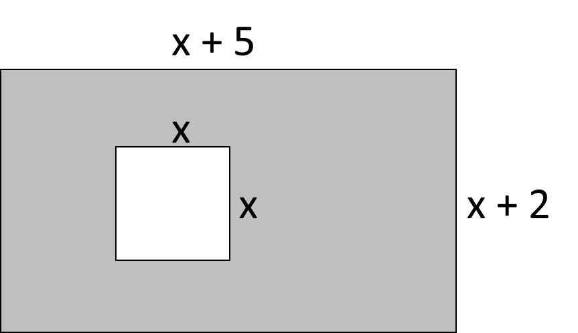  A rectangular piece of paper has length (x + 5) cm and width (x + 2) cm. A square with sides x cm is removed. Find x if the shaded area is 31 cm².  x = ____________ cm | / 4
17. | Rugs come in several shapes and sizes. A small rug has dimensions a x a. A large rug has dimensions 2a x (a + 1). The area of the large rug is 12 m². What are the dimensions of the small rug?  _____________________ | / 7

18. | Some students did a French test and a German test. Here are their results.  French test results:  44 28 39 50 14 20 32 34 20 45 31  German test results:  50 25 38 36 31 22 54 45 51 48 42  On the grid, draw diagrams that could be used to compare the French test results with the German test results.  Make one comparison between the French test results and the German test results. | / 4
19. | The cost of fuel per hour, C (in £), to propel a boat through the water is directly proportional to the cube of its speed, s (in mph). A boat travelling at 10 mph uses £50 of fuel per hour. What is the cost of fuel per hour when the boat is travelling at 5 mph?  £ _____________________ | / 5
20. | 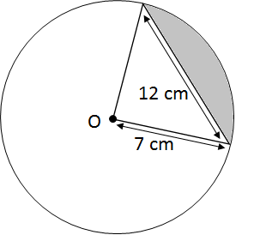  Calculate the area of the shaded segment. Give you answer correct to 3 decimal places.  ____________________ cm² | / 6
21. | A rectangle is placed symmetrically inside a square.  The rectangle has sides of length m and n. Find the area of the square in terms of m and n.  ___________________________________ | / 4
22. | Here is part of the graph of a quadratic function. Find the equation of the graph.  ___________________________ | / 4

