Frequency Trees GREEN

1. There are 28 pupils in a class. There are 18 boys and 10 girls in the class. Of the boys, 3 wear glasses. Of the girls, 8 do not wear glasses.
a) Draw a frequency tree.

b) Find the probability of a pupil chosen at random being a girl who wears glasses
…………………………

2. 78 people sat their driving test. 43 are male, out of these 32 pass. 8 females fail their driving test.
a) Draw a frequency tree.

b) Use your frequency tree to work out the probability of a pupil chosen at random being a male who fails the test.
…………………………

3. 73 people took a test. Before the test, they predicted whether they would pass or fail. 50 people predicted they would pass. 55 people did pass. Of these 55 people, 4 times as many people predicted they would pass as predicted fail.
a) Draw a frequency tree in the space below.

b) What fraction of the people predicted correctly?
…………………………

4. Students in KS3 were asked if they enjoyed their maths lessons. There are 200 students altogether in years 7, 8 and 9. Of the 70 students in year 7, 42 enjoy their maths lessons. Of the 84 students in year 8, 56 enjoy their maths lessons. 132 students enjoyed their maths lessons in total.
a) Draw a frequency tree in the space below.

b) What percentage of students are in year 9 and did not enjoy their maths lessons?
…………………………

Frequency Trees AMBER

1. There are 28 pupils in a class. There are 18 boys and 10 girls in the class. Of the boys, 3 wear glasses. Of the girls, 8 do not wear glasses.
a) Complete the frequency tree.
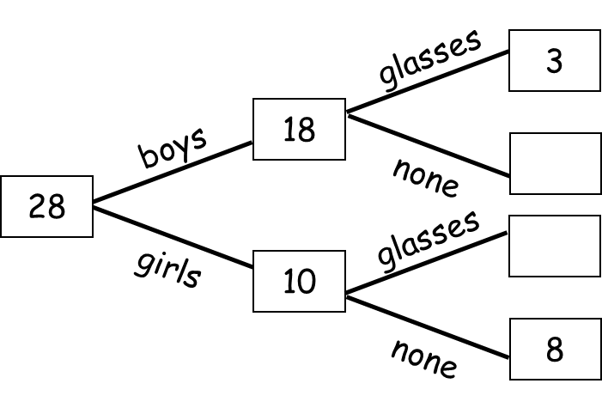

b) Find the probability of a pupil chosen at random being a girl who wears glasses
…………………………

2. 78 people sat their driving test. 43 are male, out of these 32 pass. 8 females fail their driving test.
a) Complete the frequency tree.

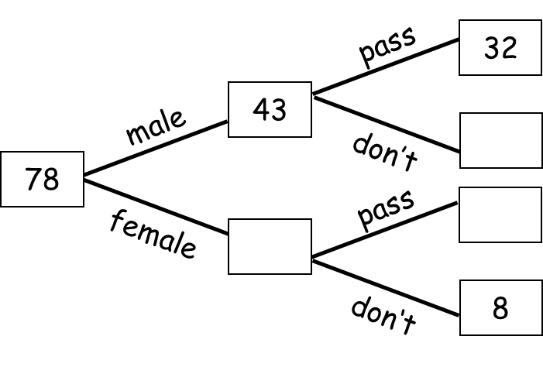

b) Use your frequency tree to work out the probability of a pupil chosen at random being a male who fails the test.
…………………………

3. 73 people took a test. Before the test, they predicted whether they would pass or fail. 50 people predicted they would pass. 55 people did pass. Of these 55 people, 4 times as many people predicted they would pass as predicted fail.
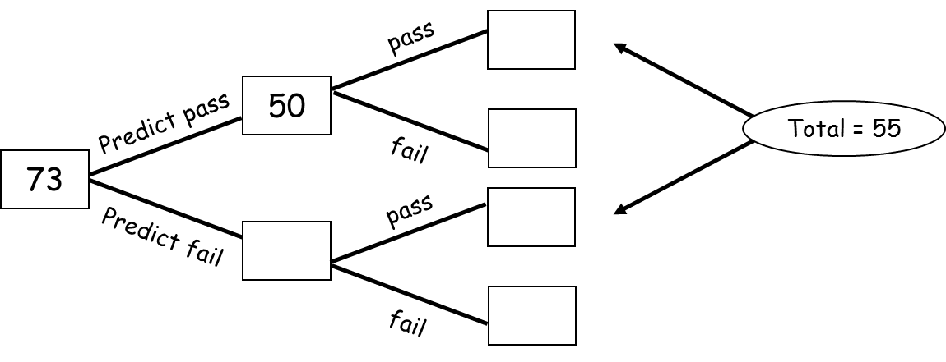
a) Complete the frequency tree in the space below.

b) What fraction of the people predicted correctly?
…………………………

4. Students in KS3 were asked if they enjoyed their maths lessons. There are 200 students altogether in years 7, 8 and 9. Of the 70 students in year 7, 42 enjoy their maths lessons. Of the 84 students in year 8, 56 enjoy their maths lessons. 132 students enjoyed their maths lessons in total.
a) Complete the frequency tree in the space below.
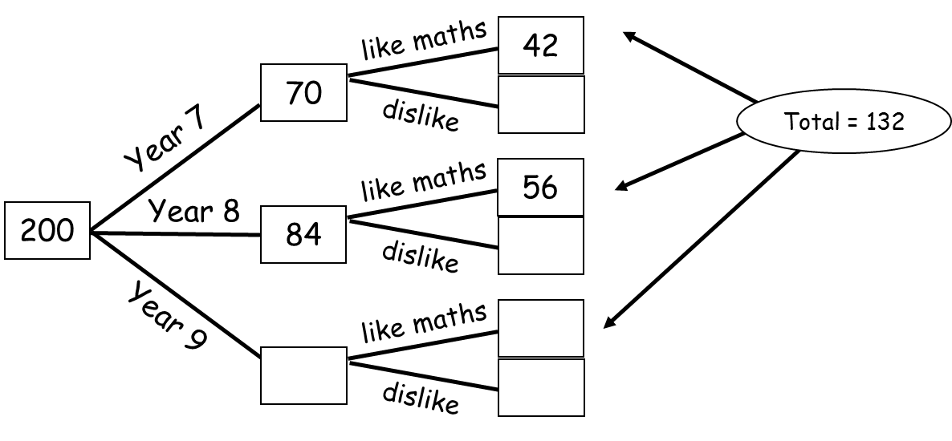

b) What percentage of students are in year 9 and did not enjoy their maths lessons?
…………………………

Frequency Trees RED

1. There are 28 pupils in a class. There are 18 boys and 10 girls in the class. Of the boys, 3 wear glasses. Of the girls, 8 do not wear glasses.
a) Complete the frequency tree.

b) Find the probability of a pupil chosen at random being a girl who wears glasses
…………………………

2. 78 people sat their driving test. 43 are male, out of these 32 pass. 8 females fail their driving test.
a) Complete the frequency tree.

b) Use your frequency tree to work out the probability of a pupil chosen at random being a male who fails the test.
…………………………

3. 73 people took a test. Before the test, they predicted whether they would pass or fail. 50 people predicted they would pass. 55 people did pass. Of these 55 people, 4 times as many people predicted they would pass as predicted fail.
a) Complete the frequency tree in the space below.

b) What fraction of the people predicted correctly?
…………………………

4. Students in KS3 were asked if they enjoyed their maths lessons. There are 200 students altogether in years 7, 8 and 9. Of the 70 students in year 7, 42 enjoy their maths lessons. Of the 84 students in year 8, 56 enjoy their maths lessons. 132 students enjoyed their maths lessons in total.
a) Complete the frequency tree in the space below.

b) What percentage of students are in year 9 and did not enjoy their maths lessons?
…………………………

