**Sketching Graphs of Quadratics, Cubics and Reciprocals GREEN**

**TIP:** When joining up the points that you have plotted, join them with a **smooth curve**, not a straight line!

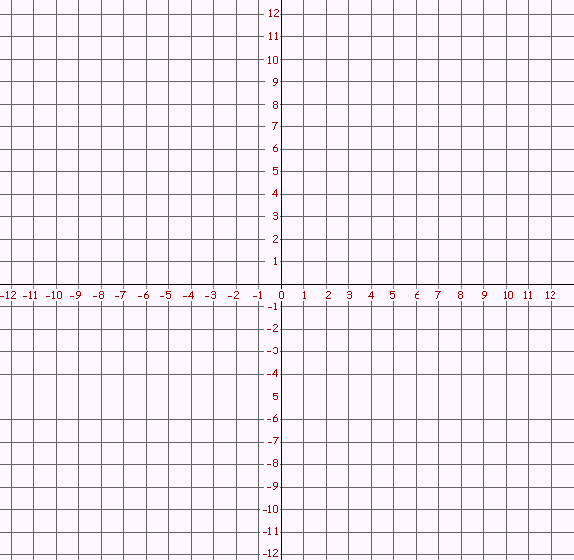1a) Complete the following table for the equation

, for :

|  |  |  |  |  |  |  |  |
| --- | --- | --- | --- | --- | --- | --- | --- |
|  | -3 | -2 | -1 | 0 | 1 | 2 | 3 |
|  |  |  |  |  |  |  |  |

b) Draw the graph of on the grid:



2a) Complete the following table for the equation

, for :

|  |  |  |  |  |  |  |  |
| --- | --- | --- | --- | --- | --- | --- | --- |
|  | -3 | -2 | -1 | 0 | 1 | 2 | 3 |
|  |  |  |  |  |  |  |  |

bb) Draw the graph of on the grid:

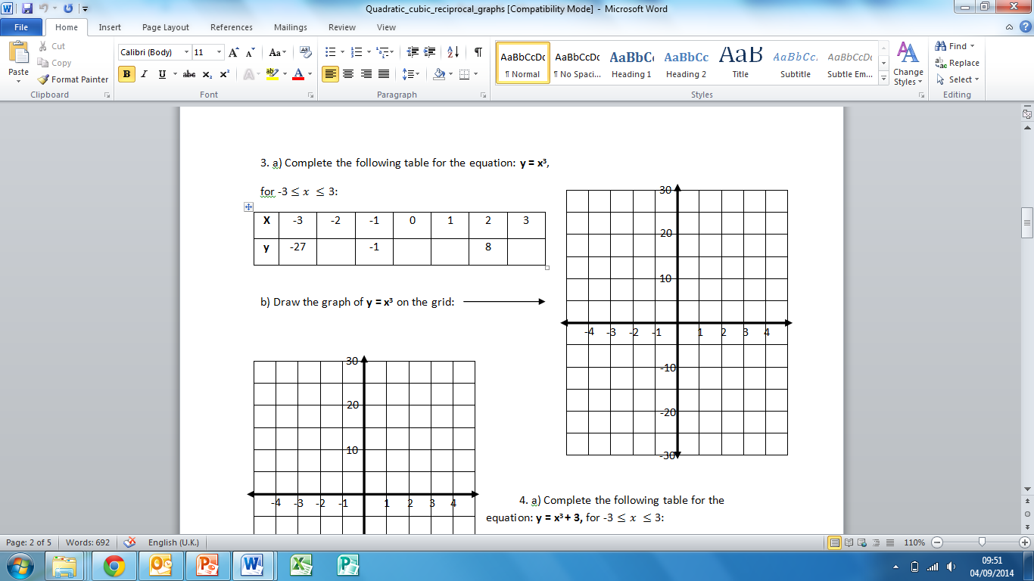3a) Complete the following table for the equation

, for :

|  |  |  |  |  |  |  |  |
| --- | --- | --- | --- | --- | --- | --- | --- |
|  | -3 | -2 | -1 | 0 | 1 | 2 | 3 |
|  |  |  |  |  |  |  |  |

b) Draw the graph of on the grid:



4a) Complete the following table for the equation

**,** for :

|  |  |  |  |  |  |  |  |
| --- | --- | --- | --- | --- | --- | --- | --- |
|  | -3 | -2 | -1 | 0 | 1 | 2 | 3 |
|  |  |  |  |  |  |  |  |

b) Draw the graph of on the grid:

5a) Complete the following table for the equation: , for :

|  |  |  |  |  |  |  |  |  |  |  |  |  |  |
| --- | --- | --- | --- | --- | --- | --- | --- | --- | --- | --- | --- | --- | --- |
|  | -3 | -2.5 | -2 | -1.5 | -1 | -0.5 | 0 | 0.5 | 1 | 1.5 | 2 | 2.5 | 3 |
|  |  |  |  |  |  |  |  |  |  |  |  |  |  |

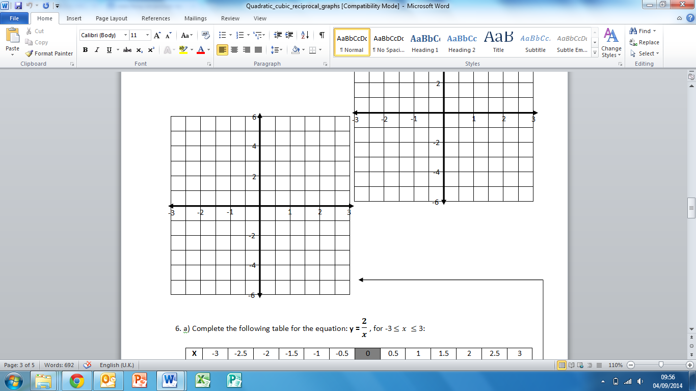b) Draw the graph of on the grid:

6a) Complete the following table for the equation: , for

|  |  |  |  |  |  |  |  |  |  |  |  |  |  |
| --- | --- | --- | --- | --- | --- | --- | --- | --- | --- | --- | --- | --- | --- |
|  | -3 | -2.5 | -2 | -1.5 | -1 | -0.5 | 0 | 0.5 | 1 | 1.5 | 2 | 2.5 | 3 |
|  |  |  |  |  |  |  |  |  |  |  |  |  |  |

b) Draw the graph of on the grid:

7) Fill in the gaps using the following words: **Cubic / Linear / Reciprocal / Quadratic**

Equations where the highest power of x is 1 (‘’) are called _________________ equations. They create a straight line when drawn graphically.

Equations where the highest power of x is 2 (‘’) are called ________________ equations. They create a ‘U’ or ‘n’ shape when drawn graphically.

Equations where the highest power of x is 3 (‘’) are called _________________ equations. They create a ‘ ‘ or ‘ ‘ shape when drawn graphically.

Equations that include a number divided by (e.g. ) are called ______________ equations. The graph never touches the axes.

8) Name the type of equation for each of the following:

a) __________ b) __________

c) __________ d) __________

e) __________ f) __________

9) Write the type of equation (linear/quadratic/cubic/reciprocal) of each graph:

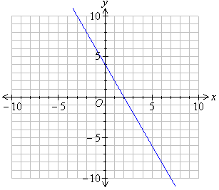

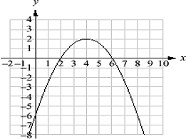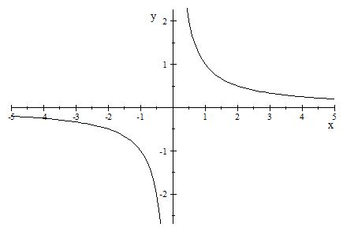a) b) c)

__________ __________ __________

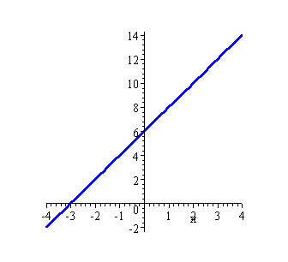

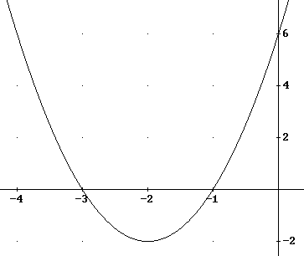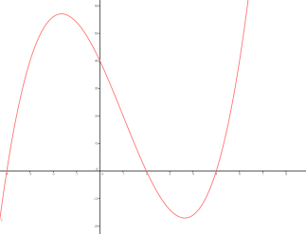d) e) f)

__________ __________ __________

10) Match the graph to the equation:



|  |  |
| --- | --- |
| Graph (letter) | Equation |
|  |  |
|  |  |
|  |  |
|  |  |
|  |  |

**Sketching Graphs of Quadratics, Cubics and Reciprocals AMBER**

**TIP:** When joining up the points that you have plotted, join them with a **smooth curve**, not a straight line!

**1a) Complete the following table for the equation

, for :

|  |  |  |  |  |  |  |  |
| --- | --- | --- | --- | --- | --- | --- | --- |
|  | -3 | -2 | -1 | 0 | 1 | 2 | 3 |
|  | 11 | 6 | 3 |  |  |  |  |

b) Draw the graph of on the grid:



2a) Complete the following table for the equation

, for :

|  |  |  |  |  |  |  |  |
| --- | --- | --- | --- | --- | --- | --- | --- |
|  | -3 | -2 | -1 | 0 | 1 | 2 | 3 |
|  | 8 | 3 | 0 |  |  |  |  |

bb) Draw the graph of on the grid:

3a) Complete the following table for the equation

, for :

|  |  |  |  |  |  |  |  |
| --- | --- | --- | --- | --- | --- | --- | --- |
|  | -3 | -2 | -1 | 0 | 1 | 2 | 3 |
|  | -27 | -8 | -1 |  |  |  |  |

b) Draw the graph of on the grid:



4a) Complete the following table for the equation

**,** for :

|  |  |  |  |  |  |  |  |
| --- | --- | --- | --- | --- | --- | --- | --- |
|  | -3 | -2 | -1 | 0 | 1 | 2 | 3 |
|  | -24 | -5 | 2 |  |  |  |  |

b) Draw the graph of on the grid:

5a) Complete the following table for the equation: , for :

|  |  |  |  |  |  |  |  |  |  |  |  |  |  |
| --- | --- | --- | --- | --- | --- | --- | --- | --- | --- | --- | --- | --- | --- |
|  | -3 | -2.5 | -2 | -1.5 | -1 | -0.5 | 0 | 0.5 | 1 | 1.5 | 2 | 2.5 | 3 |
|  | -1 | -1.2 | -1.5 | -2 |  |  |  |  |  |  |  |  |  |

b) Draw the graph of on the grid:

6a) Complete the following table for the equation: , for

|  |  |  |  |  |  |  |  |  |  |  |  |  |  |
| --- | --- | --- | --- | --- | --- | --- | --- | --- | --- | --- | --- | --- | --- |
|  | -3 | -2.5 | -2 | -1.5 | -1 | -0.5 | 0 | 0.5 | 1 | 1.5 | 2 | 2.5 | 3 |
|  | -0.67 | -0.8 | -1 |  |  |  |  |  |  |  |  |  |  |

b) Draw the graph of on the grid:

7) Fill in the gaps using the following words: **Cubic / Linear / Reciprocal / Quadratic**

(Think: cube… straight line… inverse… quadrilateral)

Equations where the highest power of x is 1 (‘’) are called _________________ equations. They create a straight line when drawn graphically.

Equations where the highest power of x is 2 (‘’) are called ________________ equations. They create a ‘U’ or ‘n’ shape when drawn graphically.

Equations where the highest power of x is 3 (‘’) are called _________________ equations. They create a ‘ ‘ or ‘ ‘ shape when drawn graphically.

Equations that include a number divided by (e.g. ) are called ______________ equations. The graph never touches the axes.

8) Name the type of equation for each of the following:

a) __________ b) __________

c) __________ d) __________

e) __________ f) __________

Choose from: **Cubic / Linear / Reciprocal / Quadratic**

9) Write the type of equation (linear/quadratic/cubic/reciprocal) of each graph:



a) b) c)

__________ __________ __________



d) e) f)

__________ __________ __________

10) Match the graph to the equation:



|  |  |
| --- | --- |
| Graph (letter) | Equation |
|  |  |
|  |  |
|  |  |
|  |  |
|  |  |

**Sketching Graphs of Quadratics, Cubics and Reciprocals RED**

**TIP:** When joining up the points that you have plotted, join them with a **smooth curve**, not a straight line!

**1a) Complete the following table for the equation

, for :

|  |  |  |  |  |  |  |  |
| --- | --- | --- | --- | --- | --- | --- | --- |
|  | -3 | -2 | -1 | 0 | 1 | 2 | 3 |
|  | 11 | 6 | 3 |  |  |  |  |

b) Draw the graph of on the grid:

Substitute, plot coordinates, join with a smooth curve!



2a) Complete the following table for the equation

, for :

|  |  |  |  |  |  |  |  |
| --- | --- | --- | --- | --- | --- | --- | --- |
|  | -3 | -2 | -1 | 0 | 1 | 2 | 3 |
|  | 8 | 3 | 0 |  |  |  |  |

bb) Draw the graph of on the grid:

Substitute, plot coordinates, join with a smooth curve!

3a) Complete the following table for the equation

, for :

|  |  |  |  |  |  |  |  |
| --- | --- | --- | --- | --- | --- | --- | --- |
|  | -3 | -2 | -1 | 0 | 1 | 2 | 3 |
|  | -27 | -8 | -1 |  |  |  |  |

b) Draw the graph of on the grid:

Substitute, plot coordinates, join with a smooth curve!



4a) Complete the following table for the equation

**,** for :

|  |  |  |  |  |  |  |  |
| --- | --- | --- | --- | --- | --- | --- | --- |
|  | -3 | -2 | -1 | 0 | 1 | 2 | 3 |
|  | -24 | -5 | 2 |  |  |  |  |

b) Draw the graph of on the grid:

Substitute, plot coordinates, join with a smooth curve!

5a) Complete the following table for the equation: , for :

|  |  |  |  |  |  |  |  |  |  |  |  |  |  |
| --- | --- | --- | --- | --- | --- | --- | --- | --- | --- | --- | --- | --- | --- |
|  | -3 | -2.5 | -2 | -1.5 | -1 | -0.5 | 0 | 0.5 | 1 | 1.5 | 2 | 2.5 | 3 |
|  | -1 | -1.2 | -1.5 | -2 |  |  |  |  |  |  |  |  |  |

b) Draw the graph of on the grid:

Substitute, plot coordinates, join with two separate smooth curves!

6a) Complete the following table for the equation: , for

|  |  |  |  |  |  |  |  |  |  |  |  |  |  |
| --- | --- | --- | --- | --- | --- | --- | --- | --- | --- | --- | --- | --- | --- |
|  | -3 | -2.5 | -2 | -1.5 | -1 | -0.5 | 0 | 0.5 | 1 | 1.5 | 2 | 2.5 | 3 |
|  | -0.67 | -0.8 | -1 |  |  |  |  |  |  |  |  |  |  |

b) Draw the graph of on the grid:

Substitute, plot coordinates, join with two separate smooth curves!

7) Fill in the gaps using the following words: **Cubic / Linear / Reciprocal / Quadratic**

(Think: cube… straight line… inverse… quadrilateral)

Equations where the highest power of x is 1 (‘’) are called _________________ equations. They create a straight line when drawn graphically.

Equations where the highest power of x is 2 (‘’) are called ________________ equations. They create a ‘U’ or ‘n’ shape when drawn graphically.

Equations where the highest power of x is 3 (‘’) are called _________________ equations. They create a ‘ ‘ or ‘ ‘ shape when drawn graphically.

Equations that include a number divided by (e.g. ) are called ______________ equations. The graph never touches the axes.

8) Name the type of equation for each of the following:

a) __________ b) __________

c) __________ d) __________

e) __________ f) __________

Choose from: **Cubic / Linear / Reciprocal / Quadratic**

9) Write the type of equation (linear/quadratic/cubic/reciprocal) of each graph:



a) b) c)

__________ __________ __________



d) e) f)

__________ __________ __________

10) Match the graph to the equation:



|  |  |
| --- | --- |
| Graph (letter) | Equation |
|  |  |
|  |  |
|  |  |
|  |  |
|  |  |