Lines, Angles and Shapes (F)

Post-Intervention Assessment

Name: _______________________________

Class: _______________________________

Date: _______________________________

Question | Objective | RAG
1 | Know angles around a point add up to 360° and angles on a straight line and angles in a triangle add up to 180°
2 | Solve problems involving corresponding, alternate and supplementary angles
3 | Calculate interior and exterior angles of a regular polygon
4 | Use the conditions for congruent triangles in formal geometrical proofs

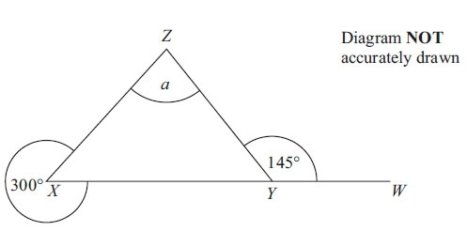
1. XYW is a straight line.
Work out the size of the angle marked a.
You must give reasons for your answer.

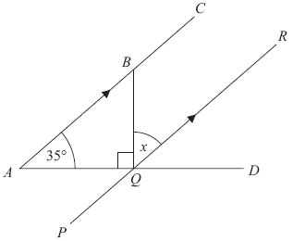
2. ABC, PQR and AQD are straight lines.
ABC is parallel to PQR.
Angle BAQ = 35°
Angle BQA = 90°
Work out the size of the angle marked x.
Give reasons for each stage of your working.

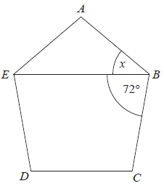
3. Diagram not drawn accurately .
ABCDE is a regular polygon.
EB is a straight line.
Angle EBC = 72°.
Work out the size of the angle marked x.

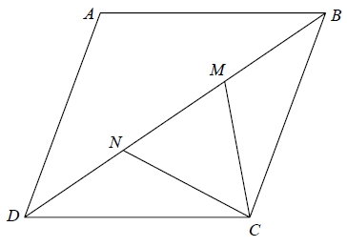
4. ABCD is a rhombus.
M and N are points on BD such that DN = MB.
Prove that triangle DNC is congruent to triangle BMC.

[Glue here]

