Factorising Single Brackets GREEN

Factorise these expressions:

1. $3a+12$ 2. $4b-10$

3. $c^{2}+7c$ 4. $6d-d^{2}$

Fully factorise these expressions:

5. $8f+12$ 6. $18h-6h^{2}$

7. $8k-8$ 8. $5ab+10a$

9. $2w^{2}-w^{3}$ 10. $8x^{2}-12x^{3}$

11. $12ab^{2}+18a^{2}b$ 12. $9x^{3}y^{2}-6x^{4}$

13. $k^{3}+8k^{2}+12k$ 14. $4ab+6b^{2}-2b$

Factorising Single Brackets AMBER

Factorise these expressions:

1. $3a+12$ 2. $4b-10$
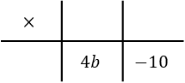
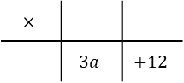

3. $c^{2}+7c$ 4. $6d-d^{2}$

Fully factorise these expressions:

5. $8f+12$ 6. $18h-6h^{2}$

7. $8k-8$ 8. $5ab+10a$

9. $2w^{2}-w^{3}$ 10. $8x^{2}-12x^{3}$

11. $12ab^{2}+18a^{2}b$ 12. $9x^{3}y^{2}-6x^{4}$

13. $k^{3}+8k^{2}+12k$ 14. $4ab+6b^{2}-2b$

Factorising Single Brackets RED

Factorise these expressions:

1. $3a+12$ 2. $4b-10$
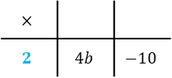
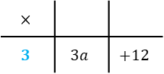

3. $c^{2}+7c$ 4. $6d-d^{2}$

Fully factorise these expressions:

5. $8f+12$ 6. $18h-6h^{2}$
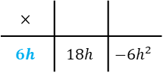
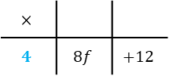

7. $8k-8$ 8. $5ab+10a$

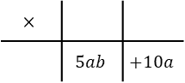
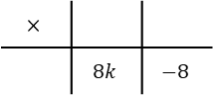

9. $2w^{2}-w^{3}$ 10. $8x^{2}-12x^{3}$

11. $12ab^{2}+18a^{2}b$ 12. $9x^{3}y^{2}-6x^{4}$

13. $k^{3}+8k^{2}+12k$ 14. $4ab+6b^{2}-2b$

