**Measures (F)**

Post-Intervention Assessment

Name: _______________________________

Class: _______________________________

Date: _______________________________

|  |  |  |
| --- | --- | --- |
| **Question** | **Objective** | **RAG** |
| 1 | Convert between metric units |  |
| 2 | Calculate with speed, distance and time |  |
| 3 | Draw and interpret real life graphs |  |
| 4 | Solve problems involving similar lengths, area and volume |  |

**1.** Lily has 3.4 kg of flour. She uses 500 grams of the flour. How much flour does

Lily have left?

...........................................................

**2**. A London airport is 200 miles from Manchester airport.

A plane leaves Manchester airport at 10 am to fly to the London airport.

The plane flies at an average speed of 120 mph.

What time does the plane arrive at the London airport?

..........................................................

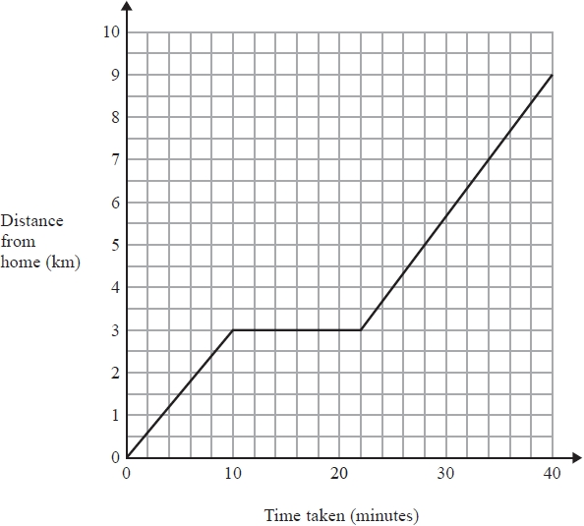**3**. One day Jane cycled from home to college.   
She stopped at a shop on the way to college.

The travel graph shows Jane's journey from home to college.

(a)   Write down the distance from Jane's home to college.

..................................km

(b)   Write down how long Jane stopped at the shop.

...........................................................minutes

**4**. Diagram **NOT** accurately drawn

The two cylinders, A and B, are mathematically similar. The height of cylinder B is twice the height of cylinder A. The total surface area of cylinder A is 180 cm².

Calculate the total surface area of cylinder B.

...........................................................

[Glue here]