Calculations and Accuracy (H)

Pre-Intervention Assessment

Name: _______________________________

Class: _______________________________

Date: _______________________________

Question | Objective | RAG
1 | Round numbers
2 | Estimate answers to calculations
3 | State the limits of accuracy
4 | Calculate with bounds

1. Write 6718 correct to the nearest hundred.

...........................................................

2. A ticket for a seat at a school play costs £2.95
There are 21 rows of seats.
There are 39 seats in each row.
The school will sell all the tickets.
Work out an estimate for the total money the school will get.

£ ……………………………………

3. A pencil has a length of 17 cm measured to the nearest centimetre.
(a) Write down the least possible length of the pencil.

……………………………………
(b) Write down the greatest possible length of the pencil.

…………………………………

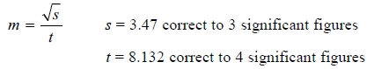
4.

By considering bounds, work out the value of m to a suitable degree of accuracy.
Give a reason for your answer.

[Glue here]

