Bands 1 – 3 Problem Solving – Test 3 Answers

1. | 12 ÷ 3 = 4 cm  4 x 4 = 16 cm | 1 mark for calculating length of one side  1 mark for correct answer | 2
2. | 134 + 125 + 30 = 289  289 ÷ 54 = 5 r 19  6 coaches needed | 1 mark for total number attending  1 mark for 289 ÷ 54  1 mark for correct answer | 3
3. | Girls Boys Total  Chemistry 7 16 23  Biology 21 28 49  Physics 10 18 28  Total 38 62 100  49 students liked biology best | 1 mark for attempt to draw two-way table  1 mark for correctly filling in information from the question  1 mark for correctly filling in gaps  1 mark for correct answer | 4
4. | 12 sides in total  60 ÷ 12 = 5 cm | 1 mark for identifying number of sides  1 mark for 60 ÷ 12  1 mark for correct answer | 3
5. | $\left(\frac{20+80}{2},\frac{15+45}{2}\right)$ = (50, 30) | 1 mark for $\frac{20+80}{2}$ or $\frac{15+45}{2}$  1 mark for correct answer | 2

6. | 200 cm² ÷ 8 squares = 25 cm² each  √25 = 5 cm side  18 x 5 cm = 90 cm | 1 mark for calculating area of one square  1 mark for calculating length of side  1 mark for 18 x 5  1 mark for correct answer | 4
7. | 80305 – 79721 = 584 units used  584 – 70 = 514  70 x 20p = 1400p  514 x 10p = 5140p  1400 + 5140 = 6540 = £65.40 | 1 mark for calculating units used  1 mark for 70 x 20  1 mark for 514 x 10  1 mark for correct answer in pounds | 4
8. | 17 15 $\vec{delay}$ 18 30 $\vec{flight}$ 21 20 $\vec{time difference}$ 22 20  2/3 of 228 = 2 x 76 = 152 | 1 mark for delay  1 mark for flight  1 mark for time difference  1 mark for 228 ÷ 3  1 mark for 2 x 76  1 mark for correct answer | 6

9. | 2x + x = 135  3x = 135  x = 45 cm  or  1 : 2  135 ÷ 3 = 45 cm  or  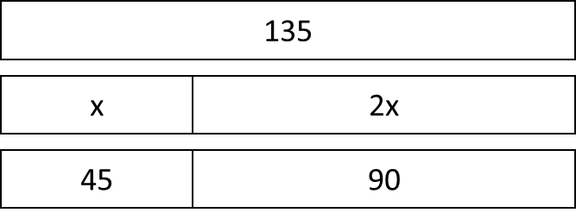 | 1 mark for expression, ratio or diagram  1 mark for 135 ÷ 3 (written or otherwise)  1 mark for correct answer
10. | Shop A 270 ÷ 9 = 30 packs Pay for 15 15 x £1.80 = £27.00 Shop B 270 ÷ 18 = 15 packs Pay for 10 10 x £2.50 = £25.00 Shop C 270 ÷ 27 = 10 packs Pay for 10 10 x £2.60 = £26.00  Shop B is cheapest | 1 mark for each price calculation  1 mark for correct answer | 4

11. | 5.7 ÷ 0.53 = 10.75 11 rolls across width  11 x 2.8 = 30.8 m needed  30.8 ÷ 21 = 2.56 3 rolls needed  3 x £12.45 = £37.35 | 1 mark for rolls across width  1 mark total length needed  1 mark for number of rolls needed  1 mark for 3 x £12.45  1 mark for correct answer | 5
12. | T-shirts R Us Pay for 3/5 of T-shirts 18 x £12 = £216 10% of £216 = £21.60 20% of £216 = £43.20 £216 - £43.20 = £172.80 Budget T-shirt Company 30 x £12 = £360 £360 ÷ 2 = £180  T-shirts R Us is cheapest | 1 mark for 18 x £12 or £216 seen  1 mark for 10% or 20% of £216  1 mark for £172.80 seen  1 mark for £180 seen  1 mark for correct answer | 5
13. | 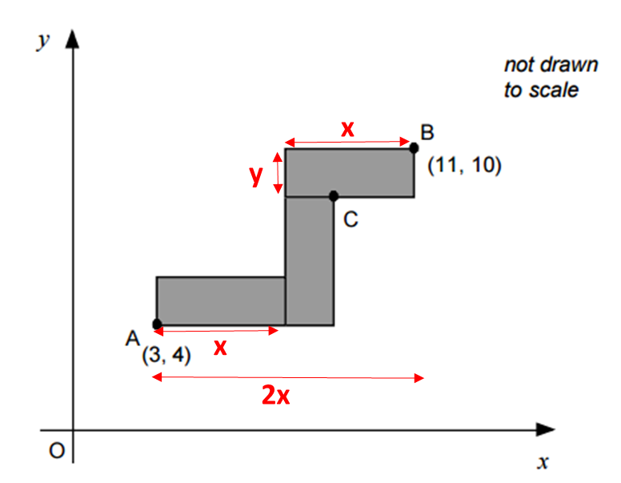  2x = 11 – 3 = 8  x = 4  x + y = 10 – 4 = 6  y = 2  Length = 4, width = 2  C = (9, 8) | 1 mark for identifying 2x = 8 oe  1 mark for x = 4 oe  1 mark for x + y = 6 oe  1 mark for y = 2  1 mark for correct answer (accept dimensions written on diagram)  1 mark for x coordinate  1 mark for y coordinate | 7

