Factorising Non-Monic Quadratics GREEN

Question | Working | Answer
$$4x²-19x+12$$

$$2x²+x-6$$

$$4x²-15x+9$$

$$4x²+7x+3$$

$$6x²+19x+10$$

$$2x²-x-21$$

$$10x²-11x+3$$

$$2x²-10x-28$$

Factorising Non-Monic Quadratics AMBER

Question | Working | Answer
$$4x²-19x+12$$  $$48$$ | 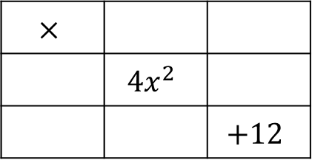
$$2x²+x-6$$
$$-12$$
$$4x²-15x+9$$
$$36$$
$$4x²+7x+3$$

$$6x²+19x+10$$

$$2x²-x-21$$

$$10x²-11x+3$$

$$2x²-10x-28$$

Factorising Non-Monic Quadratics RED

Question | Working | Answer
$$4x²-19x+12$$  $$48$$ | Factor pairs of 48:  1&48, 2&24, 3&___,  4&___,
$$2x²+x-6$$  $$-12$$ | 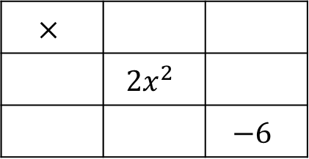  Factor pairs of 12:  1&___, 2&___,
$$4x²-15x+9$$  $$36$$ | 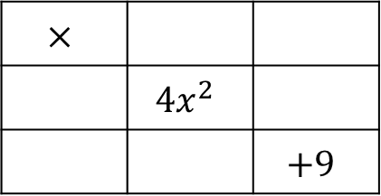  Factor pairs of 9:
$$4x²+7x+3$$

$$6x²+19x+10$$

$$2x²-x-21$$

$$10x²-11x+3$$

$$2x²-10x-28$$

