Cosine Rule GREEN

Use the cosine rule to find side x in each of the following triangles

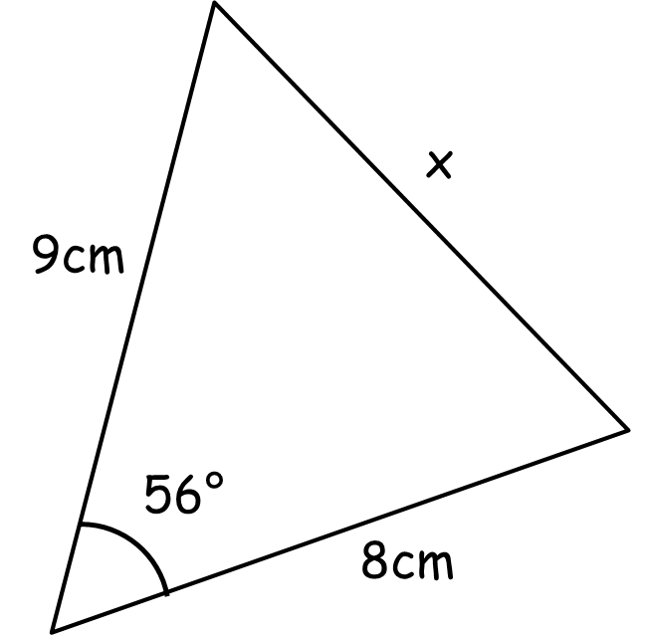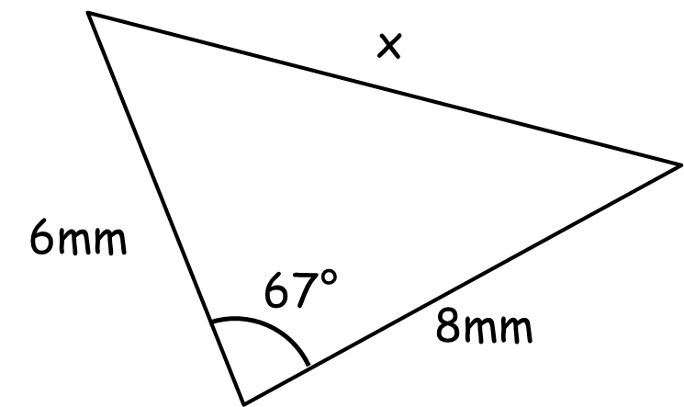

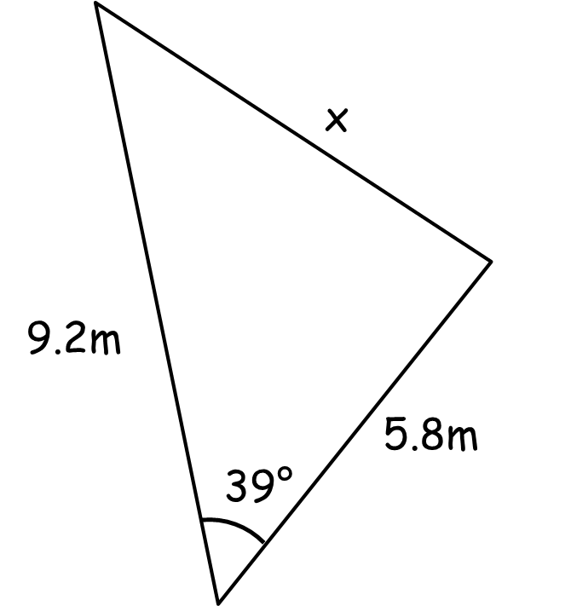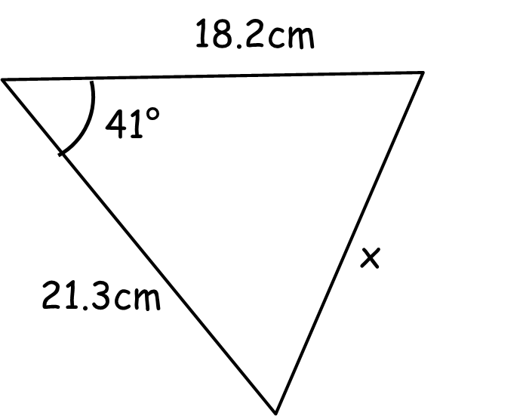

Use the cosine rule to find angle X in each of the following triangles

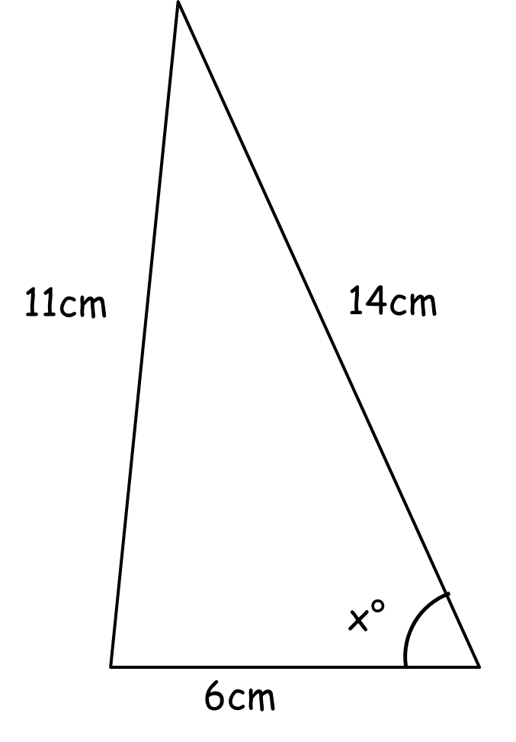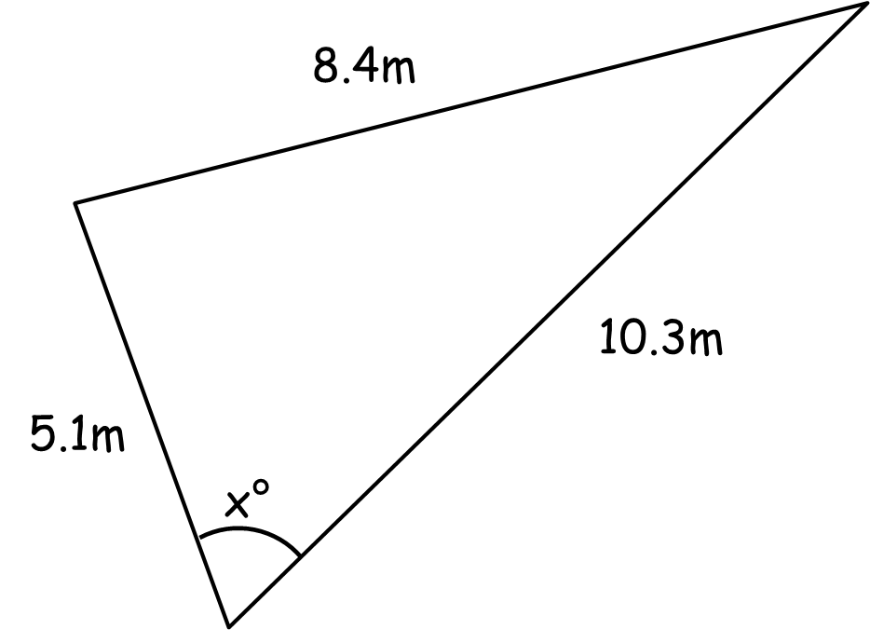

Cosine Rule AMBER

Use the cosine rule to find side x in each of the following triangles

a² = b² + c² - 2bc cosA

Use the cosine rule to find angle X in each of the following triangles

cosA = b² + c² - a²
2bc

Cosine Rule RED

Use the cosine rule to find side x in each of the following triangles

a² = b² + c² - 2bc cosA

x² = 9² + 8² - (2)(9)(8) cos56

= 81 + 64 – 144 cos56

x =

Use the cosine rule to find angle X in each of the following triangles

cosA = b² + c² - a²
2bc

cosA = 6² + 14² - 11²
(2)(6)(14)

= 111
168

A = cos⁻¹ ($\frac{111}{168}$) =

