Bands 5 – 7 Problem Solving – Test 1 Answers

1. | Length scale factor = 165 ÷ 133 = 1.24  Width scale factor = 82 ÷ 72 = 1.14  The two are not similar because their scale factors for length and width differ | 1 mark for length scale factor  1 mark for width scale factor  1 mark for correct conclusion | 3
2. | 3 x 1.7 x 10⁻²⁹ x 10²⁸  = 5.4 x 10⁻¹  = 0.54 kg | 1 mark for multiplying  1 mark for 5.4 x 10⁻¹  1 mark for correct answer | 3
3. | $\frac{5}{40}$ fish are tagged  $\frac{5}{40}$ = $\frac{40}{320}$  320 fish | 1 mark for $\frac{5}{40}$ seen  1 mark for an equivalent fraction seen  1 mark for correct answer | 3
4. | x(x + 6) = (x + 3)(x + 1)  x² + 6x = x² + x + 3x + 3  2x = 3  x = 1.5 | 1 mark for at least 1 area written  1 mark for equation set up for x  1 mark for brackets correctly expanded  1 mark for correct answer | 4
5. |  | 1 mark for 4 m from C  1 mark for 10 m from C  1 mark for 14 m from house  1 mark for correct region shaded | 4
6. | First car (x 0.9) Second car (- 800)  Week 0 10 000 10 000  Week 1 9000 9200  Week 2 8100 8400  Week 3 7290 7600  Week 4 6561 6800  Week 5 5904.90 6000  Week 6 5314.41 5200  Week 7 4782.97 4400  Week 8 4304.67 3600  After 6 weeks | 1 mark for x 0.9 seen  1 mark for at least 3 calculations for first car  1 mark for at least 3 calculations for second car  1 mark for correct answer | 4

7. | Distance (d m) Ben’s frequency M x f  6.5 ≤ d < 7.0 3 20.25  7.0 ≤ d < 7.5 7 50.75  7.5 ≤ d < 8.0 25 193.75  8.0 ≤ d < 8.5 1 8.25  8.5 ≤ d < 9.0 0 0  273 ÷ 36 = 7.583 m  Distance (d m) Jamie’s frequency M x f  6.5 ≤ d < 7.0 8 54  7.0 ≤ d < 7.5 18 130.5  7.5 ≤ d < 8.0 21 162.75  8.0 ≤ d < 8.5 3 24.75  8.5 ≤ d < 9.0 1 8.75  380.75 ÷ 51 = 7.466 m  Ben has a better chance of beating the champion as his mean is higher, despite Jamie having had more practice. | 1 mark for m x f calculated  1 mark for 273 ÷ 36  1 mark for Ben’s mean  1 mark for m x f calculated  1 mark for 380.75 ÷ 51  1 mark for Jamie’s mean  1 mark for correct conclusion | 7

8. | y = -½x + c  0 = -½ x -4 + c  c = -2  y = -½x - 2 | 1 mark for gradient –½  1 mark for substituting gradient and (-4, 0) into y = mx + c  1 mark for y-intercept calculated  1 mark for correct answer | 4
9. | 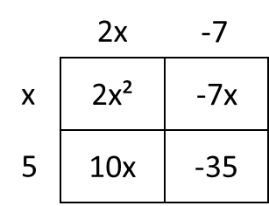  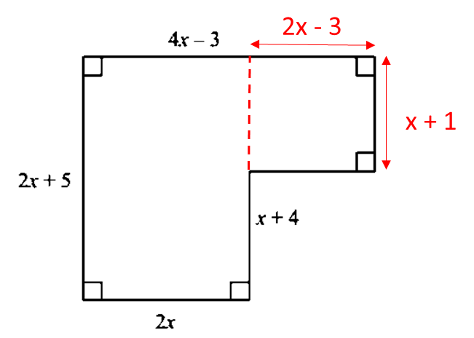  2x(2x + 5) + (2x – 3)(x + 1) = 102  4x² + 10x + 2x² - 3x + 2x – 3 – 102 = 0  6x² + 9x – 105 = 0  2x² + 3x – 35 = 0  (2x – 7)(x + 5) = 0  x = 3.5 or -5 (cannot be -5 as negative length does not make sense)  2 x 3.5 + 5 = 12 cm | 1 mark for equation set up for area of hexagon = 102  1 mark for rearranged to equal 0  1 mark for factorisation  1 mark for x values found  1 mark for 3.5 chosen  1 mark for correct answer | 6

10. | 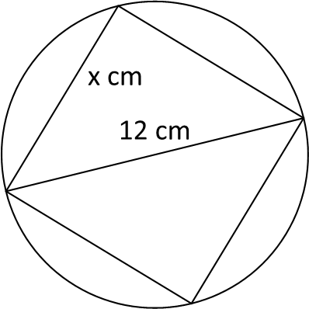  12² = 144  $\sqrt{144 ÷2}$ = $\sqrt{72}$ = 8.4852… = 8.49 cm | 1 mark for 12²  1 mark for dividing by 2 (equal sides)  1 mark for √  1 mark for 8 seen  1 mark for correct answer | 5
11. | PQ = $\left(\begin{matrix}3 \\ 3\end{matrix}\right)$ = 3$\left(\begin{matrix}1 \\ 1\end{matrix}\right)$  QR = $\left(\begin{matrix}6 \\ 6\end{matrix}\right)$ = 6$\left(\begin{matrix}1 \\ 1\end{matrix}\right)$  PR = $\left(\begin{matrix}9 \\ 9\end{matrix}\right)$ = 9$\left(\begin{matrix}1 \\ 1\end{matrix}\right)$  As the vector $\left(\begin{matrix}1 \\ 1\end{matrix}\right)$ is a factor of both (all) vectors therefore are parallel  Both share a point therefore collinear | 2 marks for any 2 of the vectors  2 marks for any 2 of the vectors factorised  1 mark for parallel conclusion  1 mark for collinear conclusion | 6

