Describing Rotations

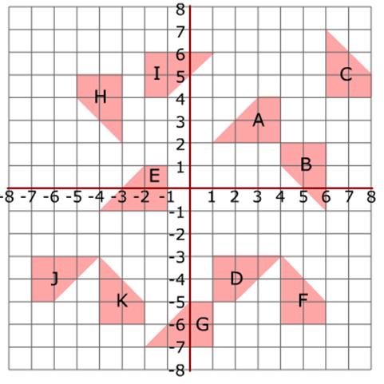

Describe fully the transformation which maps:

Rotation | 90º or 180º | Clockwise or anticlockwise | Centre of rotation
A to B
B to C
C to D
D to E
E to F
F to G
G to H
H to I
I to A

