Maths Problem Solving Starters

Levels 4 – 6

Name: ______________________________

Class: ______________________________

Teacher: ______________________________

Remember:
- You will need: pen, pencil, rubber and a ruler.
- Check your work carefully.
- Show all of your working out, with clear steps.

Formulae Sheet
Perimeter, area, surface area and volume formulae
Sphere | Cone
Volume = $\frac{4}{3}$ πr³  Surface Area = 4πr² | Volume = $\frac{1}{3}$ πr²h  Curved Surface Area = πrl

1. | Fill in the gaps:  - (x + 2)(x + ) = x² + x + 6  - (x - )(x + 8) = x² + 5x - | / 8
2. | Enzo makes a table of values and plots the graph of y = x² + 2. Which points on the graph are incorrect?  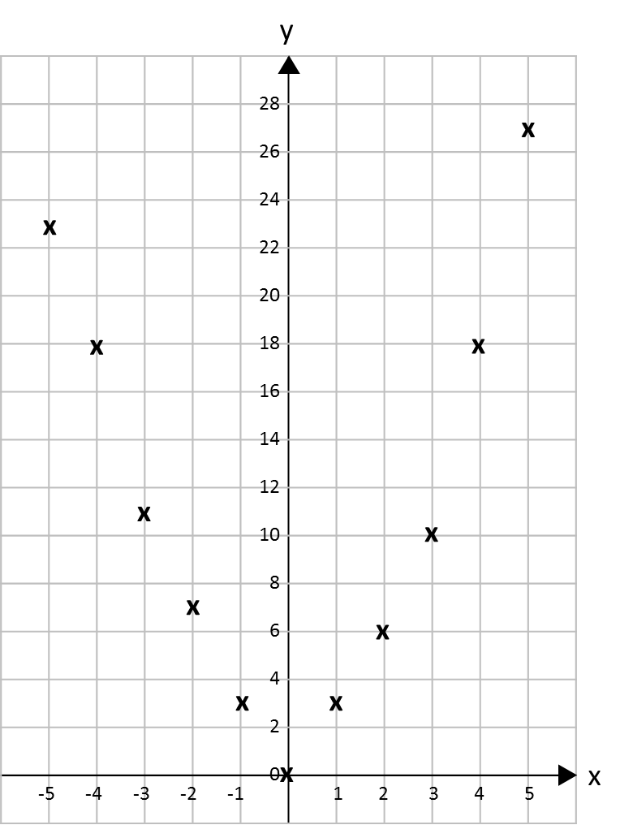 | / 6
3. | A population of ants increases at a rate of 30% per day. At the end of one week there are 3500 insects. How many insects were there at the beginning of the week?  ___________ | / 5
4. | Work out the area of this isosceles triangle. Give your answer correct to 3 significant figures.  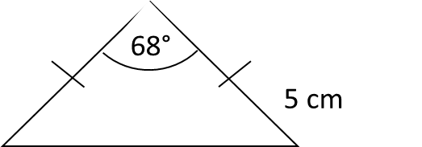  _______________ cm² | / 3
5. | Find the angle of this sector. Give your answer correct to 1 decimal place.  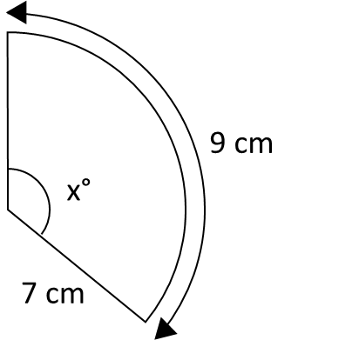  _______________ ° | / 5
6. | The pressure, P, of water on an object (in bars) is directly proportional to its depth, d (in metres). When the object is at a depth of 8 metres, the pressure on the object is 0.8 bars. A diver’s watch has been guaranteed to work at pressures up to 8.5 bars. The diver takes the watch down to 75 m. Will the watch still work? | / 6
7. | Find the coordinates of the point where these two lines meet if they are extended.  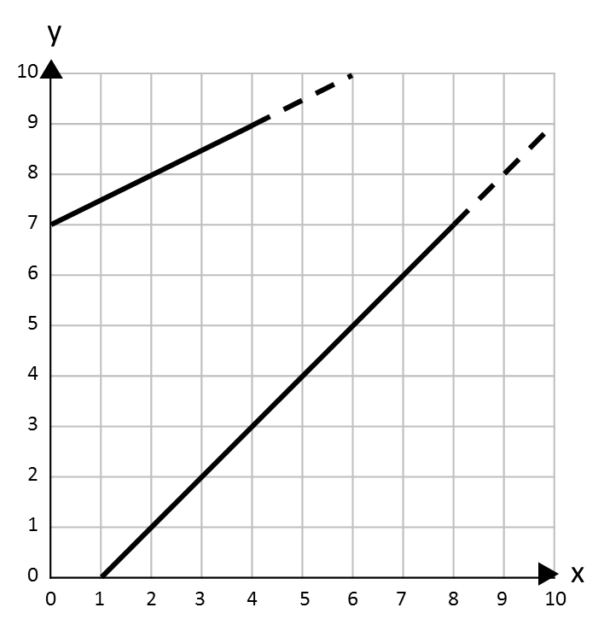  ( ____ , ____ ) | / 7
8. | The rule for a sequence of number pairs is:  (first number, last number)  (first number + last number, first number – last number)  Here is part of a sequence that follows this rule. Write in the missing number pairs.  (____ , ____) (____ , ____) (1, 2) (3, -1) (2, 4) (____ , ____) | / 7
9. | 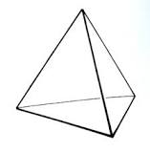  This chocolate box is in the shape of a tetrahedron. Each face is an equilateral triangle with side length 24 cm. Construct an accurate net for the box. Use a scale of 1 cm to 8 cm. | / 6
10. | 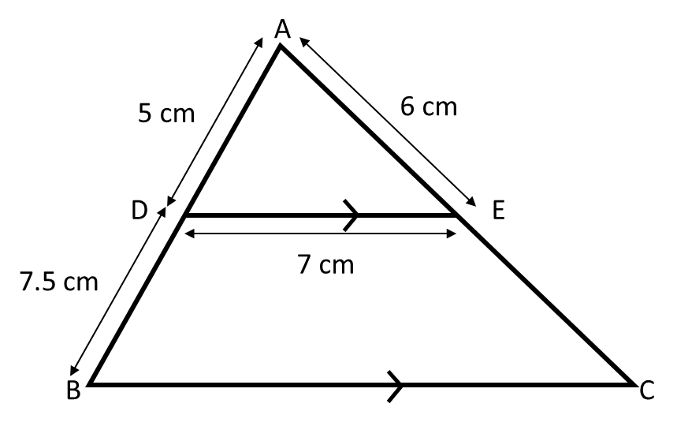  ABC is a triangle. DE and BC are parallel. Calculate the perimeter of trapezium DBCE.  ____________ cm | / 6
11. | 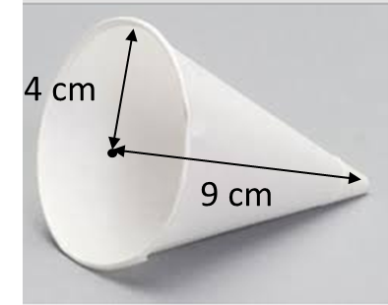  Work out the area of card needed to make this disposable cup. Give your answer correct to 1 decimal place.  _____________ cm² | / 5
12. | There are 5 boxes of cornflakes and 7 boxes of puffed wheat. Mike and Reece both choose a box at random. Work out the probability that they do not choose the same type of cereal.  _____________ | / 5
13. | The distance between Manchester airport and Luton airport is 215 km. The bearing of Luton airport from Manchester airport is 135°. Make an accurate scale map of their locations using a scale of 1 cm to 40 km. | / 3
14. | A telephone company charges £ x per month for a basic line rental and then £ y per 100 minutes. Justin pays £18 for 200 minutes. Teresa pays £21 for 300 minutes. Work out the cost of the monthly rental.  £ ____________ | / 5
15. | Find a quadratic equation that has solutions x = 0 and x = 5  Give your answer without brackets.  ________________________  Find a quadratic equation that has two solutions x = 7  Give your answer without brackets.  ________________________ | / 4
16. | A naturalist captures 30 bats in a cave and tags them. There are approximately 600 bats in the cave. The naturalist returns a month later and captures 40 bats. How many bats would he expect to be tagged?  ______________ | / 3
17. | One sheet of paper is 9 x 10⁻³ cm thick. Mark wants to put 500 sheets of paper in the paper tray of his printer. The paper tray is 4 cm deep. Is the paper tray deep enough for 500 sheets of paper? | / 4
18. | The diagram shows two right-angled triangles ABC and DEB. Find the length of the line AC.  ______________ cm | / 6
19. | An aerial photograph shows a campsite with a swimming pool. In the photograph, the pool measures 5 cm x 2 cm. The real pool in 25 m long. How wide is it?  ________ m | / 3
20. | 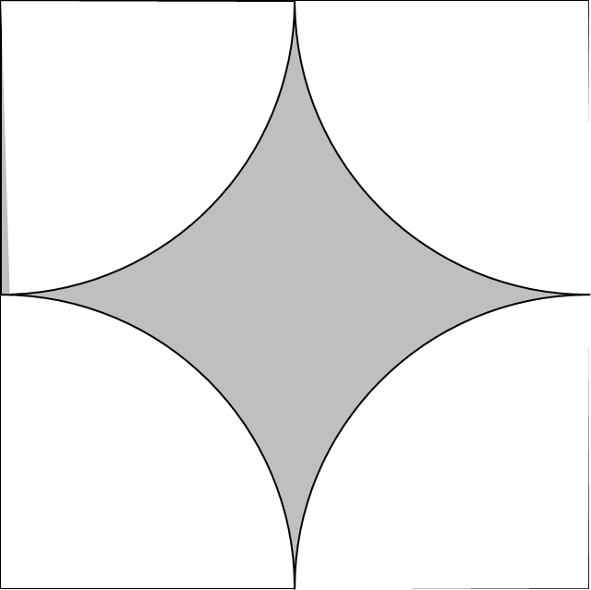  Four quarter circles are cut from a 10 cm square. Work out the shaded area and give your answer correct to 2 decimal places.  __________ cm² | / 5
21. | Will says that ${25}^{{-1}/2}$ x ${64}^{2/3}$ = 80. Show that Will is wrong. | / 5
22. | A roof truss is made of wood. The vertical support bisects the horizontal span. Work out the total length of wood needed to make the truss. Give your answer correct to 1 decimal place.  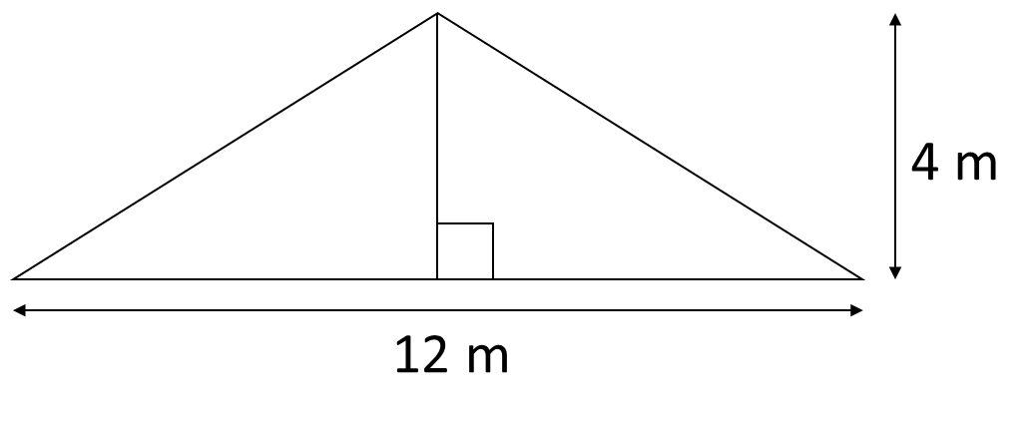  ____________ m | / 4
23. | Two meals and a bottle of wine cost £36. The bottle of wine costs £3 more than a meal. How much do each cost?  Wine: £ __________  Meal: £ __________ | / 6
24. | The lines A and B are parallel. What is the equation of line B?  ________________________ | / 5
25. | 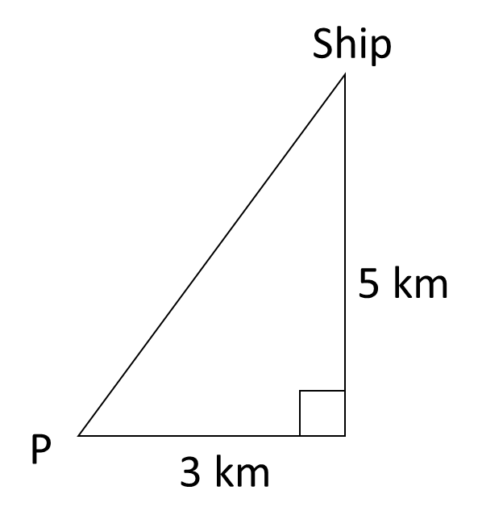  From P, a ship sails 3 km East and 5 km North to its destination. A helicopter flies from P directly to the ship. On what bearing from P should the helicopter fly? Give your answer correct to the nearest degree.  __________° | / 5
26. | In a circuit, the resistance, R ohms, is inversely proportional to the current, I amps. When the resistance is 12 ohms, the current in the circuit is 8 amps. Find the current when the resistance in the circuit is 6.4 ohms.  _______________ amps | / 5
27. | The diagram shows a rectangle EFGH. Length EF is 24 cm. width FG is 3cm. The length of the rectangle decreases by 40% and the width increases by 30%. What is the overall percentage change to the area of the rectangle?  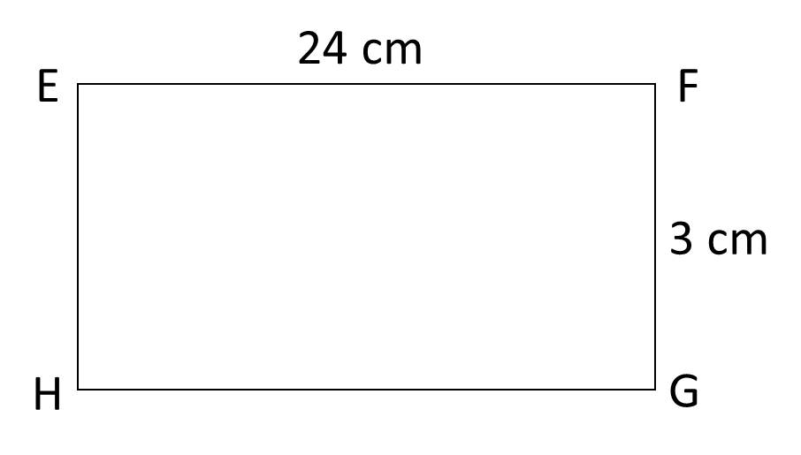  _________ % _______________________ | / 8

