Trigonometric Graphs

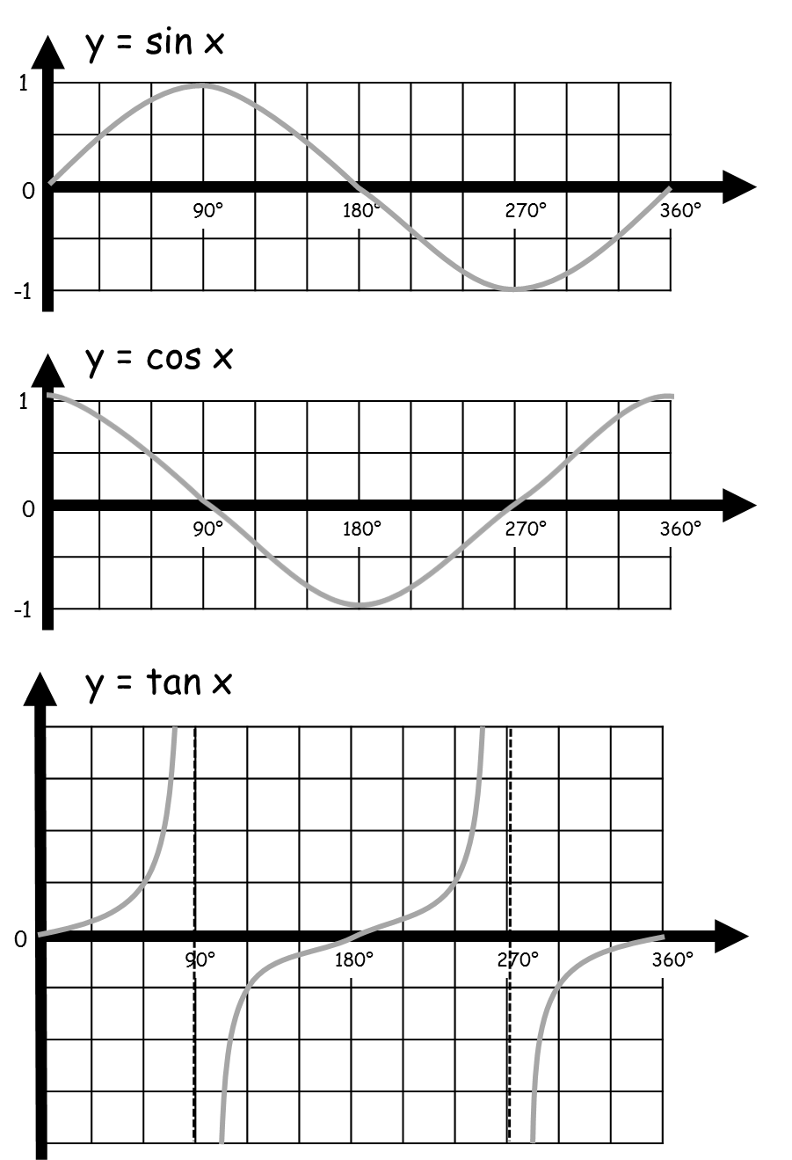
Trigonometric Graphs

