Lines, Angles and Shapes (F)

Post-Intervention Assessment

Name: _______________________________

Class: _______________________________

Date: _______________________________

Question | Objective | RAG
1 | Calculate interior and exterior angles of a regular polygon
2 | Use the conditions for congruent triangles in formal geometrical proofs
3 | Understand the relationship between a radius and a tangent
4 | Apply circle theorems

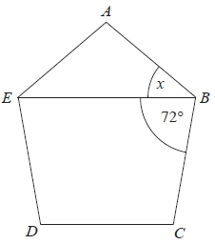
1. Diagram not drawn accurately .
ABCDE is a regular polygon.
EB is a straight line.
Angle EBC = 72°.
Work out the size of the angle marked x.

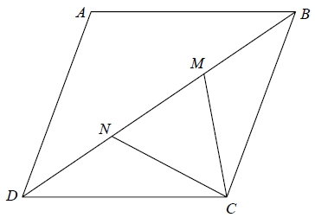
2. ABCD is a rhombus.
M and N are points on BD such that DN = MB.
Prove that triangle DNC is congruent to triangle BMC.

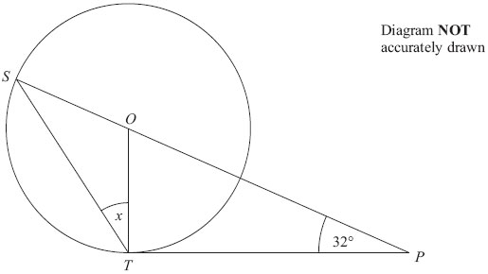
3. S and T are points on the circumference of a circle, centre O.
PT is a tangent to the circle.
SOP is a straight line.
Angle OPT = 32°
Work out the size of the angle marked x.
Give reasons for your answer.

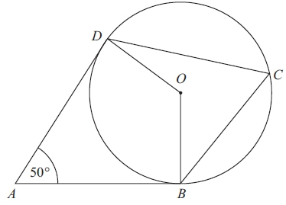
4. Diagram NOT accurately drawn
B, C and D are points on the circumference of a circle, centre O.
AB and AD are tangents to the circle.
Angle DAB = 50°
Work out the size of angle BCD.
Give a reason for each stage in your working.

[Glue here]

