Areas of Sectors and Lengths of Arcs GREEN

Question 1
Calculate the length of arc $AB$ in the sectors below. Give your answers correct to $1$ decimal place.
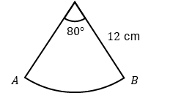  a) | 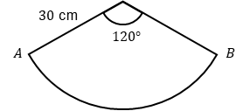  b) | 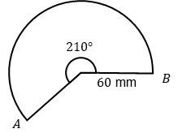  c)
Question 2
Calculate the area of each sector below. Give your answers correct to $1$ decimal place.
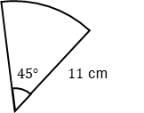  a) | 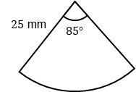  b) | 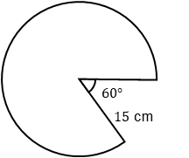  c)

Question 3
In each diagram below the length of arc $AB$ is given. Calculate the size of the angle at the centre of the sector. Give your answer correct to the nearest degree
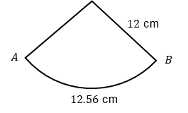  a) | 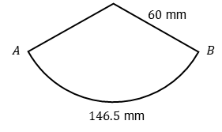  b) | 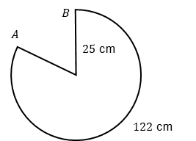  c)
Question 4
In each diagram below the area of the sector is given. Calculate the size of the angle at the centre of the sector. Give your answer correct to the nearest degree
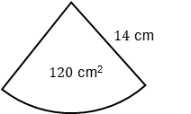  a) | 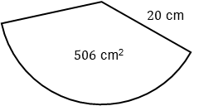  b) | 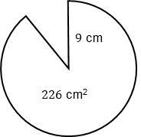  c)

Areas of Sectors and Lengths of Arcs AMBER

Question 1
Calculate the length of arc $AB$ in the sectors below. Give your answers correct to $1$ decimal place.
a)  $AB=\frac{ }{360}×π×_____$ | b) | c)
Question 2
Calculate the area of each sector below. Give your answers correct to $1$ decimal place.
a)  $AB=\frac{ }{360}×π×{_____}^{2}$ | b) | c)

Question 3
In each diagram below the length of arc $AB$ is given. Calculate the size of the angle at the centre of the sector. Give your answer correct to the nearest degree
a)  $12.56=\frac{θ}{360}×π×24$ | b) | c)
Question 4
In each diagram below the area of the sector is given. Calculate the size of the angle at the centre of the sector. Give your answer correct to the nearest degree
a)  $120=\frac{θ}{360}×π×{14}^{2}$ | b) | c)

Areas of Sectors and Lengths of Arcs RED

Question 1
Calculate the length of arc $AB$ in the sectors below. Give your answers correct to $1$ decimal place.
a)  $AB=\frac{80}{360}×π×24$  $=$ | b)  $AB=\frac{ }{360}×π×______$ | c)  $AB=\frac{ }{360}×π×______$
Question 2
Calculate the area of each sector below. Give your answers correct to $1$ decimal place.
a)  $AB=\frac{45}{360}×π×{11}^{2}$ | b)  $AB=\frac{ }{360}×π×{_____}^{2}$ | c)  $AB=\frac{ }{360}×π×{_____}^{2}$

Question 3
In each diagram below the length of arc $AB$ is given. Calculate the size of the angle at the centre of the sector. Give your answer correct to the nearest degree
a)  Solve this equation:  $12.56=\frac{θ}{360}×π×24$ | b) | c)
Question 4
In each diagram below the area of the sector is given. Calculate the size of the angle at the centre of the sector. Give your answer correct to the nearest degree
a)  Solve this equation:  $120=\frac{θ}{360}×π×{14}^{2}$ | b) | c)

