Set Theory Starter
Sort the numbers 1 – 10 into this Venn diagram.
Then write down the numbers in $A∪B'$.
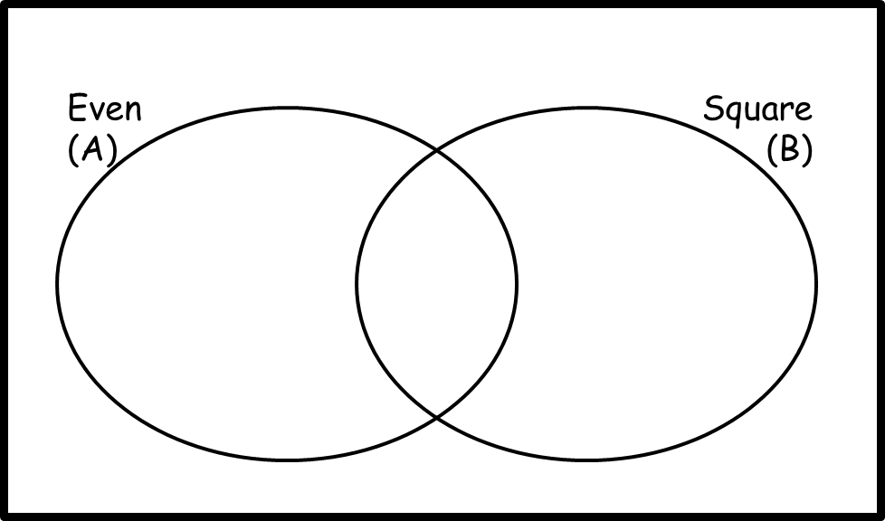

Set Theory Starter
Sort the numbers 1 – 10 into this Venn diagram.
Then write down the numbers in $A∪B'$.
Set Theory Starter
Sort the numbers 1 – 10 into this Venn diagram.
Then write down the numbers in $A∪B'$.

Set Theory Starter
Sort the numbers 1 – 10 into this Venn diagram.
Then write down the numbers in $A∪B'$.

