Measuring Bearings

Use a PROTRACTOR to find the size of the marked bearings.
Remember to measure CLOCKWISE from NORTH and give your answers 3 DIGITS.
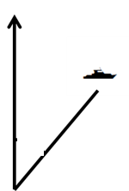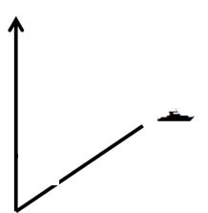

Bearing: _____ Bearing: _____ Bearing: _____

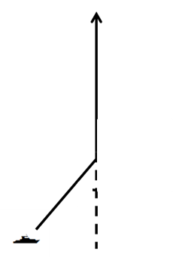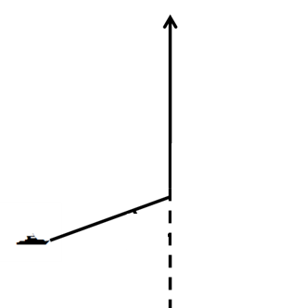

Bearing: _____ Bearing: _____ Bearing: _____

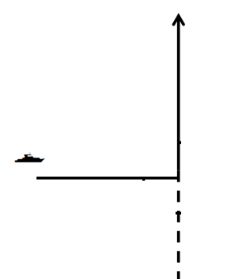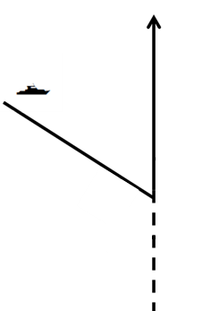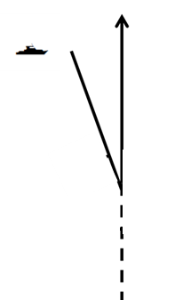

Bearing: _____ Bearing: _____ Bearing: ____

