Volume of Prisms Thoughts and Crosses

Calculate the volumes of 4 of the prisms in a row, either vertically, horizontally or diagonally.

 | a) | b) | c) | 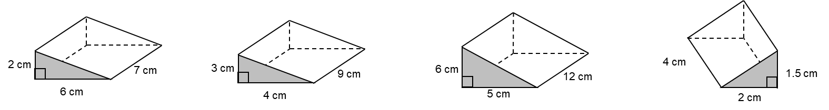  d)
 | a) | b) | c) | 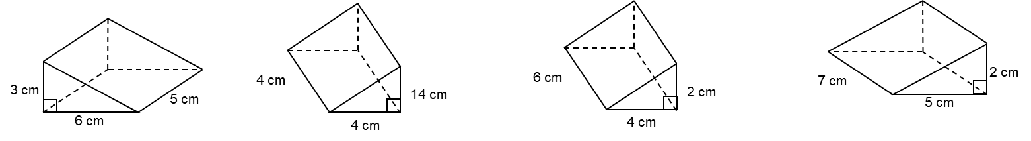  d)
 | a) | b) | c) | 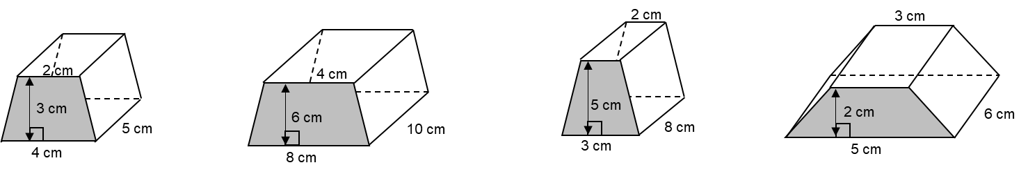  d)
 | a) | 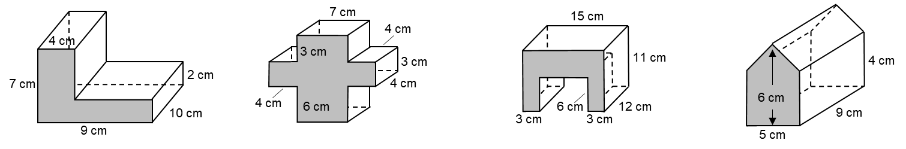  b) | c) | d)

