Money Calculations GREEN
Q1.
Edwin goes to a restaurant with some friends. Here are the meals they have:
2 fish and chips at £9.25 each
1 chicken and chips at £9.50
1 roast lamb at £10.55
4 puddings at £4.55 each.
Edwin pays for the meals with three £20 notes. How much change should Edwin get?

£______________________
(Total for Question is 3 marks)
Q2.
Sarah wants a music magazine each month for a year. She can
pay £3.50 each month
or
pay £37.20 for the year.
Sarah pays £37.20 for the year. How much cheaper is this than paying £3.50 each month?

£______________________
(Total for Question is 3 marks)

Q3.
The table shows information about the cost of hiring a cement mixer from two companies.
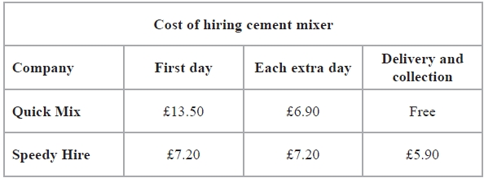
Chris wants to hire a cement mixer for 5 days. He will hire the cement mixer from either Quick Mix or Speedy Hire. Chris wants to pay the least amount of money. Which company should he choose? You must show all your working.

(Total for Question is 4 marks)
Q4.
The price list shows the normal price of some items in a catalogue.
Normal price
Bubble bath £3.00
Shower gel £2.95
Soap £2.50
Hand cream £3.50
There is a special offer. Joanna can buy any 3 different items from the list for a total price of £5. Work out the most money she can save.

£______________________
(Total for Question is 3 marks)

Q5.
Becky wants to buy a table and six chairs. Three shops sell the same types of tables and chairs.
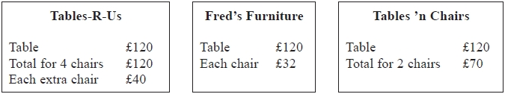
Becky wants to buy the table and six chairs from the same shop. She wants to pay the lowest total price. Which shop should Becky buy the table and six chairs from? You must show all your working.
(Total for Question is 4 marks)
Q6.
Miss Martins is organising a school play. The total cost of putting on the play is £960. The school pays £300 of this cost.
Miss Martins sells tickets to pay the rest of the cost. Miss Martins sells 500 tickets. Each ticket costs £4.
Miss Martins has enough money to pay the rest of the costs and to give all the money left over to charity. Work out how much money Miss Martins gives to charity.

£______________________
(Total for Question is 4 marks)

Q7.
Sandeep and her 3 friends are going shopping in town. Sandeep finds out these costs of getting to town.
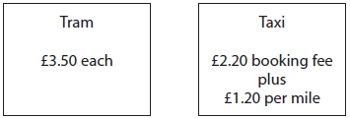
The journey to town is 10 miles. Is it cheaper for all 4 people to go to town by tram or to go to town by taxi? You must show your working.

(Total for question is 4 marks)
Q8.
Jo buys
120 bunches of daffodils for a total of £80
and 80 bunches of tulips for a total of £50
Jo then sells the flowers in a market.
In the morning, Jo sells
75 bunches of the daffodils for 80p a bunch
and 50 bunches of the tulips for 90p a bunch.
In the afternoon, Jo sells all the bunches of flowers she has left for 20p a bunch.
Does Jo make a profit? You must show all your working.

(Total for question is 4 marks)

Money Calculations AMBER
Q1.
Edwin goes to a restaurant with some friends. Here are the meals they have:
2 fish and chips at £9.25 each
1 chicken and chips at £9.50
1 roast lamb at £10.55
4 puddings at £4.55 each.
Edwin pays for the meals with three £20 notes. How much change should Edwin get?

£______________________
(Total for Question is 3 marks)
Q2.
Sarah wants a music magazine each month for a year. She can
pay £3.50 each month
or
pay £37.20 for the year.
Sarah pays £37.20 for the year. How much cheaper is this than paying £3.50 each month?

£______________________
(Total for Question is 3 marks)

Q3.
The table shows information about the cost of hiring a cement mixer from two companies.
Chris wants to hire a cement mixer for 5 days. He will hire the cement mixer from either Quick Mix or Speedy Hire. Chris wants to pay the least amount of money. Which company should he choose? You must show all your working.

(Total for Question is 4 marks)
Q4.
The price list shows the normal price of some items in a catalogue.
Normal price
Bubble bath £3.00
Shower gel £2.95
Soap £2.50
Hand cream £3.50
There is a special offer. Joanna can buy any 3 different items from the list for a total price of £5. Work out the most money she can save.

£______________________
(Total for Question is 3 marks)

Q5.
Becky wants to buy a table and six chairs. Three shops sell the same types of tables and chairs.
Becky wants to buy the table and six chairs from the same shop. She wants to pay the lowest total price. Which shop should Becky buy the table and six chairs from? You must show all your working.
(Total for Question is 4 marks)
Q6.
Miss Martins is organising a school play. The total cost of putting on the play is £960. The school pays £300 of this cost.
Miss Martins sells tickets to pay the rest of the cost. Miss Martins sells 500 tickets. Each ticket costs £4.
Miss Martins has enough money to pay the rest of the costs and to give all the money left over to charity. Work out how much money Miss Martins gives to charity.

£______________________
(Total for Question is 4 marks)

Q7.
Sandeep and her 3 friends are going shopping in town. Sandeep finds out these costs of getting to town.
The journey to town is 10 miles. Is it cheaper for all 4 people to go to town by tram or to go to town by taxi? You must show your working.

(Total for question is 4 marks)
Q8.
Jo buys
120 bunches of daffodils for a total of £80
and 80 bunches of tulips for a total of £50
Jo then sells the flowers in a market.
In the morning, Jo sells
75 bunches of the daffodils for 80p a bunch
and 50 bunches of the tulips for 90p a bunch.
In the afternoon, Jo sells all the bunches of flowers she has left for 20p a bunch.
Does Jo make a profit? You must show all your working.

(Total for question is 4 marks)

Money Calculations RED
Q1.
Edwin goes to a restaurant with some friends. Here are the meals they have:
2 fish and chips at £9.25 each
1 chicken and chips at £9.50
1 roast lamb at £10.55
4 puddings at £4.55 each.
Work out the total cost and subtract it from £60. Line up your columns to make adding and subtracting easier.
Edwin pays for the meals with three £20 notes. How much change should Edwin get?

£______________________
(Total for Question is 3 marks)
Q2.
Sarah wants a music magazine each month for a year. She can
pay £3.50 each month
or
pay £37.20 for the year.
There are 12 months in a year!
Sarah pays £37.20 for the year. How much cheaper is this than paying £3.50 each month?

£______________________
(Total for Question is 3 marks)

Q3.
The table shows information about the cost of hiring a cement mixer from two companies.
There are four “extra days” on top of the “first day”. Don’t forget to add on the delivery/collection fee.
Chris wants to hire a cement mixer for 5 days. He will hire the cement mixer from either Quick Mix or Speedy Hire. Chris wants to pay the least amount of money. Which company should he choose? You must show all your working.

(Total for Question is 4 marks)
Q4.
The price list shows the normal price of some items in a catalogue.
Normal price
Bubble bath £3.00
Shower gel £2.95
Soap £2.50
Hand cream £3.50
There is a special offer. Joanna can buy any 3 different items from the list for a total price of £5. Work out the most money she can save.

£______________________
(Total for Question is 3 marks)

Q5.
Becky wants to buy a table and six chairs. Three shops sell the same types of tables and chairs.
Becky wants to buy the table and six chairs from the same shop. She wants to pay the lowest total price. Which shop should Becky buy the table and six chairs from? You must show all your working.
(Total for Question is 4 marks)
Q6.
Miss Martins is organising a school play. The total cost of putting on the play is £960. The school pays £300 of this cost.
Miss Martins sells tickets to pay the rest of the cost. Miss Martins sells 500 tickets. Each ticket costs £4.
Miss Martins has enough money to pay the rest of the costs and to give all the money left over to charity. Work out how much money Miss Martins gives to charity.

£______________________
(Total for Question is 4 marks)

Q7.
Sandeep and her 3 friends are going shopping in town. Sandeep finds out these costs of getting to town.
The journey to town is 10 miles. Is it cheaper for all 4 people to go to town by tram or to go to town by taxi? You must show your working.

(Total for question is 4 marks)
Q8.
Jo buys
120 bunches of daffodils for a total of £80
and 80 bunches of tulips for a total of £50
Jo then sells the flowers in a market.
In the morning, Jo sells
75 bunches of the daffodils for 80p a bunch
and 50 bunches of the tulips for 90p a bunch.
In the afternoon, Jo sells all the bunches of flowers she has left for 20p a bunch.
Does Jo make a profit? You must show all your working.

(Total for question is 4 marks)

