Construction and Loci

Intervention Booklet

Name: _______________________________

Class: _______________________________

Useful websites:

www.mathswatchvle.com
(Video explanations and questions)
Centre ID: twgash
Username: firstname
Password: lastname

www.methodmaths.com
(Past papers online that get instantly marked)
Centre ID: wga
Username: firstname
Password: lastname

www.hegartymaths.com
(Online tutorials and quizzes)
Login: first name and last name are backwards and case sensitive

www.bbc.co.uk/schools/gcsebitesize/maths

Bearings

Things to remember:
- Always measure bearing clockwise from the North line and give your answer 3 digits.
- If the diagram is drawn accurately, use the given scale.
- If the diagram is not drawn accurately, use the fact that the North lines are all parallel.

Questions:
1. Martin and Janet are in an orienteering race.
Martin runs from checkpoint A to checkpoint B, on a bearing of 065°
Janet is going to run from checkpoint B to checkpoint A.
Work out the bearing of A from B.

........................................................... °
(Total for question = 2 marks)

2. The bearing of a ship from a lighthouse is 050°
Work out the bearing of the lighthouse from the ship.

........................................................... °
(Total for Question is 2 marks)

3. The map shows the positions of three places A, B and C on the edge of a lake.
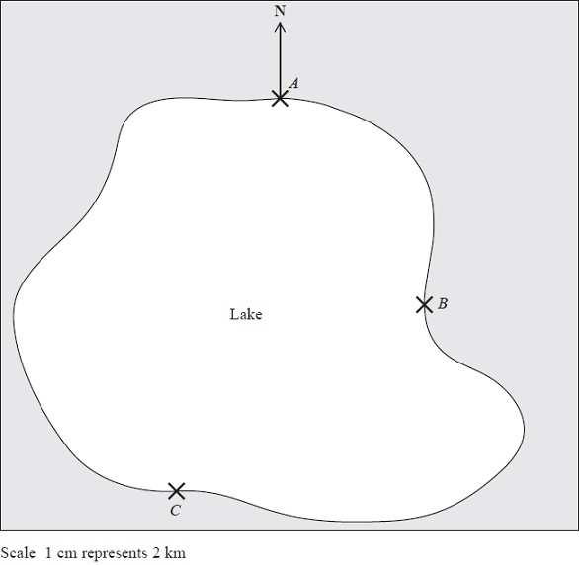
(a) Find the bearing of B from A.
........................................................... °
(1)
A ferry travels in a straight line from A to B.
It then travels in a straight line from B to C.
A speedboat travels in a straight line from A to C.
(b) How many more kilometres does the ferry travel than the speedboat?
You must show your working.

........................................................... km
(4)
(Total for Question is 5 marks)
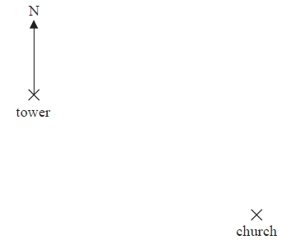
4. The diagram shows part of a map.

(a) Find the bearing of the church
from the tower.

........................................................... °
(1)
The scale of the map is 1 cm represents
2.5 km.
(b) Work out the real distance
between the tower and the
church.
........................................................... km
(2)
A school is 15 km due North of the church.
(c) On the diagram, mark with a cross (×) the position of the school. Label your cross S.
(2)
(Total for Question is 5 marks)

5. The scale diagram shows the positions of two towns, A and B.
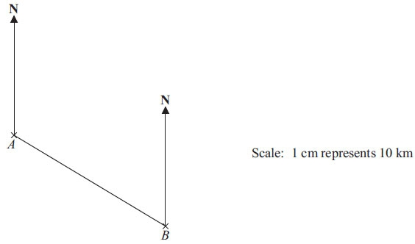

(a) Measure and write down the bearing of town B from town A.
........................................................... °
(1)
(b) What is the real distance from town A to town B?
Give your answer in km.

........................................................... km
(3)
(Total for Question is 4 marks)
Scale Drawing

Things to remember:
- The real-life object/image is n times bigger than the scale drawing for any scale 1 : n.
- To calculate the size in real-life, multiply by n.
- To calculate the size on the scale drawing, divide by n.
- Look out for differing units!

Questions:
1. The length of a car is 3.6 metres.
Karl makes a scale model of the car.
He uses a scale of 1 cm to 30 cm.
Work out the length of the scale model of the car.
Give your answer in centimetres.
……………………………… cm
(Total for question is 2 marks)

2. Here is a scale drawing of a car park.
Scale: 1 cm represents 2 m

There must be at least 5 m between rows of parking bays to enable cars to go in and out.
Stuart wants there to be 20 parking bays.
Is this possible?
You must show how you got your answer.

(Total for question = 3 marks)
3. The diagram shows the positions of White Tor and Gilly Tor on a map.

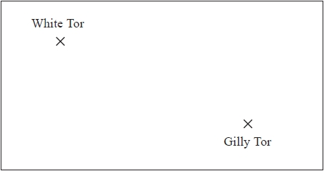

The scale of the map is 1 centimetre represents 2.5 kilometres.
Work out the real distance between White Tor and Gilly Tor.
……………………………… kilometres
(Total for question = 2 marks)

4. The scale diagram shows part of the plan of a classroom.
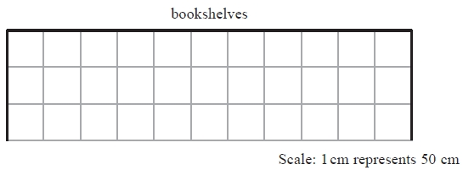
Mr Khan wants to put bookshelves along the complete length of the wall labelled "bookshelves".
There are two sizes of bookshelves.
Large bookshelves are 150 cm wide.
Small bookshelves are 100 cm wide.
(i) Work out how many large bookshelves and how many small bookshelves Mr Khan
can put along the complete length of the wall.
……………………………… large
……………………………… small
Both the large bookshelves and the small bookshelves are 50 cm from front to back.
(ii) Draw these bookshelves on the scale drawing to show how they will fit.

(Total for question = 4 marks)

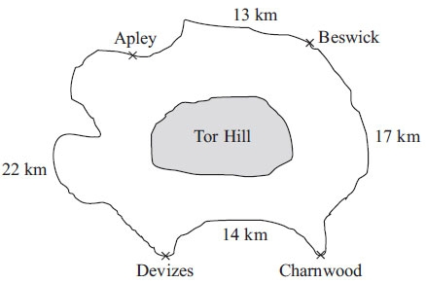
5. The diagram shows the distance
between four towns.

Diagram NOT accurately drawn
Sanjay drives from Apley to Beswick then to Charnwood then to Devizes.
He then drives back to Apley.
(a) Work out the total distance
Sanjay drives.

……………………………… km
(2)
It is further from Apley to Charnwood through Devizes, than
from Apley to Charnwood through Beswick.
(b) How much further?

……………………………… km
(3)
Sanjay runs in a race from Beswick to Charnwood.
There is a water point every kilometre.
The first water point is at Beswick.
The last water point is at Charnwood.
(c) Work out the number of water points.

………………………………
(2)
(Total for Question is 7 marks)

6. The diagram shows two places on a map.

The scale of the map is 1 centimetre represents 2 kilometres.
What is the real distance, in kilometres, from the hill to the tower?

……………………………… kilometres
(Total for Question is 2 marks)

Constructing Triangles

Things to remember:
- If you are given angles, you can use a protractor.
- If you are not given angles, you will need to use compasses.

Questions:
1. In the space below, use ruler and compasses to construct an equilateral triangle
with sides of length 8 cm.
You must show all your construction lines.
One side of the triangle has already been drawn for you.

(Total for Question is 2 marks)

2. In the space below, use a ruler and compasses to construct an equilateral triangle with sides of length 5 cm.
You must show all your construction lines.
One side of the triangle has been drawn for you.

(Total for question = 2 marks)

3. Here is a triangle.
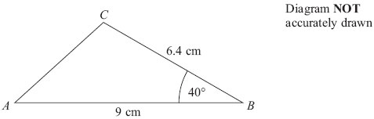
Make an accurate drawing of triangle ABC.
The line AB has already been drawn for you.

(Total for Question is 2 marks)

Loci and Construction

Things to remember:
- The question will always say “use ruler and compasses” – if you don’t you will lose marks.
- Sometimes there are marks for drawing something that is almost right, so always have a guess if you can’t remember.
- Bisector means “cut in half”

Questions:
1.
Use ruler and compasses to construct the perpendicular bisector of the line segment AB.
You must show all your construction lines.
(Total for question = 2 marks)

2. The diagram shows the plan of a park.
Scale: 1 cm represents 100 m
A fountain in the park is equidistant from A and from C. The fountain is exactly 700 m from D.
On the diagram, mark the position of the fountain with a cross (×).
(Total for question = 3 marks)

3. Here is a scale drawing of an office.
The scale is 1 cm to 2 metres.
A photocopier is going to be put in the office.
The photocopier has to be closer to B than it is to A.
The photocopier also has to be less than 8 metres from C.
Show, by shading, the region where the photocopier can be put.
(Total for question = 3 marks)

4. Use ruler and compasses to construct the perpendicular from point C to the line AB.
You must show all your construction lines.
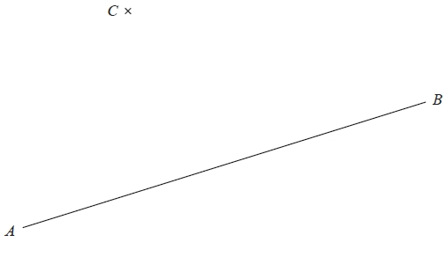
(Total for Question is 2 marks)
5. The diagram shows a scale drawing of a garden.
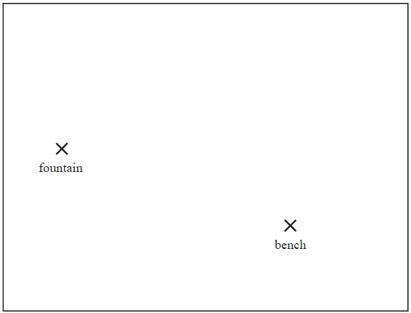
Scale: 1 centimetre represents 2 metres
Haavi is going to plant a tree in the garden.
The tree must be
less than 7 metres from the fountain, and less than 12 metres from the bench.
On the diagram show, by shading, the region in which Haavi can plant the tree.
(Total for question = 3 marks)

