Pie charts starter

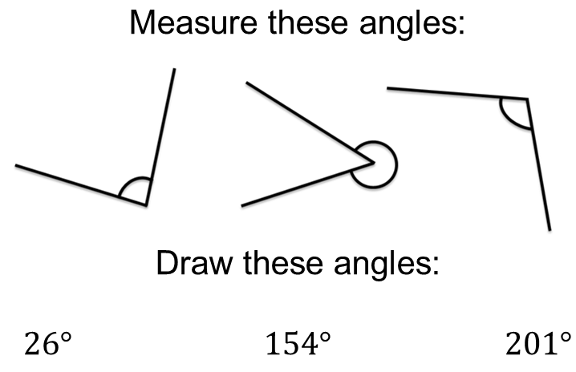

Pie charts starter

Pie charts starter

Pie charts starter

