End of Unit Test Name: ____________________________
Transformations - FOUNDATION

1) (a) Translate triangle T by the vector $\left(\begin{matrix}4 \\ -5\end{matrix}\right)$
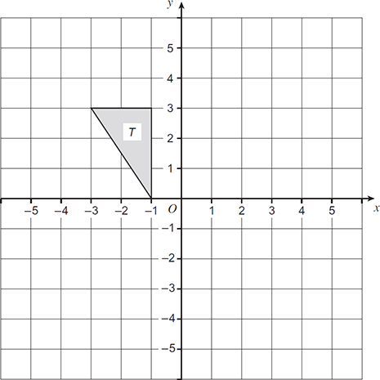
(2)
(b) Reflect triangle T in the line y = −1

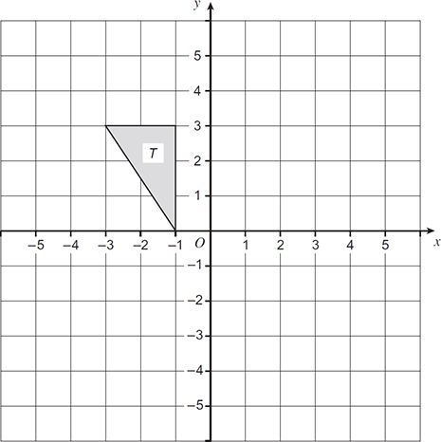
(2)
(Total 4 marks)

2) (a) Enlarge this shape by scale factor 2 with centre of enlargement point P.

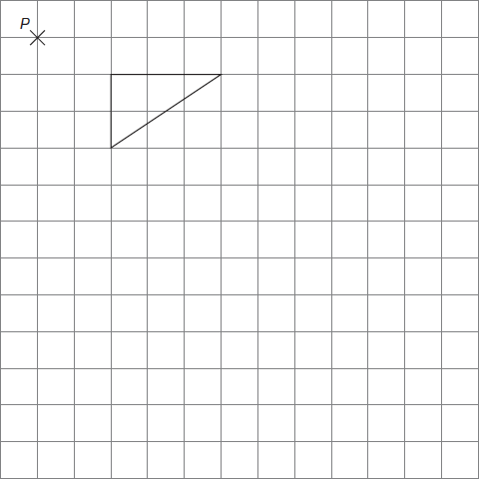
(3)
(b) Describe fully the single transformation that maps shape A to shape B.

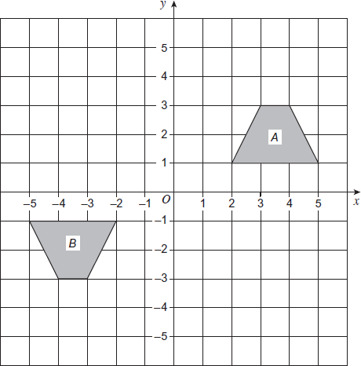

…………………………………………………………………………………………………..

…………………………………………………………………………………………………..

…………………………………………………………………………………………………..
(3)
(Total 6 marks)
3) Shapes A and B are shown on the grid.
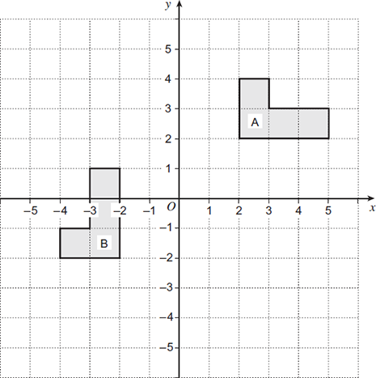

(a) Reflect shape A in the line y = 1
(2)
(b) Describe fully the single transformation that maps shape A to shape B.

…………………………………………………………………………………………………..

…………………………………………………………………………………………………..

…………………………………………………………………………………………………..
(3)
(Total 5 marks)

4) Here are two column vectors.

f = $\left(\begin{matrix}4 \\ 5\end{matrix}\right)$ g = $\left(\begin{matrix}5 \\ -2\end{matrix}\right)$

Work out 3f − 2g

…………………………………………………………………………………………………..

…………………………………………………………………………………………………..

…………………………………………………………………………………………………..

…………………………………………………………………………………………………..

Answer ...................................................................................
(Total 2 marks)

5) WXYZ is a trapezium.
= s
= t
ZY : WX = 3 : 2

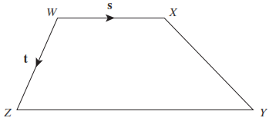

(a) Write vector in terms of s

…………………………………………………………………………………………………..

…………………………………………………………………………………………………..

Answer ......................................................................
(1)
(b) Work out vector in terms of s and t
Give your answer in its simplest form.

…………………………………………………………………………………………………..

…………………………………………………………………………………………………..

…………………………………………………………………………………………………..

Answer ......................................................................
(2)
(Total 3 marks)
(Total for test = 20 marks)

