Use the correct symbol (< or >) for each pair of numbers.  6 10 8 3 -2 -6 | Use the correct symbol (< or >) for each pair of numbers.  6 10 8 3 -2 -6
Use the correct symbol (< or >) for each pair of numbers.  6 10 8 3 -2 -6 | Use the correct symbol (< or >) for each pair of numbers.  6 10 8 3 -2 -6
Use the correct symbol (< or >) for each pair of numbers.  6 10 8 3 -2 -6 | Use the correct symbol (< or >) for each pair of numbers.  6 10 8 3 -2 -6
Use the correct symbol (< or >) for each pair of numbers.  6 10 8 3 -2 -6 | Use the correct symbol (< or >) for each pair of numbers.  6 10 8 3 -2 -6
Use the correct symbol (< or >) for each pair of numbers.  6 10 8 3 -2 -6 | Use the correct symbol (< or >) for each pair of numbers.  6 10 8 3 -2 -6
Use the correct symbol (< or >) for each pair of numbers.  6 10 8 3 -2 -6 | Use the correct symbol (< or >) for each pair of numbers.  6 10 8 3 -2 -6
Use the correct symbol (< or >) for each pair of numbers.  6 10 8 3 -2 -6 | Use the correct symbol (< or >) for each pair of numbers.  6 10 8 3 -2 -6
What inequalities do these diagrams represent?  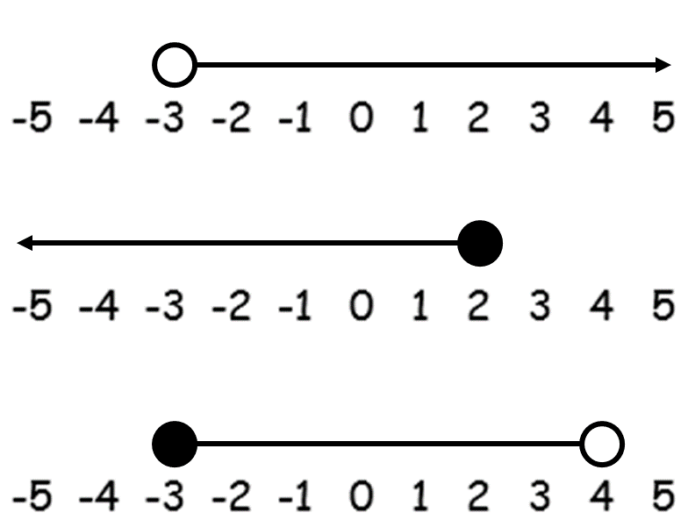 | What inequalities do these diagrams represent?
What inequalities do these diagrams represent? | What inequalities do these diagrams represent?
What inequalities do these diagrams represent? | What inequalities do these diagrams represent?
What inequalities do these diagrams represent? | What inequalities do these diagrams represent?
What inequalities do these diagrams represent? | What inequalities do these diagrams represent?
What inequalities do these diagrams represent? | What inequalities do these diagrams represent?
What inequalities do these diagrams represent? | What inequalities do these diagrams represent?
Sketch the following inequalities on a number line:  x > 4  y ≤ -1  -3 < z ≤ 2 | Sketch the following inequalities on a number line:  x > 4  y ≤ -1  -3 < z ≤ 2
Sketch the following inequalities on a number line:  x > 4  y ≤ -1  -3 < z ≤ 2 | Sketch the following inequalities on a number line:  x > 4  y ≤ -1  -3 < z ≤ 2
Sketch the following inequalities on a number line:  x > 4  y ≤ -1  -3 < z ≤ 2 | Sketch the following inequalities on a number line:  x > 4  y ≤ -1  -3 < z ≤ 2
Sketch the following inequalities on a number line:  x > 4  y ≤ -1  -3 < z ≤ 2 | Sketch the following inequalities on a number line:  x > 4  y ≤ -1  -3 < z ≤ 2
Sketch the following inequalities on a number line:  x > 4  y ≤ -1  -3 < z ≤ 2 | Sketch the following inequalities on a number line:  x > 4  y ≤ -1  -3 < z ≤ 2
Sketch the following inequalities on a number line:  x > 4  y ≤ -1  -3 < z ≤ 2 | Sketch the following inequalities on a number line:  x > 4  y ≤ -1  -3 < z ≤ 2
Sketch the following inequalities on a number line:  x > 4  y ≤ -1  -3 < z ≤ 2 | Sketch the following inequalities on a number line:  x > 4  y ≤ -1  -3 < z ≤ 2
Solve the following inequalities:  1) a + 8 < 5  2) b – 6 ≥ 2  3) 4c ≤ 8 | Solve the following inequalities:  1) a + 8 < 5  2) b – 6 ≥ 2  3) 4c ≤ 8
Solve the following inequalities:  1) a + 8 < 5  2) b – 6 ≥ 2  3) 4c ≤ 8 | Solve the following inequalities:  1) a + 8 < 5  2) b – 6 ≥ 2  3) 4c ≤ 8
Solve the following inequalities:  1) a + 8 < 5  2) b – 6 ≥ 2  3) 4c ≤ 8 | Solve the following inequalities:  1) a + 8 < 5  2) b – 6 ≥ 2  3) 4c ≤ 8
Solve the following inequalities:  1) a + 8 < 5  2) b – 6 ≥ 2  3) 4c ≤ 8 | Solve the following inequalities:  1) a + 8 < 5  2) b – 6 ≥ 2  3) 4c ≤ 8
Solve the following inequalities:  1) a + 8 < 5  2) b – 6 ≥ 2  3) 4c ≤ 8 | Solve the following inequalities:  1) a + 8 < 5  2) b – 6 ≥ 2  3) 4c ≤ 8
Solve the following inequalities:  1) a + 8 < 5  2) b – 6 ≥ 2  3) 4c ≤ 8 | Solve the following inequalities:  1) a + 8 < 5  2) b – 6 ≥ 2  3) 4c ≤ 8
Solve the following inequalities:  1) a + 8 < 5  2) b – 6 ≥ 2  3) 4c ≤ 8 | Solve the following inequalities:  1) a + 8 < 5  2) b – 6 ≥ 2  3) 4c ≤ 8
Solve the following inequalities:  1) 2m + 3 ≤ 9  2) 5n – 6 > 19 | Solve the following inequalities:  1) 2m + 3 ≤ 9  2) 5n – 6 > 19
Solve the following inequalities:  1) 2m + 3 ≤ 9  2) 5n – 6 > 19 | Solve the following inequalities:  1) 2m + 3 ≤ 9  2) 5n – 6 > 19
Solve the following inequalities:  1) 2m + 3 ≤ 9  2) 5n – 6 > 19 | Solve the following inequalities:  1) 2m + 3 ≤ 9  2) 5n – 6 > 19
Solve the following inequalities:  1) 2m + 3 ≤ 9  2) 5n – 6 > 19 | Solve the following inequalities:  1) 2m + 3 ≤ 9  2) 5n – 6 > 19
Solve the following inequalities:  1) 2m + 3 ≤ 9  2) 5n – 6 > 19 | Solve the following inequalities:  1) 2m + 3 ≤ 9  2) 5n – 6 > 19
Solve the following inequalities:  1) 2m + 3 ≤ 9  2) 5n – 6 > 19 | Solve the following inequalities:  1) 2m + 3 ≤ 9  2) 5n – 6 > 19
Solve the following inequalities:  1) 2m + 3 ≤ 9  2) 5n – 6 > 19 | Solve the following inequalities:  1) 2m + 3 ≤ 9  2) 5n – 6 > 19
Solve the following inequalities:  1) 3x + 3 > 5x – 1  2) 4g + 2 ≥ 2g - 4 | Solve the following inequalities:  1) 3x + 3 > 5x – 1  2) 4g + 2 ≥ 2g - 4
Solve the following inequalities:  1) 3x + 3 > 5x – 1  2) 4g + 2 ≥ 2g - 4 | Solve the following inequalities:  1) 3x + 3 > 5x – 1  2) 4g + 2 ≥ 2g - 4
Solve the following inequalities:  1) 3x + 3 > 5x – 1  2) 4g + 2 ≥ 2g - 4 | Solve the following inequalities:  1) 3x + 3 > 5x – 1  2) 4g + 2 ≥ 2g - 4
Solve the following inequalities:  1) 3x + 3 > 5x – 1  2) 4g + 2 ≥ 2g - 4 | Solve the following inequalities:  1) 3x + 3 > 5x – 1  2) 4g + 2 ≥ 2g - 4
Solve the following inequalities:  1) 3x + 3 > 5x – 1  2) 4g + 2 ≥ 2g - 4 | Solve the following inequalities:  1) 3x + 3 > 5x – 1  2) 4g + 2 ≥ 2g - 4
Solve the following inequalities:  1) 3x + 3 > 5x – 1  2) 4g + 2 ≥ 2g - 4 | Solve the following inequalities:  1) 3x + 3 > 5x – 1  2) 4g + 2 ≥ 2g - 4
Solve the following inequalities:  1) 3x + 3 > 5x – 1  2) 4g + 2 ≥ 2g - 4 | Solve the following inequalities:  1) 3x + 3 > 5x – 1  2) 4g + 2 ≥ 2g - 4
Show the region defined by:  x > 2, y > 1 and y ≤ -2x + 4 | Show the region defined by:  x > 2, y > 1 and y ≤ -2x + 4
Show the region defined by:  x > 2, y > 1 and y ≤ -2x + 4 | Show the region defined by:  x > 2, y > 1 and y ≤ -2x + 4
Show the region defined by:  x > 2, y > 1 and y ≤ -2x + 4 | Show the region defined by:  x > 2, y > 1 and y ≤ -2x + 4
Show the region defined by:  x > 2, y > 1 and y ≤ -2x + 4 | Show the region defined by:  x > 2, y > 1 and y ≤ -2x + 4
Show the region defined by:  x > 2, y > 1 and y ≤ -2x + 4 | Show the region defined by:  x > 2, y > 1 and y ≤ -2x + 4
Show the region defined by:  x > 2, y > 1 and y ≤ -2x + 4 | Show the region defined by:  x > 2, y > 1 and y ≤ -2x + 4
Show the region defined by:  x > 2, y > 1 and y ≤ -2x + 4 | Show the region defined by:  x > 2, y > 1 and y ≤ -2x + 4
Solve x² + 7x + 12 < 0 | Solve x² + 7x + 12 < 0
Solve x² + 7x + 12 < 0 | Solve x² + 7x + 12 < 0
Solve x² + 7x + 12 < 0 | Solve x² + 7x + 12 < 0
Solve x² + 7x + 12 < 0 | Solve x² + 7x + 12 < 0
Solve x² + 7x + 12 < 0 | Solve x² + 7x + 12 < 0
Solve x² + 7x + 12 < 0 | Solve x² + 7x + 12 < 0
Solve x² + 7x + 12 < 0 | Solve x² + 7x + 12 < 0

