**Transformations (H)**

Post-Intervention Assessment

Name: _______________________________

Class: _______________________________

Date: _______________________________

|  |  |  |
| --- | --- | --- |
| **Question** | **Objective** | **RAG** |
| 1 | Describe transformations |  |
| 2 | Enlarge shapes (fractional or negative scale factor) |  |
| 3 | Solve problems involving vectors |  |



**1.** Describe fully the single

transformation that will map shape P onto shape Q

…………………………………………

…………………………………………

…………………………………………

**2.**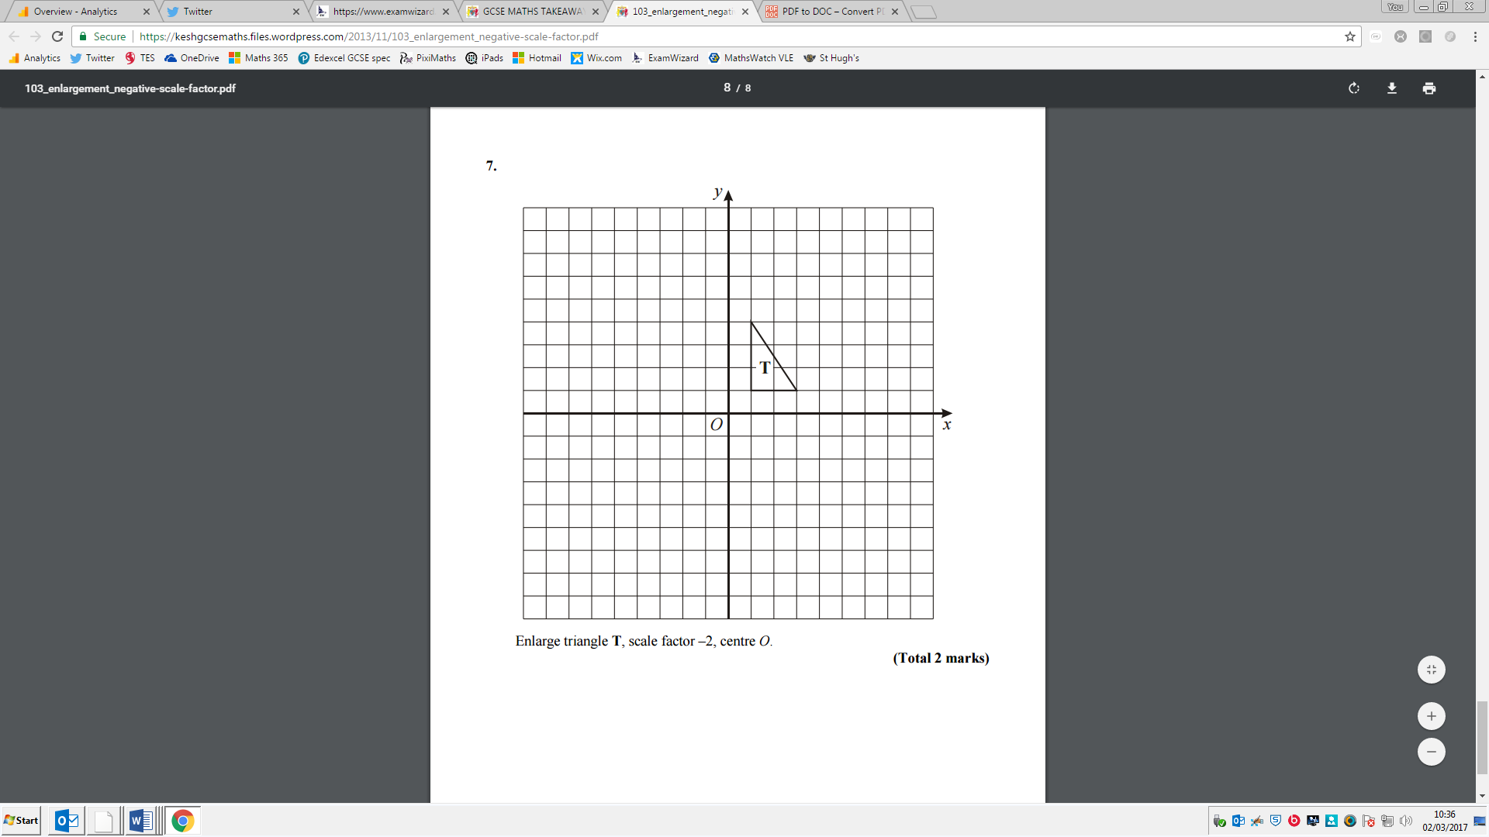Enlarge triangle T, scale factor –2, centre *O*.

**3.** *ABCD* is a straight line.



*O* is a point so that  and .

*B* is the midpoint of *AC*.  
*C* is the midpoint of *AD*.

Express, in terms of **a** and **b**, the vectors

(i) 

...........................................................

(ii) 

...........................................................

[Glue here]